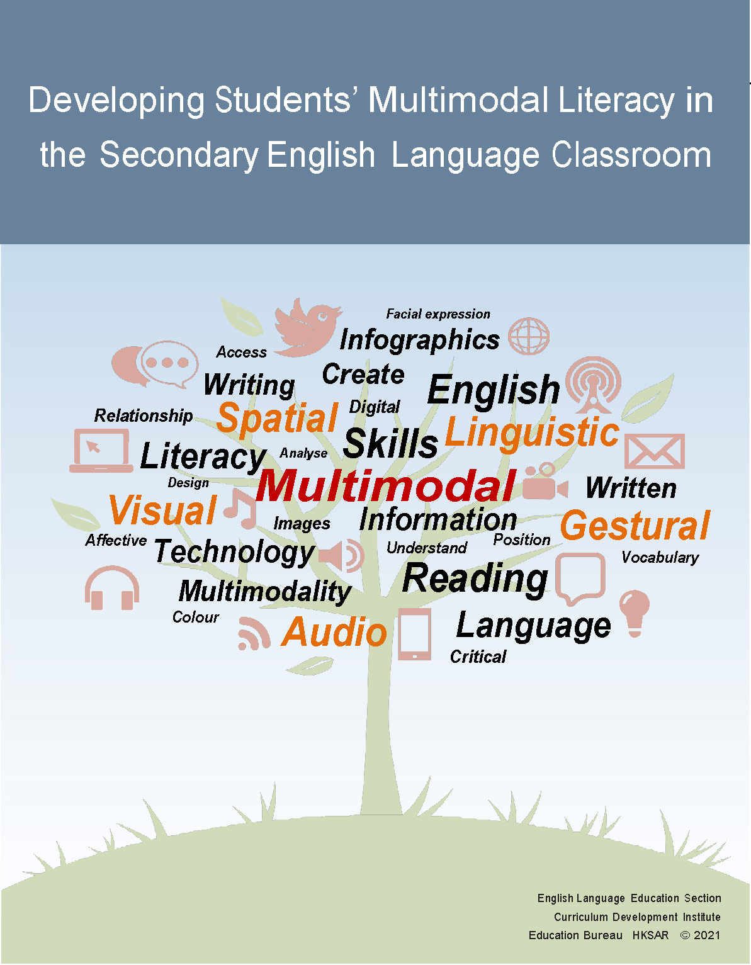

(Blank page)

English Language Education Section
Curriculum Development Institute
Education Bureau
The Hong Kong Special Administrative Region

12/F, Wu Chung House, 213 Queen’s Road East, Wan Chai, Hong Kong

Published 2021

All rights reserved. The copyright of the materials in this resource package, other than those listed in the Acknowledgements section, belongs to the Education Bureau of the Hong Kong Special Administrative Region.

Duplication of materials in this resource package other than those listed in the Acknowledgements section is restricted to non-profit making educational purposes only. Otherwise, no part of these materials may be reproduced, stored in a retrieval system, or transmitted in any form or by any means without the prior permission of the Education Bureau of the Hong Kong Special Administrative Region.

© 2021

(Blank page)

Contents

Preface III

Acknowledgements V

Chapter 1 New Literacy Skills and the Use of Multimodal Texts 1

Chapter 2 Learning and Teaching Materials for Effective Use of
Multimodal Texts 11

(1) Module: Technology
Unit: Wearable Technology 13

(2) Module: Leisure and Entertainment
Unit: Film Festival 43

(3) Module: Nature and Environment
Unit: Environmental Protection 97

References 141
Appendices 145

(Blank page)

Preface

Developing Students’ Multimodal Literacy in the Secondary English Language Classroom is a resource package produced by the English Language Education Section, Curriculum Development Institute, Education Bureau, Hong Kong Special Administrative Region, in support of the implementation of the English Language Education Key Learning Area Curriculum Guide (Primary 1 – Secondary 6) (CDC, 2017). Part of the materials in this resource package was adapted from those developed in the Collaborative Research and Development (“Seed”) Project on “Effective Use of Digital Media in Developing Students’ Critical Thinking and Creativity in the Secondary English Classroom” in the 2015/16 school year. Additional materials and ideas are also included for teachers’ reference on the use of multimodal texts to develop students’ new literacy and language skills in the English Language classroom.

Aims of the Resource Package
This resource package aims to:
- shed light on what multimodal literacy and new literacy skills refer to
- illustrate how multimodal texts can be used to develop new literacy skills in the English Language classroom
- provide opportunities for students to interact with, analyse and create multimodal texts and for creative use of the language

How can the resource package be used?
The resource package covers both theories and practices in the adoption of multimodal texts in the learning and teaching of English Language. It consists of the following:
- theoretical underpinnings of the use of multimodal texts in English Language learning and teaching;
- learning and teaching materials (coded as “LT X.X.X” in the package) for three units of tasks on different themes with increasing level of difficulty, with the first unit being the easiest; and
- suggested teaching steps (coded as “LT X.X.XT” in the package) with pedagogical ideas for teachers to adapt and adopt in the classroom.

The text files are available in both PDF and MS WORD formats for ease of use and adaptation. Teachers might like to select and use the learning materials and teaching ideas in the resource package or adapt them to suit their students’ needs, interests and abilities.

(Blank page)

Acknowledgements

We are grateful to the participating schools for their active participation in the Collaborative Research and Development (‘Seed’) Project on “Effective Use of Digital Media in Developing Students’ Critical Thinking and Creativity in the Secondary English Classroom”. Special thanks go to the teachers involved in the project for developing and trying out the teaching plans and activities included in the resource package.

We would also like to extend our gratitude to the following organisations / individuals for their permission to use and reproduce the copyrighted materials included in this resource package:
- Information Services Department for the infographic on 2015-16 Budget Highlights on p.4
- Mr Nima Raoofi for the snapshots from the film My Shoes on pp. 68-79 & 90
- Environmental Protection Department for the Air Quality Health Index logo on p.5 of sample e-booklet

The following images are used or reproduced under the Pixabay License:
- Clapperboard by Mediamodifier on p.45 (Retrieved from https://pixabay.com/zh/photos/clapper-hollywood-cinema-board-2140602/)
- Shooting by Geralt on p.65 (Retrieved from https://pixabay.com/photos/photography-photograph-woman-group-2751469/)
- Film Trophy by Alexas_Fotos on p.65 (Retrieved from https://pixabay.com/photos/award-good-movie-trophy-competition-2969422/)
- Crowded beach by Glucosala on p.71 (Retrieved from https://pixabay.com/photos/beach-people-crowd-parasol-sea-1633576/)
- Farmers Market by LonaE on p.71 (Retrieved from https://pixabay.com/photos/farmers-market-fruit-vegetable-454032/)
- Movie with popcorn by Peggy_Marco on p.90 (Retrieved from https://pixabay.com/zh/illustrations/white-male-3d-model-isolated-3d-1847732/)
- Girl on Red Carpet by Alexa_Fotos on p.90 (Retrieved from https://pixabay.com/zh/photos/red-carpet-stairs-glamour-woman-1842849/)
- Poisoning the Ocean by Atdsphoto on the PowerPoint slides (Retrieved from https://pixabay.com/photos/pollution-toxic-products-environment-3075857/)
- Clapping hands by Budikai on p.90 (Retrieved from https://pixabay.com/zh/illustrations/applause-hand-icon-symbol-sign-3547919/)
- Popcorn by Dbreen on p.90 (Retrieved from https://pixabay.com/zh/photos/popcorn-movies-cinema-entertainment-1085072/)
- Scrooge of Christmas Carol by Prawny on p.91 (Retrieved from https://pixabay.com/zh/illustrations/vintage-arthur-rackham-christmas-1705170/)
- Empty Seats in Cinema by Vladvictoria on p.91 (Retrieved from https://pixabay.com/zh/photos/seat-chair-indoors-theatre-empty-4012101/)
- Clouds on the mountain by Djedj on p.91 (Retrieved from https://pixabay.com/zh/photos/landscape-cloud-fog-sunset-3914513/)
- Sunglasses on tickets by Johnyksslr on p.91 (Retrieved from https://pixabay.com/zh/photos/tickets-cinemas-3d-cine-movies-1814606/)
- Theatre Entrance by MichaelGaida on p.91 (Retrieved from https://pixabay.com/zh/photos/cinema-movie-theater-movies-input-1241422/)
- Man in Poison Mask by Lukaszdylka on p.129 (Retrieved from https://pixabay.com/photos/gas-mask-poison-protection-469217/)

The following images are used or reproduced under the Creative Commons Licenses:
- Danish football fans, London by adrian, acediscovery on p.71 under CC BY-NC-ND 2.0
- Shark Finning- an illegal practice by indiawaterportal.org on p.125 under CC BY-NC-SA 2.0
- Respect the Fin by Ryan Steely on p.125 under CC BY-ND 4.0
- Scooping the sharks' fins by lynac on p.129 under CC BY-NC 2.0
- Shark Fins Drying for Sale by kqedquest on p.129 under CC BY-NC 2.0
- Finned by MoelSiabod on p.129 under CC BY-NC 2.0
- Plastic Bags Packaging - Awareness - 3rd Year by Noor Daghistani on p.129 under CC BY-NC-ND 4.0
- Lesser the pollution, better the life by Kristlin Visnapuu on p.129 under CC BY-NC-ND 4.0
- screened by Rockman of Zymurgy on p.129 under CC BY-NC-ND 2.0

The following images are used or reproduced under the Pexel License:
- Gray Shark by George Desipris on p.124 (Retrieved from https://www.pexels.com/photo/selective-photo-of-gray-shark-726478/)
- Traffic Roadway by Pixabay on p.129 (Retrieved from https://www.pexels.com/photo/buildings-cars-city-cross-harbour-tunnel-262100/)
- Electric Towers during Golden Hour by Pixabay on the PowerPoint slides and sample e-booklet (Retrieved from https://www.pexels.com/photo/air-air-pollution-climate-change-dawn-221012/)
- Group of Lining Men by Pixabay on the PowerPoint slides (Retrieved from https://www.pexels.com/photo/people-men-women-crowd-34291/)
- Bird’s Eye View of Woodpile by Pok Rie on the PowerPoint slides (Retrieved from https://www.pexels.com/photo/bird-s-eye-view-of-woodpile-1268076/)
- Clera Light Bulb by Pixabay on the sample e-book (Retrieved from https://www.pexels.com/photo/bulb-close-up-conceptual-current-207420/)
- Double Exhaust by Markus Spiske temporausch.com on the sample e-booklet (Retrieved from https://www.pexels.com/photo/car-tire-oldtimer-sports-car-97045/)

The following images are used or reproduced under the Photo License: Burst:
- Ice in Ocean Waters Photo by Shopify Partners on the PowerPoint slides (Retrieved from https://burst.shopify.com/photos/ice-in-ocean-waters)

The links to websites owned or operated by parties other than the EDB are provided for your reference only. We accept no responsibility for their contents, timeliness, accuracy and reliability.

If you have any reason to believe that any information or content of this resource package contains materials infringing copyright, please notify us. Upon notification of violations, we will take remedial action immediately.

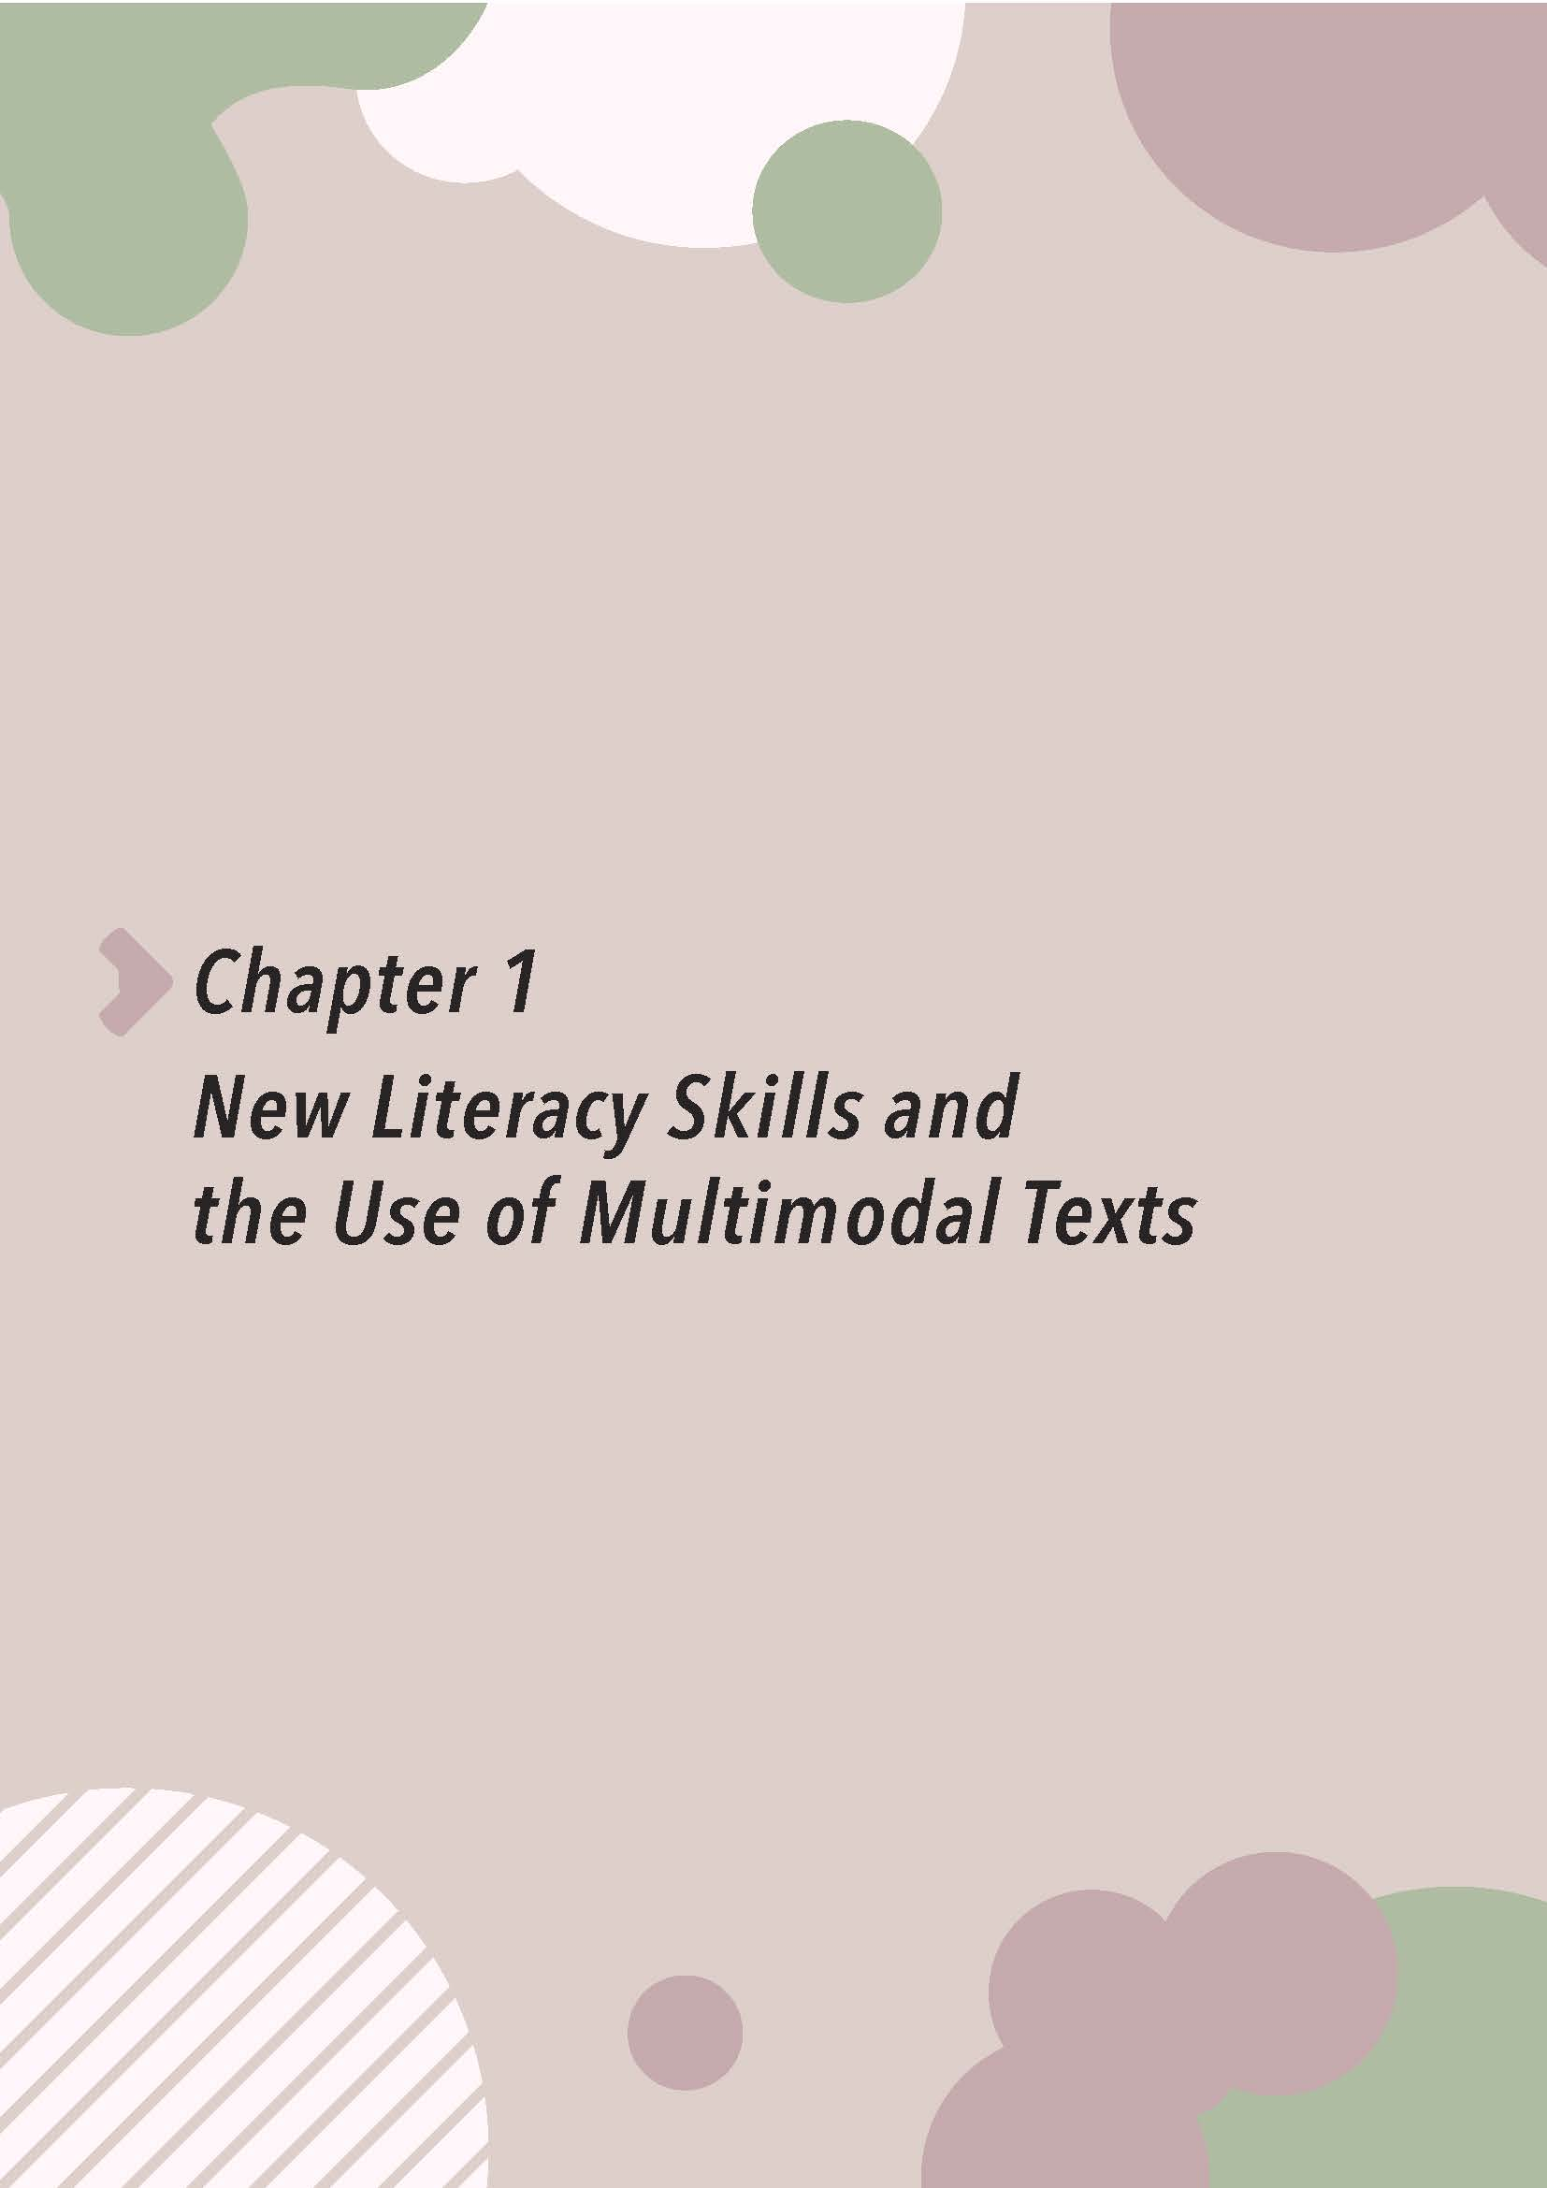

Chapter 1
New Literacy Skills and the Use of Multimodal Texts

(Blank page)

Introduction

Development of new literacy skills, in particular multimodal literacy, is one of the emphases in The English Language Education Key Learning Area Curriculum Guide (2017). With the advancement of information technology, there has been a shift in how “literacy” is defined. “Literacy” is no longer confined to the ability to read and write, but extended to cover the ability to understand and create a range of texts that integrate linguistic, audio, visual, gestural and spatial elements, as well as the ability to use different media and technological tools for effective communication and information management. New literacy skills have been given increasing attention in the learning and teaching of English worldwide. To address such changes, there is a need to adopt a pedagogical approach that provides more opportunities for students to interact with, analyse and create multimodal texts in today’s English Language classroom. This chapter attempts to explain what multimodal texts and new literacy skills are, and their implications for the English Language classroom.

- The Broadened Notion of Text

Traditionally, texts are perceived as something written in words and printed on paper. However, with the emergence of new technologies and communication channels, information and ideas are rarely expressed only in words, but often in a combination of the following modes of expression:
Mode | Elements Involved
Linguistic | written or spoken language, vocabulary, grammar, sentence structure
Audio | music, sound effect, noise, silence, the use of volume and rhythm
Visual | still and moving image, diagram, colour, page layout, framing, camera angle and movement, lighting
Gestural | action, physical movement, eye contact, facial expression, body language
Spatial | the design of environmental and architectural space, position and organisation of object in space, direction and distance

A typical example of this kind of multimodal texts is infographics, in which the message is presented in multiple modes through the choice of colours and fonts, the use of words and graphics, etc. Readers need to explore the relationship between words and visual-spatial elements to fully comprehend the text. An example of infographic text is provided on the following page.
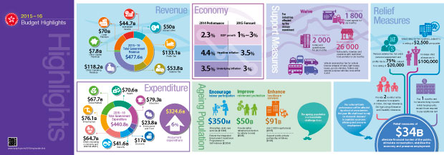

- New Literacy Skills and Information Literacy Framework for Hong Kong Students

With the broadened definition of texts and the prevalence of multimodal texts in our daily life, “literacy” has taken on a new meaning. The traditional language-focused approaches are no longer adequate for developing students into critical literates in the Age of Information. Churchill (2010) uses the term “New Literacy” to sum up the set of skills required for students to survive and thrive in the digital world, as shown in the diagram below:
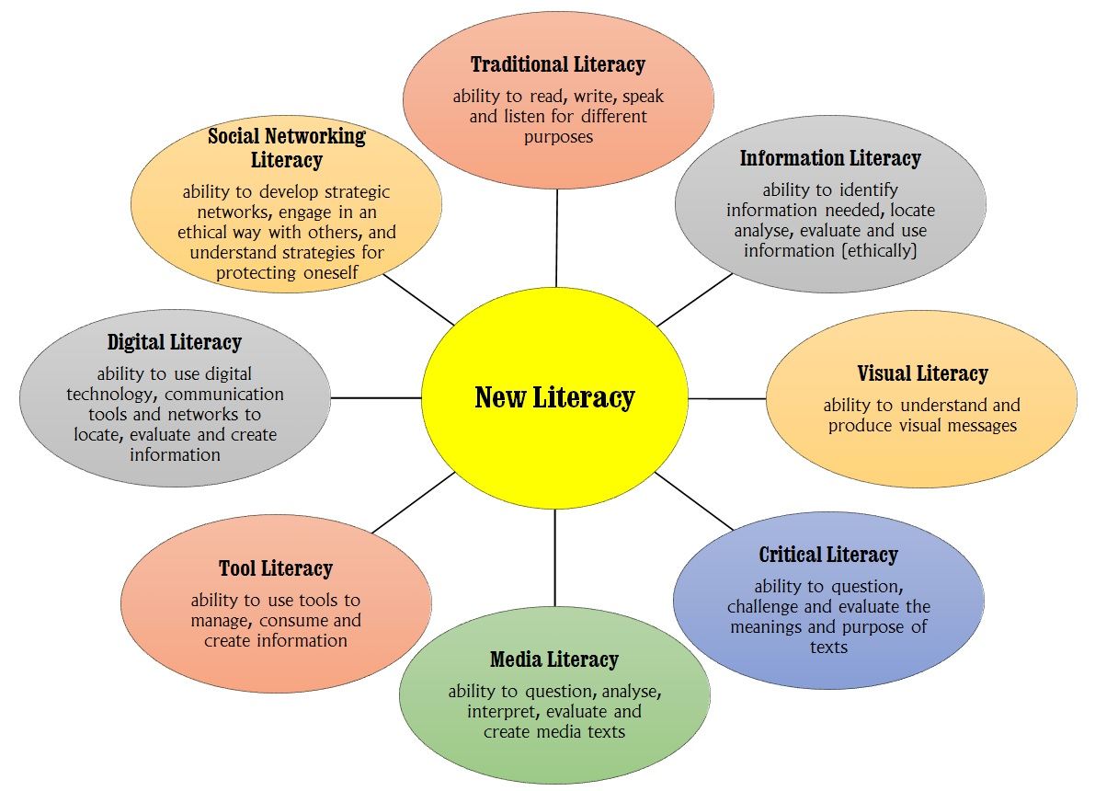
Source: Daniel Churchill “New Literacy in the Digital World: Implications for Higher Education” https://core.ac.uk/download/pdf/61010522.pdf
To address the global changes and education trends, the Education Bureau (EDB) has developed the Information Literacy (IL) Framework for Hong Kong Students to help schools develop students’ knowledge, skills and attitude to use information and information technology ethically and effectively at different key stages. The IL Framework has covered a range of new literacy skills mentioned by Churchill and can be accessed through the link below:
https://www.edb.gov.hk/attachment/en/edu-system/primary-secondary/applicable-to-primary-secondary/it-in-edu/Information-Literacy/IL20180516E.pdf

This package also provides examples to illustrate how some of the learning targets in the IL Framework can be achieved with the use of multimodal texts in the English Language classroom.

- Pedagogical Approaches to Using Multimodal Texts to Develop New Literacy Skills in the English Language Classroom

While students nowadays may be more technologically savvy, they are not automatically multimodal literates. One key component of new literacy instruction is, therefore, to guide students to decipher multimodal texts. This process of close textual analysis is no new to students and teachers. In reading lessons, students are guided to read between and beyond the lines to make meaning of written texts. By the same token, students can be challenged to dig deeper into the different modes of expression and understand what they mean.

In this resource package, Callow’s (2005) three-dimension framework is adapted for use to guide students to analyse and tease out layers of meaning in multimodal texts:

- The affective dimension mainly deals with the reader/viewer’s feelings and emotional response to the text
- The compositional dimension focuses on how the text is constructed and its presentation
- The critical dimension focuses on hidden messages and embedded values of the text, as well as its social-cultural impacts

To understand how the three-dimension framework helps us formulate questions, please refer to Examples of Guiding Questions for Analysing Multimodal Texts at the end of this section.

In designing activities and tasks in the units of work featured in this package, the task-based approach is adopted to develop students’ new literacy and language skills in meaningful contexts, as well as to provide opportunities for students to process and create multimodal texts, as illustrated in the diagram below.

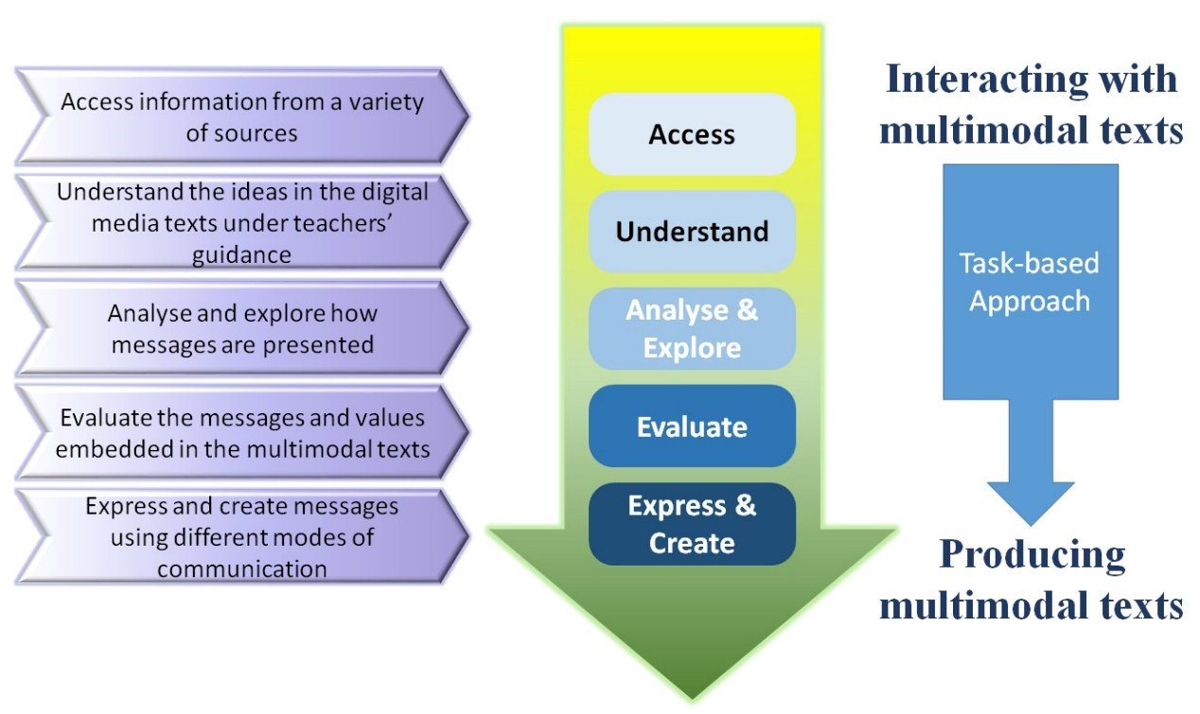

This approach allows students to progress from the surface layer of the text (literal meaning) to the subtext (hidden messages, embedded values and points of view) and representation, enabling them to be critical and active viewers of multimodal texts. As students learn to analyse how messages are constructed, they can apply the knowledge of the text features and media conventions to produce effective multimodal texts to get their messages across.

- Conclusion

Language learning today has to take into consideration that messages and information we receive daily no longer come in just written words, but in multimodal ensembles. This package illustrates how everyday learning tasks can be translated into effective new literacy practices when students are engaged in close analysis and production of multimodal texts in the English Language classroom. By providing access to motivating materials and asking stimulating questions about them, teachers can help students form the habit of mind to question the messages in all texts, regardless of the media through which they are delivered and the forms/modes in which they are presented.

Examples of Guiding Questions for Analysing Multimodal Texts

The following are some questions teachers can use to guide students to explore the three dimensions of a multimodal text and structure their responses.
Dimension | Questions
Affective  (the viewer’s/reader’s feelings and emotional responses to the text) | - How does the text make you feel?  - Why does it make you feel this way?  - What catches your attention first when you look at the text (e.g. the background, the characters, the use of colours, the music)?  - How do your eyes move across the text/image to understand what’s happening?  - What comes to your mind when you see the text? Does it remind you of other texts you have come across or any of your past experience?  - Can you relate to anyone or anything in the text in any way? If yes, how?  - What questions do you have in mind as you read/view the text?  - Do you find the text powerful? Why?  - Which part is particularly striking/weak?  - What idea seems most important in the text?  - Do you find the information, ideas and views presented in the text convincing and credible? Why?
Compositional (ways the text is constructed and presented) | Different structural components and elements:  Visual-spatial  - What can you see in the foreground and background of the text?  - How do the people in the text look like? Describe their appearance, costumes and hairstyle.  - What is included in the frame? How is the image composed?  - What is absent or not included in the frame?  - Which part of the image is the focus?  - From what angle and distance is the image taken?  - Are there any special effects, alteration and editing?  - What is special about the use of colours?  - What is special about the lighting?  - How are events/details connected in the text?  - What do you notice about the layout of the text? How is the content arranged?  - What is the spatial distance between characters/objects?  Linguistic  - What written text accompanies the image (e.g. a title, a caption)? What does it add to the image?  - What is special about the use of fonts and font sizes? Are there any changes and irregularities in the text?  - What rhetorical features (e.g. rhetorical questions, inversion), figurative language (e.g. similes, metaphors) or techniques (e.g. rhymes, alliteration, puns) are used?  - Does the language appeal to our five senses (i.e. senses of sight, hearing, smell, taste, and touch)?  - What is special about the word choice (e.g. extensive use of emotional adjectives)?  - Can you identify any patterns in the language (e.g. repetition, parallel structures)?  - How does the use of language enhance the conveyance of messages and overall presentation of the text?  Audio  - What kind of music is used in the text?  - Are there any special sound effects added?  - When and why are music and sound effects added?  - Are there any changes in the arrangements and choice of music?  - What mood and tone does the use of music and sound effects create?  Gestural  - What are the people in the text doing? Describe their physical actions and body movements.  - What are the people in the text looking at? Are they looking directly at you or away? Is the eye level high, low or even?  - Does their eye contact or gaze (i.e. act of seeing or being seen) give you a certain impression or feeling (e.g. an air of superiority, arrogance, hostility or friendliness)?  - What do the people’s actions, physical movement, eye contact, facial expressions and body language suggest about their feelings, characters and backgrounds?  - Do the people’s facial expressions, body language and movement appeal to you emotionally?  - Do you think the people in the text look real and natural?
Critical  (hidden messages, embedded values and socio-cultural impacts) | - Who is the creator of the text?  - Who is the target audience of the text?  - When was the text made? Where and how is the text shared with the public/audience (i.e. the context and medium)?  - What is the main purpose of creating the text?  - What is the main idea of the text? What message does the text try to convey?  - Are there other ways of interpreting the text? Will other people (e.g. parents) view the text differently? If yes, how?  - Is the text presented from a particular point of view? Are any ideas or perspectives left out?  - Does the text present a biased, stereotypical or idealised view?  - Who/what has the power in the text/image?  - Whose interest is served in the text? What kind of people may benefit from and/or be disadvantaged by the text?  - What is the text trying to make the audience believe or do?
* The questions are designed to illustrate Callow’s three-dimension framework. The questions are by no means exhaustive. Teachers should feel free to select and adapt them to suit the chosen texts and target group of students.

(Blank page)
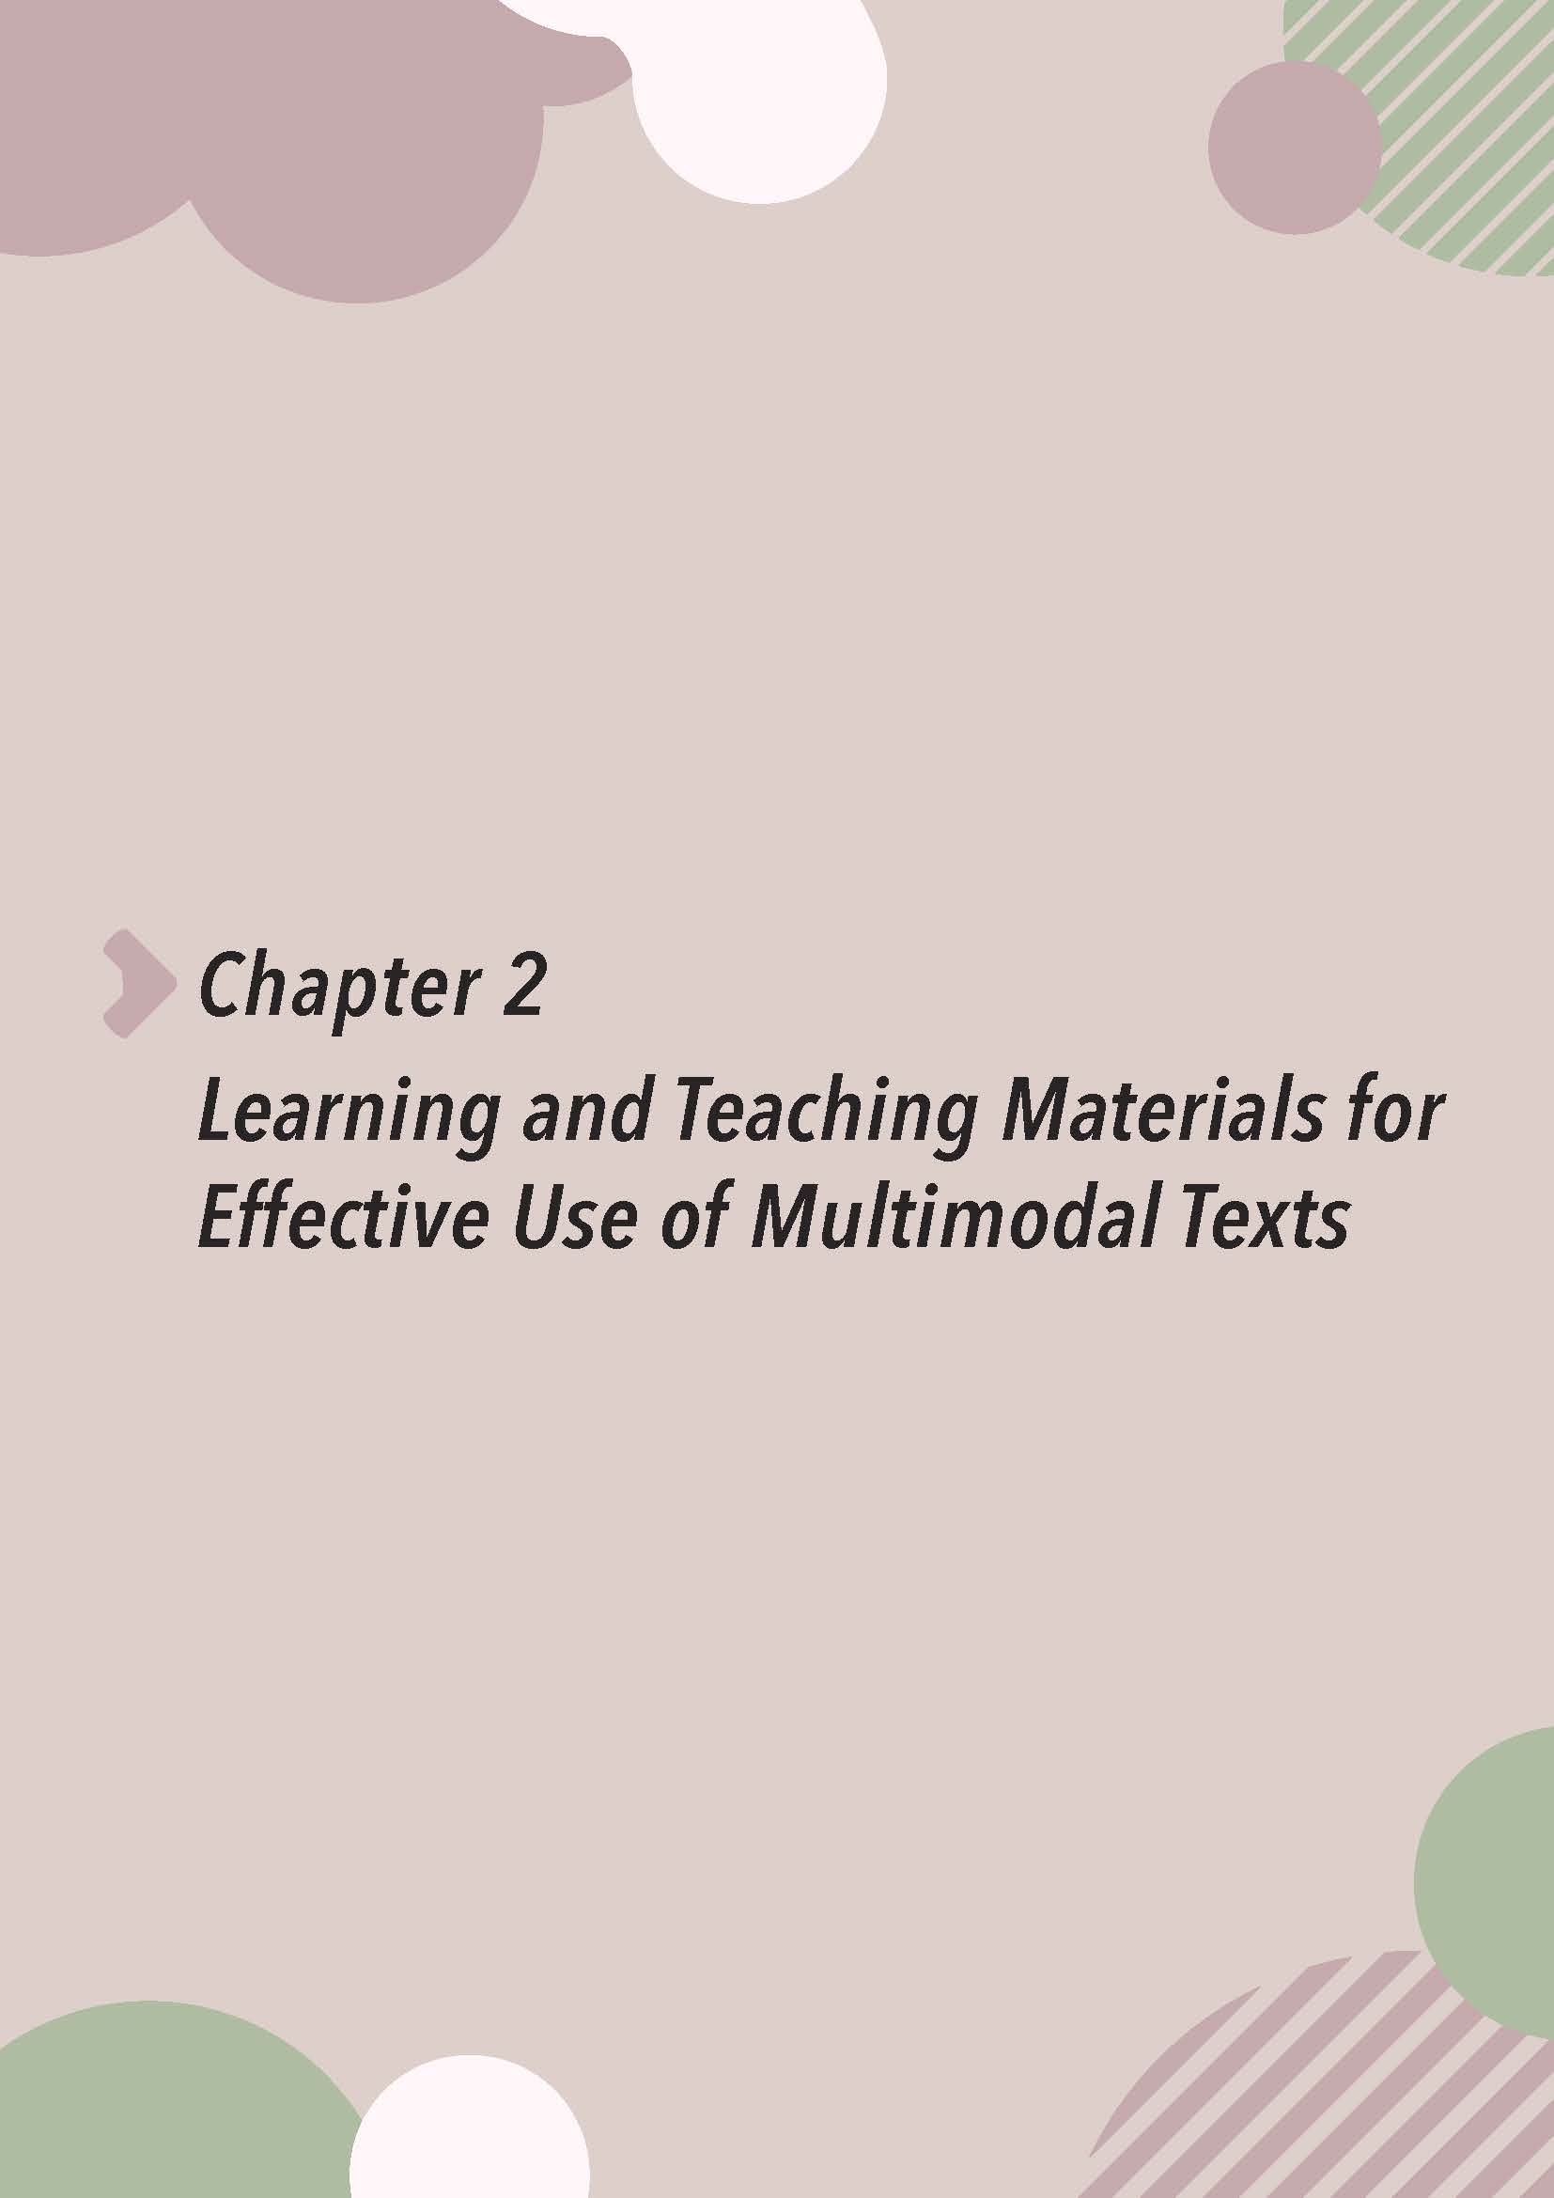

Chapter 2
Learning and Teaching Materials for Effective Use of Multimodal Texts

(Blank page)

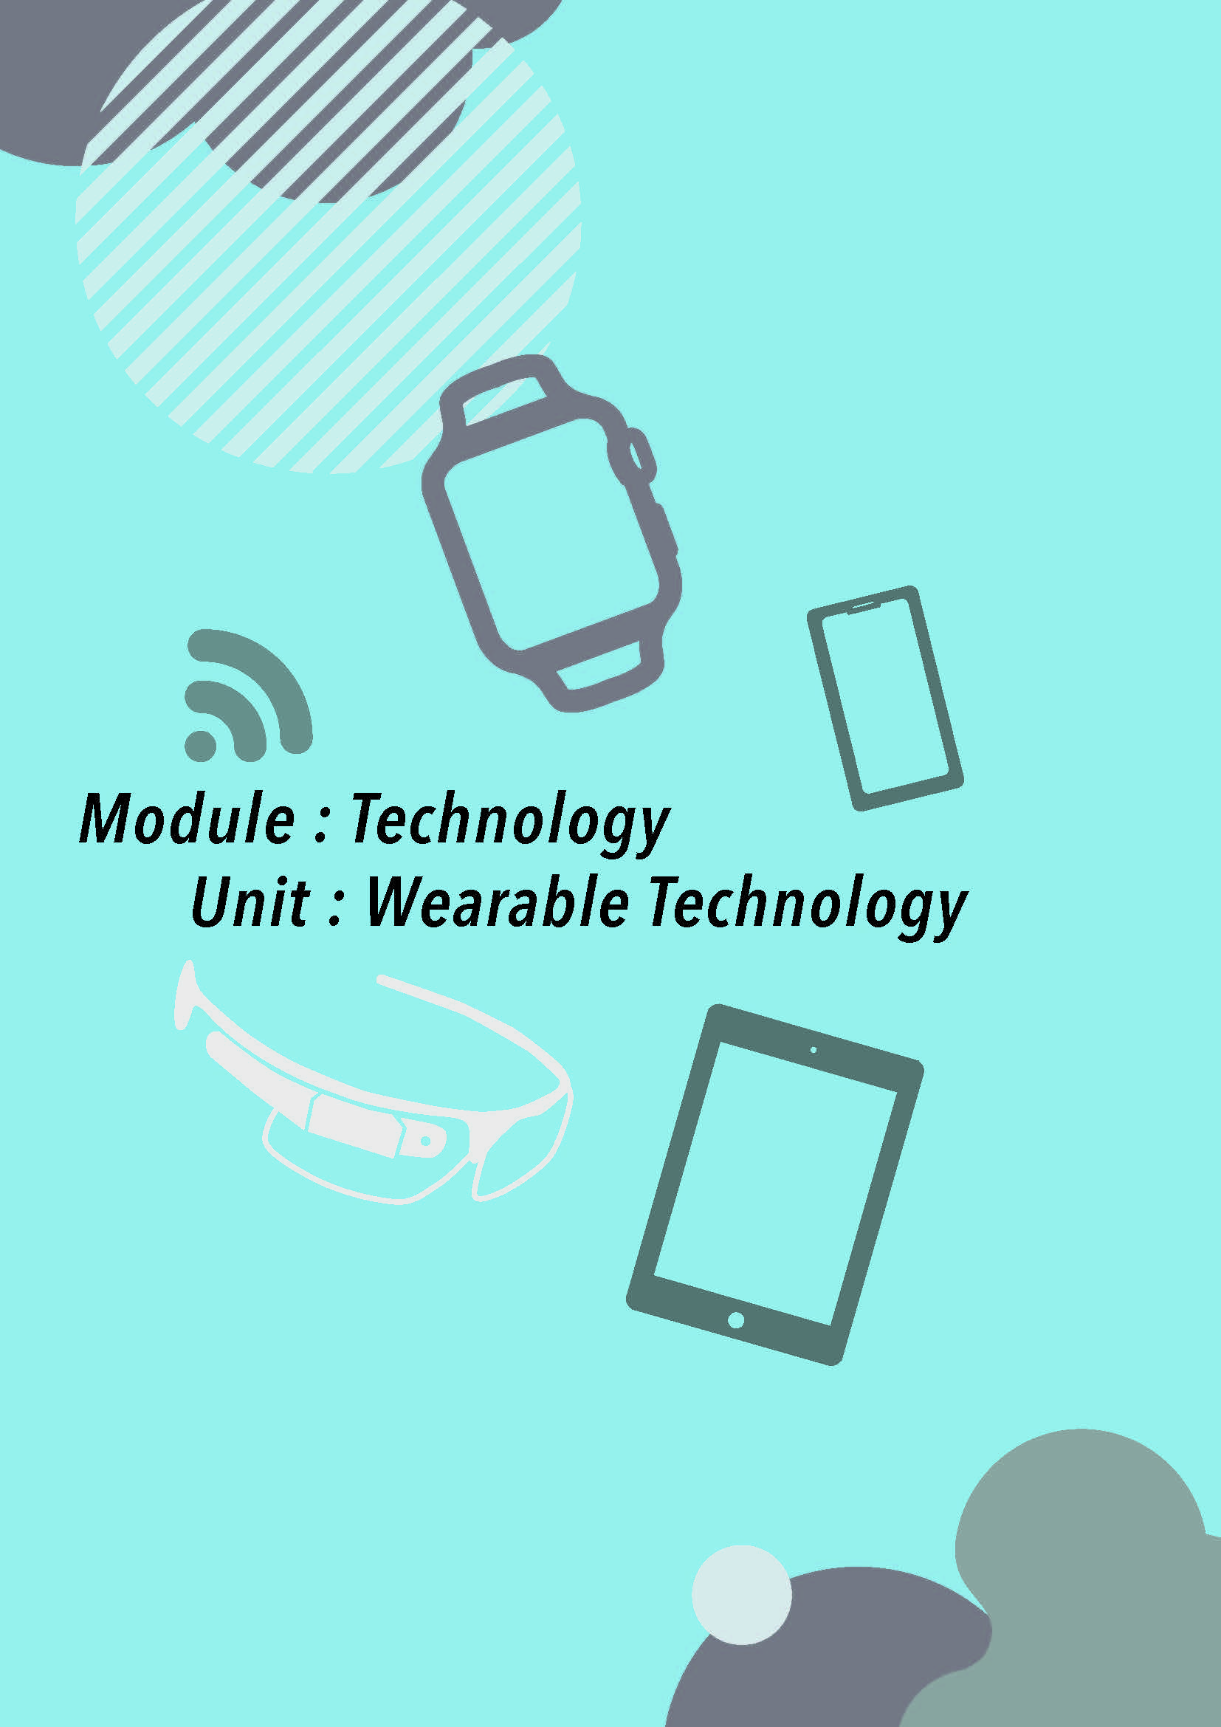

(1) Module: Technology
Unit: Wearable Technology

(Blank page)
Overview

Situation
You are newly recruited as a marketing executive for SamSam, an electronic device manufacturing company. Your boss, Jack Cheung, has asked you to assist in the launch of the latest product of the company.

You will have to complete the following tasks:

Task 1: Understanding Wearable Technology and Writing a Product Description
You will watch a video to understand more about wearable technology. You will then read and write a product description.

Task 2: Comparing Products
You will listen to a briefing session, take notes on the similarities of and differences between two smartwatches, and prepare a comparison summary.

Task 3: Commenting on an Infographic
You will familiarise yourself with the use of icons to represent different objects / ideas and comment on the effectiveness of an infographic.

Task 4: Writing a Speech
You will write a speech and prepare some slides to be used at the launch event of the latest wearable technology product of your company.

Materials
- LT 1.1.1 – LT 1.4.4
- Audio-visual materials (accessible with the QR code provided)
- Audio materials
- PowerPoint slides (Smartie Watch 2.0) (Appendix A)

Procedures:

- Ask students to name a few hi-tech products they come across in their daily lives.
- Introduce the context and the tasks to students with reference to the Overview.

Task 1 Understanding Wearable Technology and Writing a Product Description

Part A: Getting to know what wearable technology is (LT 1.1.1)

- Explain to students the situation and the learning objectives of Task 1, i.e. understanding the features of a product description and writing one with the use of adjective phrases / clauses.

- Go through the table with students. Allow time for students to predict the answers. Play the video “What is Wearable Tech and what can I do with it?” in class and ask students to complete the table so that they have a brief idea of wearable technology. For less advanced students, turn on the subtitle function when playing the video.

- Allow students some time to discuss other wearable technology products they find in their daily lives. Invite students to share their ideas with the rest of the class. Ask students to explain briefly the functions of the wearable technology product(s) they have come up with.

Part B: Reading a product description (LT 1.1.2)

- Ask students what they want to know about a product before they buy it. Then discuss with students the details or information commonly found in a product description.

- Ask students to read the product description and complete the table.

- Ask students to compare their answers before going through the answers with them.

Part C: Describing a product (LT 1.1.3)

- Introduce to students the eight aspects they need to include when writing a product description.

- Highlight to students the language features / patterns with the support of the examples.

- Draw students’ attention to the way different colours are described, i.e. adding another adjective before a colour to produce a more vivid description, e.g. “metallic grey”, “navy blue”.

- Ask students to decide on a wearable technology product and generate relevant ideas by answering the eight questions. For less advanced students, ask them to work in pairs or groups. Allow time for them to research the product and share their ideas.

Part D: Writing a product description (LT 1.1.4)

- Introduce to students the difference between a phrase and a clause:
  - A phrase: a meaningful unit with more than one word and does not contain a subject and a verb, e.g. “in the morning”
  - A clause: a group of words that include a subject and a verb, e.g. “a product that is produced in China”

- Explain to students that an adjective phrase / clause functions like an adjective and is used to describe a product / item / person.

- For more advanced students, leave out the line numbers to make the task more challenging and ask them to identify the different kinds of adjective phrases and clauses, e.g. participle phrases and prepositional phrases. For less advanced students, take out the column on “Structures”, which requires students to identify the different kinds of adjective phrases / clauses, so that they can focus on the target sentences and structures used instead of the grammatical terms.

- Ask students to compare their answers before going through the answers with them.

- With reference to the annotated product description (LT 1.1.4T), explain to students that an adjective phrase can come before or after a noun / noun phrase.

- Ask students to write a product description based on their own ideas generated in Part C (i.e. the eight aspects of a product description) with the use of adjective phrases / clauses. Allow time for students to read and comment on others’ product descriptions.

Task 2 Comparing Products

Part A: Taking notes on the similarities and differences of the two versions of the Smartie Watch series (LT 1.2.1)

- Explain to students the situation and the learning objective of Task 2, i.e. making comparisons and contrasts.

- Go through the items in the table. Play the audio recording for the first time and ask students to get the overall message of the briefing session and write down as many answers as possible. Play the audio recording for the second time and ask students to complete and confirm their answers.

- Ask students to compare their answers before going through the answers with them.

Part B: Identifying the language for comparing and contrasting (LT 1.2.2)

- Hand out the transcript of the audio recording in Part A (LT 1.2.1) to students.

- Explain to students that they will need to identify the language used for comparing and contrasting in the transcript.

- For less advanced students, go through a few items with them before asking them to work on their own. There is no need to explain to them the grammatical terms.

- Refer to the following notes for more examples of the language for comparing and contrasting:

A. Comparative and superlative
 | Examples | Sample sentences
comparative | lighter than / more expensive than | A is bulkier than B.  A is more modern than B.
superlative | the biggest / the most beautiful | A has the smallest screen among all similar products. B is the most expensive watch available on the market.

B. Adverbs and adverb phrases
 | Examples | Sample sentences
similarities | similarly, likewise | A is pitched at the high-end market. Similarly, B is not affordable to everyone.
differences | by contrast, on the other hand, however, yet | A is good value for money. By contrast, B is a rip-off.

C. Nouns
 | Examples | Sample sentences
similarities | similarities | There are a number of similarities between A and B.
differences | differences | The difference between A and B lies in their weights.

D. Verbs
 | Examples | Sample sentences
similarities | share | A and B share a number of similar features.
differences | differ from, contrast with | A differs from B.

E. Other expressions & structures
 | Examples | Sample sentences
similarities | as, both, none, all, neither | A is equipped with GPS as other versions are. / Both A and B are made of plastic.
differences | whereas, while, other, another | A is made of plastic while B is made of polyester. / A is made of other materials.

Part C: Preparing a comparison summary (LT 1.2.3)

- Before asking students to complete the summary, ask them to make sentences to compare and contrast the different aspects and features of the two versions of Smartie Watch based on the information on LT 1.2.1 and check whether they can use the target language items correctly. For example,

No. of colour choice | (1) | 2 different colours | (2) | 6 different colours

There are two different colour choices for the wristband of Smartie Watch while / whereas there are six for that of Smartie Watch 2.0.

- Ask students to fill in the blanks with the language for comparing and contrasting learnt in Part B.

- For more advanced students, ask them to write the comparison summary in their own words without using the gap-filling worksheet.

Task 3 Commenting on an Infographic

Part A: Discussing the icons to be used (LT 1.3.1)

- Explain to students the situation and the learning objective of Task 3, i.e. understanding the features of an infographic and how an infographic is constructed effectively.

- Explain to students that icons are widely used in infographics to grab users’ attention, and enhance readability and communication. They also serve as a “common visual language” which is readily recognisable.

- Ask students to study the icons on the right of the worksheet, guess what each icon represents and match it to the corresponding item on the left. Allow time for students to discuss their answers.

- Point out to students that some icons are universal and they represent the same thing or idea in different parts of the world, e.g. Bluetooth and GPS.

- Ask students to discuss in groups if they want to change the design of any of the icons so as to make it more effective in communicating the information.

Part B: Commenting on the design of an infographic (LT 1.3.2)

- Go through the questions with students.
  - For Q1 and Q2, explain to students that the purpose of the infographic affects the design and the way information is organised. For example, if the purpose of the infographic is to show the evolution of a product, a timeline or a linear presentation of information will be used. If the purpose of the infographic is to report a large amount of figures, different charts and graphs will be used to present the trend / pattern / proportion in a concise manner.

  - For Q3, ask students to refer to the comparison table on LT 1.2.1 to check the coverage and accuracy of the information presented in the infographic.

  - For Q4, discuss with students other aspects to be considered when designing an infographic:
    - Appropriate use of visuals e.g. icons, images, pictures
    - Appropriate use of headings and subheadings
    - Appropriate use of fonts and font sizes
    - Appropriate use of colours
    - Appropriate use of wording

- For less advanced students, use the checklist on LT 1.3.2T to guide them to comment on the infographic.

- Put students in groups and ask them to suggest improvements to the design of the infographic on LT 1.3.2. Invite students to share their ideas.

Task 4 Writing a Speech

Part A: Understanding signpost language in a speech (LT 1.4.1 & PowerPoint slides)

- Explain to students the situation and the learning objectives of Task 4, i.e. writing a speech and developing slides to introduce a product at a launch event.

- Allow students some time to read the speech and get them to fill in the blanks with appropriate letters.

- Ask students to compare their answers before going through the answers with them.

- Go through the speech with students again with the use of the slides provided (see below). Explain to students that the slides are meant to aid the presentation and their design will be discussed in the subsequent activity.

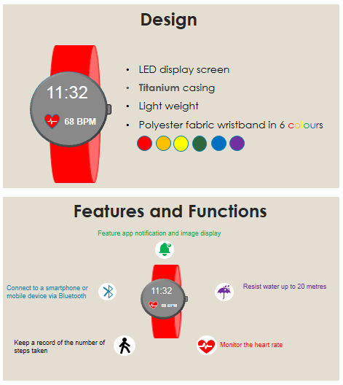

Part B: Analysing the functions of signpost language (LT 1.4.2)

- Point out to students that the phrases in the word boxes (A – I) (LT 1.4.1) perform different functions in a speech. Get students to work in pairs and write down an example from the speech for each of the functions in the table. Check the answers with students.

- Get students to think of at least one more example for each of the functions and provide appropriate feedback.

Part C: Understanding the design of slides for presentation (LT 1.4.3)

- Explain to students that while more details and supporting information such as reasons, elaboration and examples are usually found in a speech, only key messages are presented on the slides.

- Draw students’ attention to how the text is constructed and the information presented. Explain to students the two major components of slides for presentation, i.e. text and visuals. Illustrate to students the text features with p.2 (see below) of the PowerPoint slides provided, i.e. the use of keywords, headings, bullet points and different ways to emphasise important words and ideas.

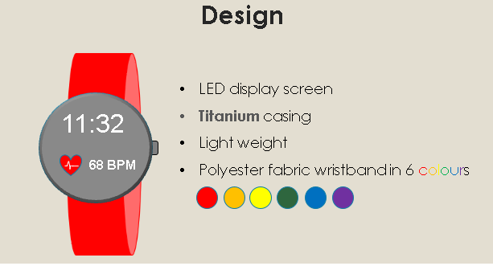

- Allow some time for students to compare the two slides (Slide A and Slide B) on LT 1.4.3 in pairs and decide which one is more effective. Elicit reasons from students and comment on their answers.

- Summarise the features of effective slides for presentation with reference to the teacher’s notes on LT 1.4.3T and remind students to include these features when creating their own slides for presentation.

- Advise students to use copyright free images, e.g. images from Creative Commons when developing the slides.

Part D: Writing a speech and creating slides for presentation (LT 1.4.4)

- Explain to students the task requirements, i.e. writing a launch speech for Super Ring 2.0 and creating some slides for the presentation.

- Check students’ understanding of the details of the two generations of Super Ring listed in the table. For more advanced students, allow them to think of any new features and functions for Super Ring 2.0.

- Go through each of the assessment criteria on the self-assessment form with students. Ask students questions to check their understanding of the criteria and remind them to refer to the form when they are working on the assignment.

Task 1 Understanding Wearable Technology and Writing a Product Description
LT 1.1.1T

Part A: Getting to know what wearable technology is
To familiarise yourself with what wearable technology is, you have been asked to view a video. Scan the QR code below, watch the video titled “What is Wearable Tech and what can I do with it?” to know more about wearable technology products. Jot notes in the table below while watching the video.

https://bit.ly/2srL4iN

 | What can you do with these devices?
Smart bracelets / watches |  | read
Smart bracelets / watches |  |  |  |  |  | incoming messages or calls
Smart rings |  | turn on |  |  | TV
Smart rings |  | dim |  |  | the lights
Smart glasses |  | take | pictures
Smart glasses |  | receive | directions
Smart glasses |  | translate voices
Contact lenses |  | monitor blood glucose levels in eyes

What other wearable technology products can you find in your daily life?
e.g. VR headsets, wireless earbuds (any reasonable answers)

Part B: Reading a product description
LT 1.1.2T
Read the description of Smartie Watch, a product of your company, and jot notes in the table below.

 | SMARTIE WATCH
5  10 | Smartie Watch⁽¹⁾ is one of the most popular products of our company specifically designed for women entrepreneurs. The LED display screen is rectangular⁽⁵⁾ in shape and has a high resolution which enables images to be sharply displayed. Its wristband is made of genuine leather⁽⁴⁾ and comes in candy pink or navy blue⁽²⁾. It is available in two different case sizes: 40 mm and 44 mm⁽³⁾ at about 60 g and 78 g⁽⁶⁾ respectively. Made of stainless steel⁽⁴⁾, the casing is strong and durable and offers effective protection to the display screen. With the built-in Bluetooth technology⁽⁷⁾ and a waterproof shell⁽⁷⁾, Smartie Watch can be connected to other mobile devices such as smartphones and offers protection from water damage. It also has notification functions for incoming calls, messages and emails⁽⁸⁾ and is equipped with a Global Positioning System (GPS) sensor⁽⁷⁾ for navigation⁽⁸⁾ and location detection⁽⁸⁾.

1. | Product name | Smartie Watch
2. | Colour | candy pink & navy blue
3. | Case size | 40 mm & 44 mm
4. | Material | casing: stainless steel | band: genuine leather
5. | Shape / Appearance | rectangular
6. | Weight | 60 g & 78 g
7. | Feature | waterproof shell, GPS sensor, Bluetooth technology
8. | Function | - navigation  - location detection  - notification functions for incoming calls, messages and emails

Part C: Describing a product
LT 1.1.3T
When describing a product, we may ask ourselves the following questions to help us generate ideas and related vocabulary. Work in pairs, think about a wearable technology product and provide relevant details in the spaces provided.

Teacher’s note:
Ask students to brainstorm more ideas / vocabulary items for each question.
(3) How big/small/tall is it? (size & height)
- It has a height of 42 mm.
- It is 40 mm wide.
- It provides sizes from 4.5 to 17.

(6) How much does it weigh? (weight)
- It is 56 g.
- It weighs from 18 g to 36 g.
(1) What is it?
- It is a smartwatch.
- It is a wristband.
- It is a smart ring.
(2) What colour is it?
- It is light pink / lime green / pale yellow / dark purple…
- It comes in metallic grey and navy blue.
(4) What is it made of? (material)
- It is made of plastic / metal / gold / steel / iron / aluminum…
- It is made of titanium.

(5) What shape is it?
- It is square / rectangular / triangular / hexagonal / pointed…
- It is round / circular.

(8) What function(s) does it perform?
- It monitors running performance / notifies you when there’s a call.
- You can use it to unlock phones / make and receive calls.
- It tracks steps and monitors heart rate.
(7) What is/are its feature(s)?
- It carries useful features such as GPS, Bluetooth and extended battery life.
- It is waterproof.
- It features a step-tracking sensor and a heart rate monitor.

Part D: Writing a product description
LT 1.1.4T
Adjective phrases and clauses are often used to describe or provide additional information of a product. Examples include relative clauses, participle phrases and prepositional phrases. Refer to the product description in Part B. Identify the structures used to describe the features and functions of Smartie Watch and complete the following table. Two have been done for you as examples.

Line number (optional) | Adjective phrase / clause | Noun / Noun phrase being described | Structure (optional)
(lines 1-2) | specifically designed for women entrepreneurs | one of the most popular products of our company | participle phrase
(lines 2-3) | rectangular in shape | display screen | adjective phrase
(line 3) | which enables images to be sharply displayed | resolution | relative clause
(line 5) | available in two different case sizes | it (Smartie Watch) | adjective phrase
(line 6) | made of stainless steel | casing | participle phrase
(lines 7-8) | with the built-in Bluetooth technology and a waterproof shell | Smartie Watch | prepositional phrase
(lines 10-11) | for incoming calls, messages and emails | notification functions | prepositional phrase
(line 12) | for navigation and location detection | Global Positional System (GPS) sensor | prepositional phrase
Teacher’s Note:
- Explain to students the difference between a “phrase” and a “clause”.
- Point out to students that participle phrases and prepositional phrases can serve as adjective phrases whereas relative clauses can act as adjective clauses.
- Draw students’ attention to the position of the adjective phrase and highlight to students that it can come before or after the noun / noun phrase it is describing. Explain it with the support of the Annotated Text – Smartie Watch (LT 1.1.4T).
- For less advanced students, ask them to identify the adjective phrases and clauses without categorising them.
- The answers in the table are by no means exhaustive. Any reasonable answers should be accepted.

Annotated Text – Smartie Watch
LT 1.1.4T

 | SMARTIE WATCH
5  10 | Smartie Watch⁽¹⁾ is one of the most popular products of our company specifically designed for women entrepreneurs. The LED display screen is rectangular⁽⁵⁾ in shape and has a high resolution which enables images to be sharply displayed. Its wristband is made of genuine leather⁽⁴⁾ and comes in candy pink or navy blue⁽²⁾. It is available in two different case sizes: 40 mm and 44 mm⁽³⁾ at about 60 g and 78 g⁽⁶⁾ respectively. Made of stainless steel⁽⁴⁾, the casing is strong and durable and offers effective protection to the display screen. With the built-in Bluetooth technology⁽⁷⁾ and a waterproof shell⁽⁷⁾, Smartie Watch can be connected to other mobile devices such as smartphones and offers protection from water damage. It also has notification functions for incoming calls, messages and emails⁽⁸⁾ and is equipped with a Global Positioning System (GPS) sensor⁽⁷⁾ for navigation⁽⁸⁾ and location detection⁽⁸⁾.

Based on what you have written down in Part C, write a short product description about a wearable technology product using adjective phrases and clauses.
LT 1.1.4T

The Super Ring, which is circular in shape, comes in metallic grey and navy
blue. Made of titanium, the ring only weighs from 18 g to 36 g. It provides sizes
ranging from size 4.5 to size 17. The step-tracker installed allows the user to
keep a record of the steps taken. A heart rate monitor is also installed for
heartbeat measurement.

Task 2 Comparing Products
LT 1.2.1T

Part A: Taking notes on the similarities and differences of the two versions of the Smartie Watch series
You are attending a briefing session on Smartie Watch 2.0 with Mr Cheung. He has asked you to take notes and prepare a summary on how Smartie Watch 2.0 is different from Smartie Watch. While you are listening to the briefing, take notes and complete the table below. (See Appendix A for the audio clip)

 | Smartie Watch |  | Smartie Watch 2.0
No. of colour choice | (1) | 2 different colours | (2) | 6 different colours
Case size | (3) | 40 mm & 44 mm | (4) | 40 mm & 44 mm
Material - casing | (5) | stainless steel | (6) | titanium
Material - wristband | (7) | genuine leather | (8) | polyester fabric
Shape (display screen) | (9) | rectangular | (10) | circular
Weight | (11) | 60 g & 78 g | (12) | 48 g & 60 g
Feature and Function (Put a tick in the appropriate box)
Waterproof | (13) |  | (14)
Bluetooth technology | (15) |  | (16)
GPS | (17) |  | (18)
Step-tracker and heart rate monitor | (19) |  | (20)
Call display | (21) |  | (22)
Message display | (23) |  | (24)
Email display | (25) |  | (26)
Image display | (27) |  | (28)
App notification display | (29) |  | (30)

Task 2 Part A Transcript
LT 1.2.1T

Susan: |  | In the coming session, I’m going to compare Smartie Watch 2.0, our latest product, with Smartie Watch so that you can have a better idea of the improved design. Please don’t hesitate to interrupt if you have any questions. Alright, let’s start from the obvious — the shape of the display screen. Unlike the rectangular display screen on Smartie Watch⁽⁹⁾, the latest design is circular in shape⁽¹⁰⁾. Another obvious change is the material and colour used for the wristband. The wristband of the latest version is made of polyester fabric⁽⁸⁾ and is available in six different colours⁽²⁾ while there are only two colour options for the previous version⁽¹⁾.
Jack: |  | It’s good to have more choices in colour. But why do we change the material used from genuine leather⁽⁷⁾ to polyester fabric⁽⁸⁾ for the wristband?
Susan: |  | Thank you Jack for raising the question. According to our marketing survey last season, those smartwatches that have a large market share offer a wide selection of wristband colours at an affordable price. That’s why we decided to use a more economical material instead of the expensive genuine leather⁽⁷⁾. We also expect the sales of wristbands as a standalone product will bring us extra profit. I hope it answers your question, Jack.
Jack: |  | Perfectly. Thanks, Susan.
Susan: |  | Good. Let’s take a look at the change in the material used for the casing, shall we? You may not notice it by simply looking at it but you can definitely feel it when you put the new watch on. It is significantly lighter than the previous version, thanks to the lighter material used – titanium⁽⁶⁾. Compared to the stainless steel⁽⁵⁾ used for Smartie Watch, titanium⁽⁶⁾ makes the new watch 20% lighter.
Jack: |  | How much does each watch actually weigh?
Susan: |  | Let me see… Smartie Watch weighs 60 grams and 78 grams⁽¹¹⁾ whereas Smartie Watch 2.0 weighs 48 grams and 60 grams⁽¹²⁾, depending on the size of the case.
Jack: |  | Thank you Susan.
Susan: |  | No problem at all. That actually brings us to the size of the watch. Smartie Watch 2.0 comes in two sizes, i.e. 40 mm and 44 mm⁽³⁾⁽⁴⁾, the same as those for Smartie Watch. Okay, we’ve covered the design of the watch so far. If you have no questions, I’ll move on to the functions and features. Both watches share a number of similar functions and features. For example, they are both equipped with Bluetooth technology⁽¹⁵⁾⁽¹⁶⁾. Connecting the watch to the smartphone or mobile device via Bluetooth, users can read incoming calls, messages and emails on the watch⁽²¹⁾⁻⁽²⁶⁾.
Jack:  Susan: |  | We have successfully marketed Smartie Watch as a sports and swimming watch. Is the new version as water-resistant as its predecessor?  Rest assured, neither of them will break. They are both waterproof⁽¹³⁾⁽¹⁴⁾.
Jack: |  | Then how is Smartie Watch 2.0 an improved version in terms of functions?
Susan: |  | Good question, Jack. On top of the functions mentioned previously, Smartie Watch 2.0 features app notification⁽³⁰⁾ and image display⁽²⁸⁾ whereas Smartie Watch doesn’t support such functions⁽²⁷⁾⁽²⁹⁾. Besides, Smartie Watch 2.0 functions as a health tracker since it includes both a heart rate monitor and a step-tracker⁽¹⁹⁾⁽²⁰⁾. With a companion app, users can keep track of the number of steps taken and monitor their heart rate.
Jack: |  | I can see that the GPS is taken away from Smartie Watch 2.0⁽¹⁸⁾. Why is that?
Susan: |  | The GPS is taken away in response to the feedback of Smartie Watch users⁽¹⁷⁾. Many users complain that the GPS, for one thing, is not working very well and, more importantly, it may give away their physical location, which raises an obvious privacy and security concern.
Jack : |  | I see…
LT 1.2.1T

Part B: Identifying the language for comparing and contrasting
LT 1.2.2T
Study the transcript of the briefing session. Highlight the language used to compare and contrast the two versions of Smartie Watch, and complete the table below. Some examples have been provided.

Item for comparison | Example from the text | Language for comparing and contrasting
Shape (display screen) | Unlike the rectangular display screen on Smartie Watch, the latest design is circular in shape. | Unlike
No. of colour choice | The wristband of the latest version is made of polyester fabric and is available in six different colours while there are only two colour options for the previous version. | while
Size | Smartie Watch 2.0 comes in two sizes, i.e. 40 mm and 44 mm, the same as those for Smartie Watch. | the same as
Weight | Smartie Watch weighs 60 grams and 78 grams whereas Smartie Watch 2.0 weighs 48 grams and 60 grams. | whereas
Material (wristband) | That’s why we decided to use a more economical material instead of the expensive genuine leather. | more
Feature and function | Both watches share a number of similar functions and features. | Both, share
Feature and function | They are both equipped with Bluetooth technology. | both
Feature and function | Is the new version as water-resistant as its predecessor? /  Neither of them will break. They are both waterproof. | as … as , neither, both
Teacher’s Note:
Explain to students that on top of comparatives / superlatives, there are other ways to compare and contrast. Examples include:
- adverbs and adverb phrases
- linking words, and
- nouns and verbs
Refer to the teaching procedures for details.

Part C: Preparing a comparison summary
LT 1.2.3T
Below is a summary of the briefing session. With reference to the notes taken in Part A and the language for comparing and contrasting in Part B, complete the summary by filling in each blank with a word or phrase that is grammatically correct and fits the meaning.

Smartie Watch comes in two different colours (1) |  |  |  |  |  |  | whereas /  while |  | Smartie Watch 2.0
comes in six. They (2) |  |  |  |  | both | offer two sizes, i.e. 40 mm and 44 mm.
(3) | Unlike |  | Smartie Watch, Smartie Watch 2.0 features a titanium circular
casing and a wristband made of polyester fabric. The latest version is not (4) |  |  |  |  |  |  |  |  |  |  | as
heavy as |  | (heavy) its predecessor and weighs only 48 g and 60 g.
(5) | Both |  |  | Smartie Watch and Smartie Watch 2.0 are waterproof and are
installed with Bluetooth technology. Instead of a GPS, Smartie Watch 2.0 features
a step-tracker and a heart rate monitor. (6) |  |  |  |  |  | While |  | (7) |  | both
watches can display incoming calls, messages and emails, only Smartie Watch 2.0
features app notification and image display.

Task 3 Commenting on an Infographic
LT 1.3.1T

Part A: Discussing the icons to be used
Your company has decided to create an infographic to introduce Smartie Watch 2.0 and show the improvements made from the previous version. Match the following items with the appropriate icons. Discuss whether the icons are effective and easily understood. Make improvements if necessary.
Teacher’s Note:
Draw students’ attention to the fact that some icons are universal, e.g. Bluetooth, GPS while some are not. These universal icons are understood to be representing the same idea, object or action in different parts of the world.
1 | notification |  | E |  | A
2 | heart rate monitor |  | J |  | B
3 | colour |  | C |  | C
4 | size |  | A |  | D
5 | Bluetooth technology |  | F |  | E | 4
6 | message |  | H |  | F
7 | GPS |  | I |  | G
8 | weight |  | B |  | H
9 | water-resistant |  | D |  | I
10 | step-tracker |  | G |  | J

Part B: Commenting on the design of an infographic
LT 1.3.2T
The draft of the infographic has been completed. Comment on the draft by discussing with your partner(s) the following questions:
- What is the purpose of the infographic? 1. Ans: for comparison
- How is the information organised and presented? 2.Ans: items for comparison are put side by side
- Is there any missing important information / inaccurate information when compared with the comparison table (LT 1.2.1)?
missing info:
(1) Casing material
(2) Image display for Smartie Watch 2.0
3. Ans:
- How would you change the design to make it more effective?
inaccurate info:
(3) Smartie Watch 2.0 DOES feature Bluetooth technology.
4. Ans: Suggested areas for improvement in terms of design
Use different fonts / font sizes to highlight the difference between the heading and the subheadings.
Be consistent in fonts.
Use headings to categorise items, e.g. design, features & functions.
Use different colours to show similarities and differences.
Underline / bold / italicise important words.

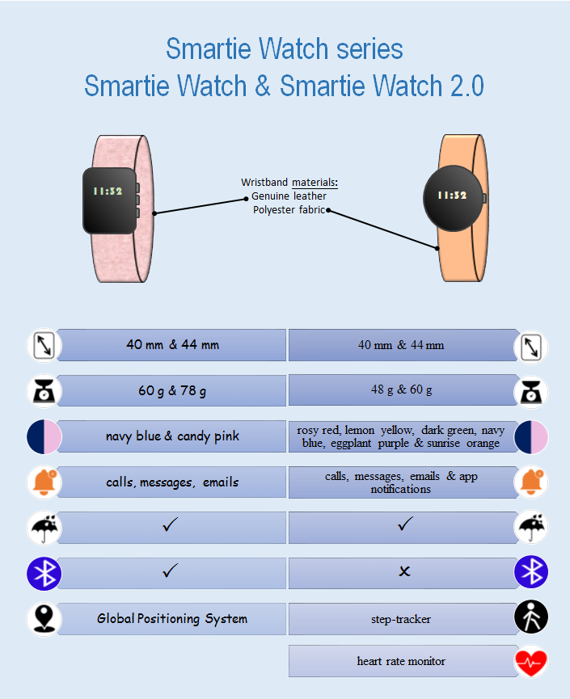

Teacher’s Note:
For less advanced students, use the checklist on LT 1.3.2T to guide students to comment on the infographic.
LT 1.3.2T
CHECKLIST - INFOGRAPHIC
has a clear purpose
includes ALL important information
uses appropriate icons / images / pictures / words to facilitate understanding and communicate information
uses headings and subheadings appropriately to organise information
uses different fonts and font sizes appropriately
uses colours effectively to show similarities and differences
Note:

CHECKLIST - INFOGRAPHIC
has a clear purpose
includes ALL important information
uses appropriate icons / images / pictures / words to facilitate understanding and communicate information
uses headings and subheadings appropriately to organise information
uses different fonts and font sizes appropriately
uses colours effectively to show similarities and differences
Note:

Task 4 Writing a Speech
Teacher’s Note:
Guide students to read the speech together with the slides provided.
LT 1.4.1T

Part A: Understanding signpost language in a speech
To prepare for the launch of Super Ring 2.0, the latest wearable technology product of your company, Mr Cheung has asked you to write a speech and develop some slides for presentation at the launch event. You have been given a speech previously used at the launch event of Smartie Watch 2.0 for reference. Study the speech and fill in the blanks with appropriate letters (A-I).
- First, let me take you through
- OK, I think you should have a better idea about
- Now, I’m proud to present to you
G. To put it another way
H. Are there any questions you would like to ask

- Welcome, and thanks for coming to
- As you can see from the diagram
F. To close this off
I. Let’s move on to

1  5  10  15  20  25 | Ladies and gentlemen,  (D) this very launch event of our latest product. I’m sure many of you are already familiar with Smartie Watch, which shook up the market two years ago.  (C) our top-notch e-gadget, Smartie Watch 2.0.  (B) the design of our latest invention. Unlike its predecessor, Smartie Watch 2.0 features a circular display screen in a titanium casing. Such a change contributes to the reduction in weight by 20% and you will notice the difference the moment you put it on your wrist. The casing comes in two sizes, 40 mm and 44 mm, the same as those for Smartie Watch. Attached to the two ends of the casing is the wristband. Made of polyester fabric, the wristband is available in six colours and there must be one to your liking.  (A) the design by now. (I) the features and functions of Smartie Watch 2.0. The second generation inherits some useful features and functions of the previous version. Both versions are equipped with Bluetooth technology and a waterproof shell. Connected to a smartphone or mobile device via Bluetooth, they can receive incoming calls, messages and emails.  (E) , Smartie Watch 2.0 has a number of new features. First, it features app notification and image display, which ensures you won’t miss any important information or messages. Also, the watch is built in with a step-tracker and a heart rate monitor. With a companion app, you can keep track of the number of steps you have taken, and measure your heart rate at your convenience. (G) , wearing the watch is like having a personal medical consultant with you at all times.  (F) , Smartie Watch 2.0 is among the finest and you cannot find any comparable piece on the market at such a competitive price. I hope that my presentation has given you some light on our brand new product. (H) ?

Part B: Analysing the functions of signpost language
LT 1.4.2T
The phrases in the word boxes on LT 1.4.1 (A – I) are called signpost language, which is commonly used in speeches to provide audience with a sense of orientation and guide them through the presentation. Read the speech again and write down the signpost language used to perform each of the following functions. One has been done for you as an example.

Function | Example from the speech | Your ideas
1. To welcome the audience | - Welcome, and thanks for coming to… | - It’s good to see you all here to…  - On behalf of XX company, allow me to extend a warm welcome to you…
2. To introduce the topic / product of the presentation | - Now, I’m proud to present to you… | - I’d like to start by introducing to you all…  - The subject / topic of my talk is…  - My presentation is concerned with…
3. To introduce the first section of the presentation | - First, let me take you through… | - Let me start by…  - To begin with, I’d like to…  - First of all, I’ll…
4. To sum up a section just completed | - OK, I think you should have a better idea about… | - By now, you should have a better understanding of…  - That’s all I have to say about…  - We’ve looked at…
5. To start a new section | - Let’s move on to… | - Moving on now to…  - The next feature / topic / area I’d like to focus on is…  - Let’s now look at…
6. To refer to a visual aid / slide | - As you can see from the diagram… | - Referring to the graph / chart / table on the screen…  - The diagram shows…  - Let’s take a look at the figures / pictures on the slide…
7. To paraphrase or clarify | - To put it another way… | - In other words…  - Simply put…  - So, what I’m saying is…
8. To wrap up the presentation | - To close this off… | - To finish up…  - To summarise…  - I’d like to conclude…
9. To invite questions from the audience | - Are there any questions you would like to ask? | - Any questions?  - Please feel free to ask questions.  - I’m happy to answer any questions / queries.

Can you think of other useful words or phrases for the presentation? Write your ideas in the table above.
Teacher’s Note:
Accept any other reasonable answers.

Part C: Understanding the design of slides for presentation
LT 1.4.3T
Study the two major components of slides for presentation.

- Text
- use keywords; complete sentences are not a must
- use headings and subheadings
- use bullet points in parallel structure
- use bold / italics / font colours and / or sizes to emphasise important words or ideas

- Visuals
- use relevant or thought-provoking images to illustrate your points
- use graphs / charts / icons to enhance audience’s understanding

Compare the two slides (Slide A and Slide B) below. Which one do you find more effective? Discuss with your partner.

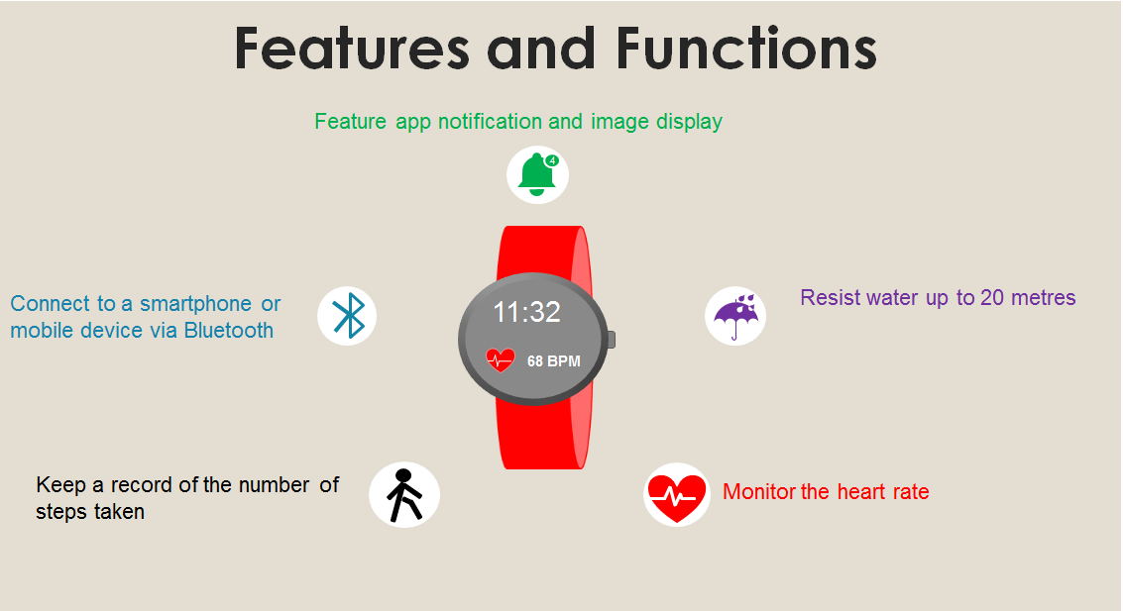
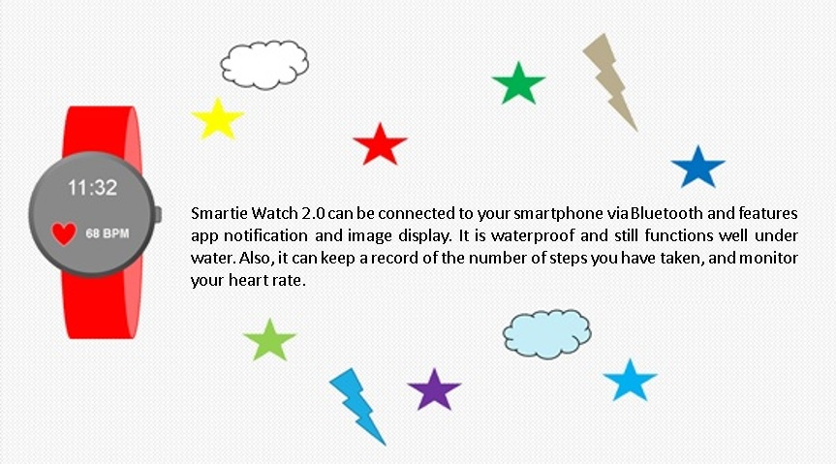
Slide B

Irrelevant images
No clear heading
Lengthy description
Parallel structure
Heading with an enlarged font size
Different colours
Appropriate images and icons
Slide A

Part D: Writing a speech and creating slides for presentation
LT 1.4.4T
Write a launch speech for the latest wearable technology product, Super Ring 2.0, of your company and create some slides to be used at the launch event.

Product name | Super Ring | Super Ring 2.0
Colour | Gold and Silver | Gold, Silver and Metallic Green
Size | Inside diameter from 13.8 mm to 22.5 mm | Inside diameter from 13.8 mm to 22.5 mm
Material | Stainless Steel | Stainless Steel / Ceramic
Weight | 226 g – 283 g | 226 g – 283 g
Feature | - Android-compatible  - Bluetooth  - GPS | - iOS and Android-compatible  - Bluetooth  - Water resistant up to 10 m  - GPS
Function | - Communicate with smartphones and mobile devices  - Connect to social media accounts  - Beep to alert the owner when the smartphone(s) and / or mobile device(s) are left behind | - Communicate with smartphones and mobile devices  - Connect to social media accounts  - Beep to alert the owner when the smartphone(s) and / or mobile device(s) are left behind  - Support gesture control  - Monitor sleep quality  - Make wireless payment

Use the following assessment form to assess your speech and slides.
LT 1.4.4T

Self-assessment Form
 |  | Needs  Improvement | Satisfactory | Excellent
Speech
A | Content
 | Explaining the design of the new product, covering its different aspects
 | Comparing and contrasting the features and functions of the new product with those of its previous version
B | Organisation
 | Consisting of four to five paragraphs, each with a clear focus
 | Using an appropriate organisational framework (e.g. an opening section to welcome the audience, a body section to provide the details of the new product, and a concluding section to persuade others to buy the new product and to invite questions from the audience)
C | Language
 | Using appropriate signpost language for various purposes (e.g. “First, let me take you through…” to introduce the first section of the talk)
 | Using adjective phrases and clauses to describe or provide additional information of the new product (e.g. With a companion app, you can keep track of …)
 | Using appropriate language to compare and contrast the new product with its previous version (e.g. Unlike its predecessor, Smartie Watch 2.0 features…, Both versions are equipped with…)
Slides
D | Text
 | Using keywords
 | Using headings and subheadings
 | Using bullet points in parallel structure
 | Using special effects to highlight important words or ideas (e.g. boldface, italics, font colours, font sizes)
E | Visuals
 | Using relevant or thought-provoking images
 | Using graphs / charts / icons to enhance audience’s understanding
F Overall Comments

(Blank page)
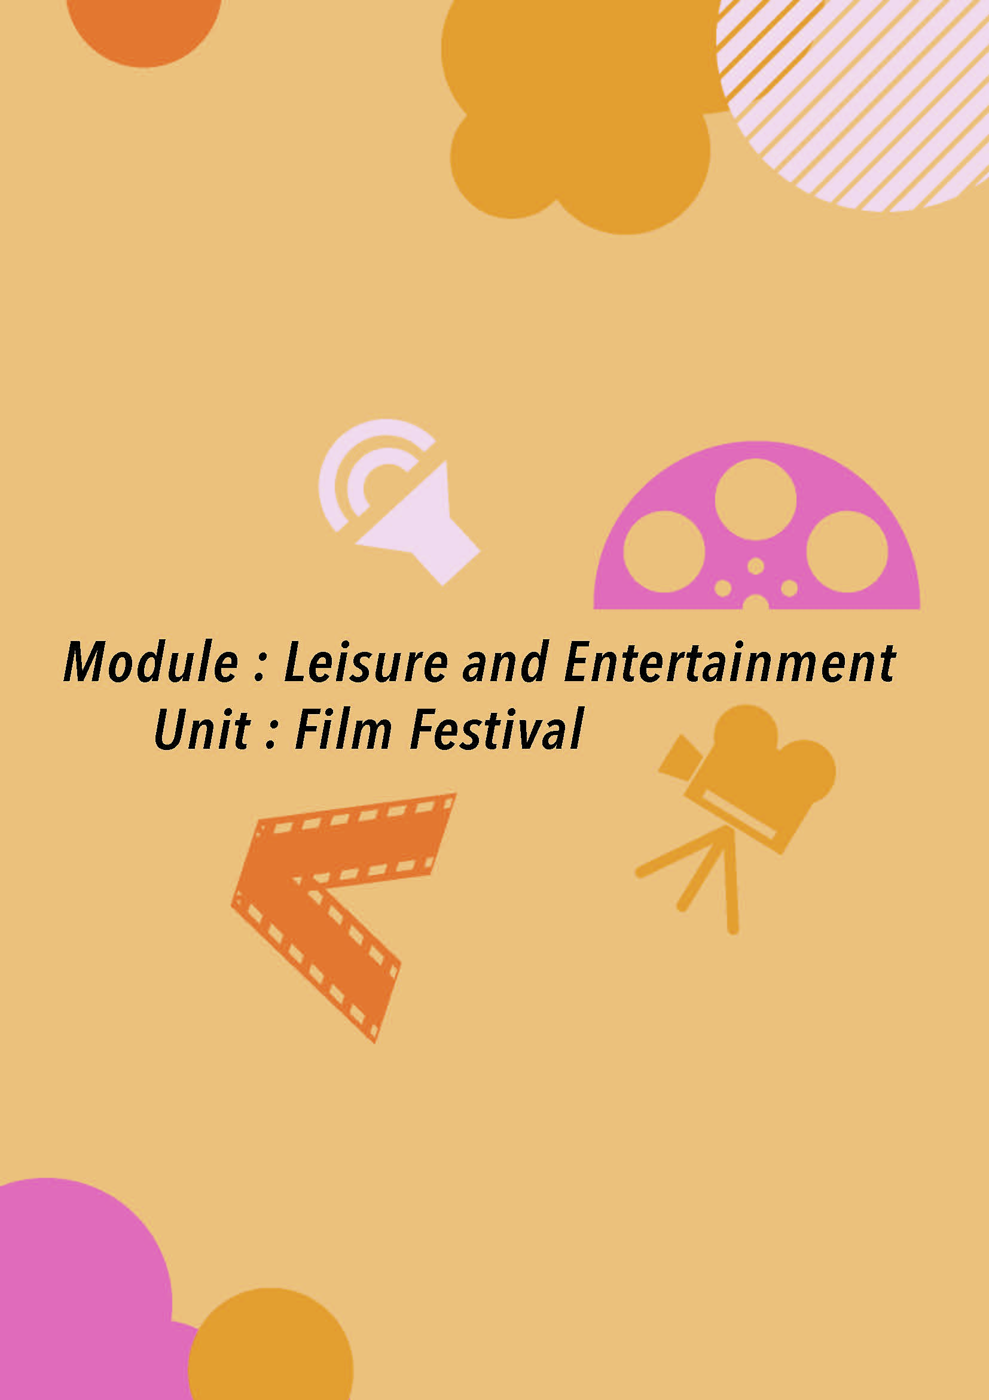

(2) Module: Leisure and Entertainment
Unit: Film Festival

(Blank page)
Overview

Situation
Mr Roger Lam, the teacher in charge of the Film Society at your school, encourages students to take part in a short film competition. He has organised a workshop to prepare you for the competition. You will make a short film of under five minutes and write a short synopsis of about 100 words to present your film at the end of the workshop.

You have to complete the following tasks:

Task 1: Analysing and Appreciating a Short Film
You will watch an award-winning short film titled My Shoes, explore its messages and analyse how ideas are presented in the film.

Task 2: Designing a Storyboard
You will read a story and select a few events from it to create a storyboard. You will then work in groups to brainstorm ideas for your English short film and present the plot in a storyboard.

Task 3: Reading Synopses and Comments on Films
You will read some film synopses and commentaries and study the language used.

Task 4: Entering the Short Film Competition
You will make a short film in English of under five minutes and write a short synopsis on the film for the competition. You will then view the film entries, comment on two of them and vote for the Audience Award.


Materials
- LT 2.1.1 – LT 2.4.3
- Audio-visual materials (accessible with the QR codes and URLs provided)
- A flyer
- An enlarged storyboard (Appendix B)

Procedures:

- Arouse students’ interest in the unit by eliciting their previous knowledge and experience related to films, for example:
- Film events (e.g. The Oscars, Cannes Film Festival, The Academy Awards)
- Words related to films (e.g. director, box office, blockbuster, actor / actress, film genres: horror, romance, comedy, sci-fi)

- Introduce the context and situation of the task to students with reference to the Overview. Explain to students that they are going to shoot a short film, which can be done with HD camcorders or mobile devices.

- If possible, create a competition site using an online learning platform such as Edmodo, Schoology and Google Classroom to add authenticity to the tasks.

Task 1 Analysing and Appreciating a Short Film

- The purpose of the task is to guide students to analyse the core aspects of a film and explore its affective (e.g. viewer’s feelings and emotional responses), compositional (e.g. the fictional, dramatic and cinematic elements) and critical (e.g. hidden messages) dimensions.

- Explain the details of the short film competition (e.g. themes of the films, prizes, rules and deadline) with the use of the flyer.

Part A: Understanding the three aspects of film analysis (LT 2.1.1)

- Viewing a film trailer
- Explain the three aspects of film analysis to students.
- The fictional aspect covers elements that can be found in a story, including theme, plot, character(s) and setting.
- The dramatic aspect covers elements that can also be found in a drama performance, including acting, movements, costumes and props.
- The cinematic aspect covers features unique to film, including audio-visual effects such as the use of camera shots and angles.

- Play the trailer of Lion King (2019) directed by Jon Favreau in class. Alternatively, provide the URL or QR code for students to watch the trailer on their mobile devices or tablets.

- Ask students to watch the trailer at least two times with the three aspects of film analysis in mind. In the first viewing, focus mainly on the fictional aspect to understand the story and characters. In the second viewing, pay attention to the dramatic aspects.

- Ask students to answer Q1 and Q2 after watching the trailer twice. Encourage students to come up with as many themes as possible and invite some of them to share their answers. Students may read synopses online to verify their answers. [Note: IMDb (International Movie Database) https://www.imdb.com/ is a useful website which provides official and reliable information about films.].

- For Q3, play the trailer the third time. Pause and replay the relevant parts if necessary. Allow time for students to choose the right answer for each item. Invite students to share and explain their answers.

- Identifying the aspects of film analysis
- Ask students to work in pairs to identify the aspect(s) of film analysis each question touches upon and fill in the blanks. Go through the answers and recap the three aspects of film analysis to consolidate their understanding.

Part B: Preparing viewing notes (LT 2.1.2)

- Play the short film My Shoes (2012) directed by Nima Raoofi in class. Alternatively, provide the URL or QR code for students to watch the short film on their mobile devices or tablets. Ask students to look at the set of questions first before viewing. Allow students who need more support to work in groups and / or focus on fewer questions.

- To encourage critical and analytical viewing, remind students to view the short film two times. Students may focus on understanding the ideas / content of the film in the first viewing, and formulate brief answers to the questions assigned in the second viewing.

- Remind students to jot viewing notes in the viewing process. Do NOT provide answers at this stage as students will be given opportunities for in-depth analysis later.

Part C: Analysing the fictional elements – identifying themes (LT 2.1.3)

- Explain to students “theme” means the central idea of the film and it is often expressed in the form of an abstract noun. Introduce more themes in addition to the listed ones to more able students (e.g. justice, integrity, forgiveness, benevolence, generosity, identity, faith, death, determination).

- Guide students to practise using the following structures to talk about the key messages and themes of films. Draw their attention to the difference in the parts of speech:

Key Message | Theme
A Christmas Carol tells us to be kind and generous to other people. | A Christmas Carol centres on the themes of kindness and generosity.

- For Q1, encourage students to come up with more than one theme for each story summary and use words not provided to express the themes. They can use a thesaurus to find synonyms (e.g. determination, resolution, perseverance, will power, persistence) to expand their vocabulary bank.

- Ask students to work in pairs for Q2. Before they start:
- explain the significance of a film title and how it often presents the theme and central message of the film,
- explain what a symbol is (i.e. an object, person or event which has a deeper meaning in context and can give insight to the reader / audience), and
- introduce idiomatic expressions such as “put yourself in somebody’s shoes” or “walk in somebody’s shoes” and ask students to consider the meaning of such expressions in connection to the short film.

- To deepen their understanding of symbolism, ask students to come up with some symbolic objects commonly found in films / stories / advertisements and identify the hidden meaning they carry, for example:
Object / Image | Suggested / Implied Meaning
a clicking clock | passage of time
a red heart / rose | passionate love / romance
a lion | bravery / courage
pigeons / people holding hands | peace

- Ask students to think of an object with a symbolic meaning to present the message “Count your blessings” / “Never judge a book by its cover” in a subtle way in their film. For example, a box of assorted chocolates may represent different blessings in life; a distorting mirror may suggest that appearance is deceptive.

Part D: Analysing the fictional elements – describing and creating a setting (LT 2.1.4)

- Explain to students that “setting” means the place and time a story takes place. It provides a background and creates a mood for the development of the theme(s), plot and character(s).

- For Q1, ask students to imagine they were the characters in My Shoes and describe what they could see, hear, smell, taste and feel / touch. Provide language support to help them turn their description into adjectives (e.g. a lot of grass “grassy”, many trees “tree-lined”) and express how they feel in that environment or setting (e.g. relaxed, peaceful).

- For Q2(a), ask students to colour-code words / phrases in the descriptions that appeal to different senses with highlighters of different colours and complete the table. Explain to students that a setting (whether presented in words or images) should appeal to readers’ / viewers’ senses.

- For Q2(b), allow students to work in pairs / small groups and discuss which place they would choose as a setting for a story about honesty. Encourage them to come up with a brief storyline related to the setting. Emphasise to students that all settings work equally well provided that the people and things found in the place are effectively used to develop the plot.

Part E: Analysing the fictional elements – developing the plot (LT 2.1.5)

- For Q1, ask students to arrange the jumbled sentences into a logical plot sequence of the film My Shoes.

- Explain to students that for a story / film to be engaging, the plot should consist of the following parts:
- Exposition is the opening that provides background information such as the setting and main characters.
- Rising action, also known as complication, refers to the stage where conflicts and problems are building up.
- Climax is the most exciting part of the story, which often involves the confrontation of conflicting forces or a sudden change.
- Falling action paves way for the ending (but can be absent in the stories).
- Resolution means the ending, which may sometimes involve a realisation of the truth or a solution to the problem.

- For Q2, ask students to fit the relevant parts of the film (sentences in Q1) into the plot diagram.

- Draw students’ attention to the twist (a surprise and an unexpected ending) in My Shoes. Discuss the effects created by an unpredictable ending (e.g. thought-provoking and memorable to the audience).

Part F: Analysing the dramatic elements – establishing characters through costumes and acting (LT 2.1.6)

- Explain to students that in a film, characters are presented through:
- Appearance (e.g. make-up, hairdo)
- Costumes (e.g. clothes, shoes, accessories)
- Acting (e.g. facial expressions, body movements, speeches and dialogues)
The above can tell us about characters’ personalities and cultural and socio-economic background.

- For Q1, ask students to describe the appearance, costumes and facial expressions of the two characters in My Shoes. Provide students with language support if they have difficulty describing the characters’ appearance (e.g. messy fluffy hair, worn-out clothes and shoes), facial expressions (e.g. frowning, grinning), feelings (e.g. anxious, content, upset) and personalities (e.g. optimistic).

- For Q2, students are free to express their views regarding whether acting (body movements and facial expressions) tells more than speeches and dialogues in My Shoes. Draw students’ attention to reliance on acting for the role of the rich boy, as he does not speak at all in the film. Remind students that films with little dialogues and speeches can also be very effective in presenting deep feelings and appeal to the audience’s emotions.

Part G: Analysing the cinematic elements – describing music and sounds in films (LT 2.1.7)

- Explain to students the functions of music in films. Music can:
- arouse the audience’s emotions (e.g. fear, excitement, sadness)
- build up the mood and atmosphere of the film (e.g. tension, suspense, mystery)
- enrich the images (e.g. lyrics in theme songs addressing what happens in the scene)
- facilitate plot development (e.g. suggesting a change or turning point)

- Go through the list of adjectives for describing the following aspects of film music with students. Invite students to brainstorm additional words.
- musical style
- instrument used
- melody
- beat and pace
- feeling, mood and psychological effect

- Reduce or increase the number of vocabulary items to be introduced depending on students’ readiness. Focus on the mood and melody of the music for less advanced students. For more advanced students, ask them to expand the list of adjectives by exploring the following website: www.words-to-use.com/words/music/

- For Q1, play a few sound tracks and ask students to describe each with three adjectives. The tracks can be from famous movies, musical performance or popular songs. If the sound track is taken from a film, ask students to predict the film genre (e.g. sci-fi, thriller, romance) as well. If there is difficulty sourcing suitable soundtracks, select some of the items from “The Best Movie Soundtracks” playlist on YouTube:
www.youtube.com/watch?v=dv4LeWBLAyU&list=PL8A7860B0F9BD22A6

- Invite different students to share their answers and encourage exchange of views in class, as feelings and judgment on music may vary from person to person.

- For Q2, play My Shoes again with the screen off to ensure that students focus entirely on the music. Ask students to recall the events in the film as they listen to the sound track. Signal to students when the music changes to check if they can remember what happens at that point, so that they understand how the change in music corresponds to the development of the plot.

- Guide students to use the appropriate sentence structures to express their ideas (e.g. using sentences like “The music creates a sense of feeling nouns (e.g. sadness, excitement, tension)” to discuss the effects of the music).

Part H: Analysing the cinematic elements – identifying camera shots and angles (LT 2.1.8)

- Camera Shots
- Ask students if they have used the zoom functions of their mobile phones or digital cameras to move the point of view closer or further away from the subject. Show them different kinds of zoom shots.

- Heighten students’ awareness of why different shots are used and the functions they serve. For example:
- Long shots help set the scene and show the background.
- Medium shots allow us to gradually identify with a character and enter the story with him / her.
- Close-ups show facial expressions clearly to highlight emotions and feelings of characters.

- Ask students to identify the types of shots used based on the images and descriptions provided.

- Camera Angles
- Elicit students’ experience of taking photos with the camera placed in different positions (e.g. taking an aerial shot of students playing basketball on the playground from the classroom).

- Explain to students that the camera angle can affect the relationship between the people / objects and create different psychological effects. For example:
- High angle shots (with the camera placed above) make the objects look small and powerless.
- Low angle shots (with the camera placed below) make the objects look large and threatening.
- Eye-level shots (with the camera placed straight on) present an equal relationship with the objects in the shots.

- Ask students to identify the different kinds of camera angles used based on the images and descriptions and fill in the blanks in the table. Discuss with students why the camera angles are used in the chosen shots and how they help present the relationship between the two boys.

- After going through all the important elements of a film, distribute the suggested answers to the questions in Part B (LT 2.1.2) for students’ reference.

Task 2 Designing a Storyboard

Part A: Understanding the features of a storyboard (LT 2.2.1)

- Explain to students that a storyboard provides a brief outline of the story. It is a useful tool for planning and analysing a story, and it gives the reader an idea of how the plot develops. Developing a storyboard allows students to plan and think about how a story can be presented visually, which heightens their awareness of how a film is constructed.

- Elements of a storyboard
- Ask students to skim the sample storyboard of A Christmas Carol in Q1. Draw their attention to the key elements of a storyboard by eliciting from students answers to the following questions:
- How many panels are there in the storyboard? (six)
[Introduce to students that the boxes in a storyboard are called “panels”.]
- Do you include all the scenes and events in a story in the storyboard? What scenes / events should be included?
(No, only scenes / events that show the development of the story (e.g. beginning, major problem / conflict, climax, ending) should be included.)

- Revisit the major elements in plot development (i.e. exposition, rising action, climax, falling action and resolution) covered in LT 2.1.5 with students if necessary.

- Before students start to label the different elements featured in a storyboard, check their understanding of the vocabulary items provided (i.e. lighting, dialogues, foreground [the front part of the scene closer to the audience] and background, short descriptions of the scene, props) and provide explanations where necessary.

- Go through the answers with students and consolidate their understanding of the terms with the following prompts:
- Panel 1 – props: What props are used to show the story is set in a house? (chair, table)
- Panel 2 – lighting: How is lighting used to present conflicts? (Lights are turned off to prepare for Scrooge’s confrontation with the ghost in the dark room.)
- Panel 3 – foreground and background: Does putting the characters and props in the foreground or background make any difference? (The characters and props placed closer to the audience / camera are given more attention and emphasis.)
- Panels 4 and 5 – short descriptions of the scene: Why are wordy and lengthy descriptions unnecessary? (A storyboard, like other multimodal texts such as comic strips, should also express ideas and show details through images. The descriptions should be concise to show only the outline of the story.)
- Panel 6 – dialogues: What functions do dialogues perform? (Dialogues move the story forward, show the relationship and interaction between characters, create conflicts and reveal emotions.)

- For Q2, ask students to review the dramatic and cinematic elements covered in Task 1 and suggest which of the elements can be shown in the storyboard (e.g. camera shots and angles, costumes).

- How to draw a storyboard?
- Go through the seven steps for drawing a storyboard and the examples provided. Ask students to work in pairs and number the steps.

Part B: Turning a story into a storyboard (LT 2.2.2)

- Explain to students that fictional elements such as plot and characterisation are common to all stories, whether they are told in words (as in short stories) or with images and sound effects (as in films). The purpose of this task is to help students visualise and picturise ideas expressed in written and printed forms, which is a process directors go through to turn a story / script into a film.

- Before instructing the students to read the story “The Gift of the Magi”, explain the following:
- The text is an “abridged”, meaning shortened or simplified, version of the original story.
- The title “The Gift of the Magi” comes from the Bible. The Magi (/ˈmeɪ.dʒaɪ/) were the Three Kings who followed a guiding star and travelled from the East to Bethlehem to give presents to the baby Jesus. The Magi were considered wise men in Christian tradition. Ask students to bear this in mind and think about how the title is relevant to the story as they read. They will be asked to share their views on whether the title is well-designed after reading the story.

- Read the first two paragraphs of the story with the students. Ask them to identify Della’s problem (i.e. lack of money to buy her husband a Christmas gift) and predict what might happen and whether the ending would be happy or sad.

- Get students to finish reading the story on their own and answer Q1 – Q11, which will help them analyse the plot and theme of the story and get prepared for drawing the storyboard.

- Check students’ understanding of the story by going through Q1 – Q11. Invite students to share their views on how the story illustrates the theme of “Count your blessings” in Q11. (Though Jim and Della were not rich and they ended up losing their most valuable possession, their love was deep and they were willing to make sacrifice for their loved one. Most importantly, they did not blame each other and were contented with what they had. The story reminds us to count our blessings, not to focus on the misfortunes.)

- Discuss the following with students after they finish reading the story:
- Does the story meet your expectation?
- Do you think it is a sad story? Why? (Yes, the ending was poignant as the couple’s money and efforts were wasted. They both lost their most valuable possession and received a gift that was no longer useful. / No, the story was sweet as the couple cherished the time together and the wife smiled in contentment in the end. The story showed that the couple were willing to sacrifice for each other and their love was deep and priceless.)
- How does the title relate to the message of the story? Is the title effective? (The story was set at Christmas time, which was also the time the Magi offered the gifts to the infant Jesus. The Magi gave the most precious gifts to Jesus, like Della and Jim, who tried to give each other the nicest gifts.)
- What alternative title could you think of for this story?
(Accept any reasonable answer to encourage creativity but stress that a good title often carries a symbolic meaning and adds to the theme(s)).

- Ask students to work in pairs to complete the plot diagram of the story “The Gift of the Magi”. One student can focus on the drawing and the other the words. Remind them to select important parts / scenes from the story to be included in the storyboard and be ready to justify their choices.

- Display the completed plot diagrams in the classroom. Invite students to comment on their storyboards and choose the best one.

Part C: Designing a storyboard (LT 2.2.3 & an enlarged storyboard)

- Introduce the task and tell students that they are going to:
- decide on the message of the short film they are going to produce for the competition, and
- brainstorm ideas and provide an outline of the short film with the use of a storyboard.

- Put students in groups of 4-6 and introduce the two messages for their choice (i.e. “Count your blessings” and “Never judge a book by its cover”). Explain briefly the meaning of the two proverbs.

- Revisit “The Gift of the Magi” and explain that it is a story which carries the message of “Count your blessings”. Elicit from students some ideas that can be turned into a story with the message of “Never judge a book by its cover”. Relate the proverb to My Shoes, which also tells us that appearance can be deceptive.

- Guide students to plan for the scenes to be included in the storyboard using the following questions:
On the development of the story
- Setting: When and where does the story take place?
- Characters: Who are the main characters of my story?
- Theme: What object(s) with a symbolic meaning can be used to show the theme / message?
- Plot: Does the story show a clear plot structure (i.e. exposition, conflict, rising action, climax, falling action, resolution)?
On filming and presentation
- How many characters do you need in the shot?
- What props are needed in the shot?
- What types of camera shots (close-up, wide shot, etc.) should be used?
- Is any lighting needed? (The lighting depends on the type of mood you are trying to create, e.g. strong sunlight, moonlight, candlelight, fading light, pitch darkness)
- What other special effects could be added (e.g. changing the tone and colour of the shot, slow motion or time lapse)? What effects are to be created?
- Remind students of the following:
- Be realistic: set the story in an accessible place where shooting can easily be arranged.
- Be critical: come up with a logical story that illustrates the theme adequately. Evaluate ideas in the process of drawing and refining the storyboard.
- Be creative: avoid clichés in storylines and stereotypes in characterisation.
- Refine the plot before considering presentation details such as the use of special effects and camera shots.
- Come up with an appealing film title, preferably with a symbolic or metaphorical meaning, to shed some light on the story and catch the viewers’ attention.

- Designate and distribute Post-it notes of different colours or shapes for students to draw the illustrations and add the special effects, camera shots and descriptions of the scenes on the plot diagram to raise students’ awareness of the different elements to be added to the storyboard. Tell students that the easy removal of the Post-it notes enables them to revise and edit their storyboard easily.

- Allow time for students to finish the storyboard after class. Provide feedback and display the storyboards in class to facilitate sharing and peer feedback among students.

Task 3 Reading Synopses and Comments on Films

Part A: Reading and writing film synopses (LT 2.3.1)

Question 1
- Explain to students that Q1 aims to familiarise them with the text and language features of a film synopsis and prepare them for writing one for their short film.

- Ask students to work on two or three of the film synopses depending on their readiness and time. As the objective of the activity is to heighten students’ awareness of the language features, it is not necessary for students to know every word in the synopses.

- Go over the answers with students and highlight the features of an effective film synopsis:
- Short and precise (around 100 words)
- Using the present tenses to tell the plot
- Providing key information (e.g. setting, main characters and plot) of the film
- Putting names of actors / actresses in brackets next to the main characters’ names
- Not giving away the ending and leaving readers interested to watch the film

Question 2
- Ask students to write a film synopsis on a film of their own choice (similar to those they see at the back of movie DVDs). Remind them to:
- research online for more information about the film (e.g. the cast list),
- avoid copying directly from online plot summaries and synopses, and rewrite and paraphrase where necessary, and
- check if their work has displayed the features of a film synopsis discussed in Q1.

- For more advanced students, draw their attention to sentence patterns and language items used in the three film synopses in Q1, for example:
- Participle phrases – “Resolved to avenge Stefan’s betrayal, Maleficent places a curse on Stefan’s baby girl Aurora.”
- Relative clauses – “…, and this is particularly true for Riley, who is relocated from Minnesota to San Francisco when her father starts a new job.”
- Appositives and post-modifiers – “Maleficent, a young fairy with giant wings, enjoys a tranquil life growing up in the Moors, a peaceful forest kingdom inhabited by many kind supernatural creatures.”

Explain that the language structures can also be used in combination. For example:
- Appositives + relative clause – “Riley experiences a myriad of emotions - Joy, Fear, Anger, Disgust and Sadness, which all live in Headquarters, the control centre inside Riley’s mind.”
- Participle phrase + relative clause – “Caught between life and death, Mia has only one critical decision to make, which will not only decide her future but also her ultimate fate.”

- Read students’ work to see if they have displayed the text type features and provide feedback which focuses on the target features. Detailed marking is not required.

- Select some students’ work for display. Guide students to identify the strengths and weaknesses in their peers’ writing and make suggestions for improvement.

- Tell students that they will need to apply the language learnt in the final task, where they will write a synopsis for their own short film.

Part B: Reading comments on films to master the language (LT 2.3.2)

- Ask students to read the eight comments (four on each film). Depending on students’ ability, allow students to work individually, in pairs or in groups. For example, less advanced students may work in groups of four, with each member focusing on two comments only.

- Ask students to answer Q1 as they are reading:
- Identify the area / aspect of the film each comment focuses on
- Decide whether each comment is positive or negative about the film

- Go over the answers of Q1 to check students’ understanding of the comments.

- Point out to students that adjectives are often used in comments to describe the different levels of achievements of a film. They often come before nouns or after the verb “to be”. Ask students to identify the adjectives used in the comments and complete Q2.

- In addition to the words identified, ask students to think of more adjectives that can be used. Here are some examples:

 | Adjective
Acting skill | excellent, brilliant, natural, fine, passionate, pretentious, exceptional
Music | delightful, gentle, romantic, noisy, melodious,  rhythmic, mysterious
Visual image / cinematic effect | spectacular, powerful, fascinating, dazzling, compelling, gripping, striking, astonishing, impressive, comical
The whole film in general | family-friendly, intriguing, boring, predictable, fast-paced, highly original, touching, light-hearted, well-directed

- Ask students to read the comments again and complete Q3 with the words provided. For more advanced students, encourage them to expand their vocabulary bank with the help of a thesaurus or collocation dictionary. Below are some examples:
- The film presents / explores / develops / examines the theme of kindness and spreads / conveys / sends/ delivers / puts forth the message that love is the most powerful force.
- The use of different camera angles contributes to / lends weight to the development of the story.
- They help to create / build / evoke an eerie mood / suspense.
For less advanced students, focus on helping them master core vocabulary items.

- Remind students that they will need to apply the adjectives and verbs they have learnt in the final task, where they will write comments on two short films.

Task 4 Entering the Short Film Competition

Part A: Producing and presenting a short film (LT 2.4.1)

- Ask students to return to the groups previously formed in Task 2 (LT 2.2.3). Explain to students that they are to complete the following tasks to enter the competition:
- producing a short film of under five minutes on one of the messages: “Count your blessings” or “Never judge a book by its cover”;
- writing a synopsis of about 100 words for the short film produced; and
- uploading the short film and synopsis to the competition page on the online learning platform.

- To prepare students for the shooting, go through the reminders and steps on LT 2.4.1 with students. Guide students to:
- revisit the storyboard for the refinement of the theme, plot and characters;
- discuss the cast (what role they would each take up) and think about the lines (speeches and dialogues) for each role;
- consider the props, costumes, music and sound effects to be used, and
- plan the schedule and procedures for shooting the short film and anticipate the possible challenges (e.g. finding a suitable venue for shooting, sound quality, a large number of mistakes which may affect the progress of shooting).

- Allow time for students to do the shooting. After they have completed the shooting, ask students to make use of editing tools (e.g. iMovie) to edit their short film. Should students have difficulty editing their film, they may:
- check online for some YouTube tutorials on the editing tools and apps they are using, and / or
- approach the ICT teachers, technicians or IT prefects for assistance.
Alternatively, assign a more technologically savvy student in each group to be the IT leader and provide them with some training on basic editing skills.

- Go through Part A of “Assessment Form: Short Film and Synopsis” (LT 2.4.1), which will be used for assessing students’ final work. Elicit from students the criteria under the three aspects to raise their awareness of the elements of a well-produced short film.
- Fictional aspect: theme, message, plot, characters, setting
- Dramatic aspect: use of voice, tone, body language, movements, facial expressions, costumes
- Cinematic aspect: audio-visual effects - music and sound effects, camera shots and angles

- Go through Part B of “Assessment Form: Short Film and Synopsis” (LT 2.4.1) and use the assessment criteria as a checklist to remind students of the key elements of an effective synopsis. Revisit the text type and language features learnt in Task 3 (LT 2.3.1 – LT 2.3.2) by asking the following questions:
- What tense should be used to tell the story? (the present tenses)
- What should be included in the synopsis? (setting, main characters, cast, plot)
- Should the ending of the story be revealed? (No. A secret ending helps hook the readers to view the short film to the end.)

- Demonstrate how to upload the short film and synopsis to the online learning platform. Inform the groups of the deadline for uploading the short film and synopsis. For ease of giving feedback, assign a representative in each group to print out and hand in the synopsis.

- Assess students’ short films and synopses with the use of the assessment form (LT 2.4.2). Highlight the strengths and areas for improvement in the “Overall Comments”.

Part B: Commenting on other entries and voting for the audience award (LT 2.4.2)

- Ask students to work individually now and complete the following in the role of a viewer:
- Watching two short films produced by other groups
- Writing a 50-word comment on each of the two films, each focusing on a different aspect (fictional, dramatic and cinematic)
- Casting a vote on the online learning platform to nominate one of the short films for the “Audience Award”

- Help students connect their learning experience in Tasks 1 and 3 and encourage them to use the adjectives and sentence structures learnt in LT 2.3.2 to comment on the chosen films.

- Make use of “Assessment Form: Comments on Films” (LT 2.4.2) to assess the comments written by students. The form can also be shared with students for conducting peer or self-assessment. Check if they have selected two different short films and commented on a different aspect for each.

- Select a few sample comments written by students for discussion in class. Guide students to identify the aspect(s) commented and use different colours to highlight the vocabulary or language patterns used. Ask students to discuss the strengths and weaknesses of the selected comments and make suggestions for improvement.

- As a round-up to the unit and competition, select the best film for the “Jury Prize” and announce the polling results and the recipient of the “Audience Award”. Play the award winning films and present the accompanying synopses for the class to appreciate. Highlight key cinematic features (e.g. how camera angles are used to convey messages, how music or lighting enhances the effects) and language used in the synopses to encourage critical viewing and reading. Present certificates and prizes if applicable.

Task 1 Analysing and Appreciating a Short Film
LT 2.1.1T
Mr Lam has shown you and your classmates the following flyer on a short film competition today and encouraged all of you to take part in the competition.


Call for Entries
Short Film Competition
Hong Kong Schools English Film Festival

We are now calling for budding filmmakers and talented youths to submit entries to the Short Film Competition.

Your short film should be under five minutes and based on one of the themes below:

- Count your blessings
- Never judge a book by its cover

Selected entries will be awarded:
- Jury Prize
- Audience Award

The Jury Prize is selected by the Jury composed of world-famous filmmakers and critics, while the Audience Award is selected by the audience through online polling.

The winning directors will get a sponsorship for their future production and represent Hong Kong in the Berlin Youth Film Festival, with the travelling expenses covered. Their works will be shown in the Hong Kong Schools English Film Festival and the Berlin Youth Film Festival.

Entries should be uploaded to the website: www.hkseff.org.hk/shortfilm with a short synopsis of about 100 words before 10 December this year.

For enquiries, please contact us through:
Email: shortfilm@hkseff.org Tel: 3111 8888 Fax: 3111 8000

Part A: Understanding the three aspects of film analysis
LT 2.1.1T
To help students understand what makes a good film and prepare them for making one, Mr Lam has organised a film appreciation workshop. The first session of the workshop focuses on the key elements of a film and how they help convey ideas and messages to the audience.

Three aspects of film analysis
- The fictional aspect covers elements that can be found in a story, including theme, plot, character(s) and setting.
- The dramatic aspect covers elements that can also be found in a drama performance, including acting, movements, costumes and props.
- The cinematic aspect covers features unique to film, including audio-visual effects such as the use of camera shots and angles.

- Viewing a film trailer
Watch the trailer of the film The Lion King (2019) directed by Jon Favreau and answer the five questions that follow:

www.youtube.com/watch?v=7TavVZMewpY
Teacher’s note:
Accept any reasonable answers.
1. | What do you think is the main theme of the movie?
 | courage and bravery, family love, friendship, power and glory, perseverance and
 | determination (Any reasonable answer)
2. | (a) What adjectives would you use to describe little Simba’s character? Find examples / evidence from the trailer to support your answer. Some answers have been provided as examples.
  Adjective | Example / evidence
  - timid /  diffident | He steps back in the face of the hyenas.
  - curious | He watches an insect crawling on a stone from behind.
  - obedient/  dependent | He tags along with his father and follows him to the hanging cliff.
(b) Simba does not speak at all in the trailer. How are his character traits revealed to the audience?
LT 2.1.1T
His character traits are shown through his facial expressions, actions and
movements, as well as interactions with other animals.

3. | Cinematic techniques are often used to create moods and psychological effects that impact on the viewers’ interpretation of the characters and story. Match the following cinematic techniques used in the trailer with their intended purposes and effects.
  Cinematic Technique |  | Purpose / Effect
  featuring the darkness of the setting (0:18-0:22) | ( c ) | - to build a sense of tension and excitement
  shooting the animals from high above (0:34-0:36) | ( e ) | - to create a light-hearted mood when introducing the comical characters
  close-up to the character’s body and face (0:48-0:51) | ( d ) | - to create an eerie mood and a sense of danger
  fast changing of scenes and alternating between day and night (1:06-1:15) | ( f ) | - to show the character’s inner feelings and emotions
  using dramatic, fast-paced and heavy music (0:54-1:07) | ( a ) | - to show the vast landscape and power of the character(s)
  changing to light-hearted music (i.e. the singing of Timon and Puba) (1:38-1:45) | ( b ) | - to show the passage of time and transformation of the character
- Identifying the aspects of film analysis
Which aspect(s) of film analysis does each of the above questions focus on?
- Question 1 focuses mainly on the fictional aspect.
- Question 2 focuses mainly on the fictional and dramatic aspects.
- Question 3 focuses mainly on the cinematic aspect.
Part B: Preparing viewing notes
LT 2.1.2T
In the second session of the film appreciation workshop, you will watch an award-winning short film – My Shoes by Nima Raoofi and prepare viewing notes. Scan the QR Code below or access the film online with the URL provided.

 | 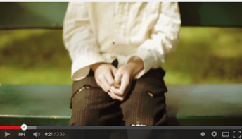  https://goo.gl/ymM3U

Watch the short film My Shoes two times. Focus on understanding the messages and ideas in the first viewing. Study the questions, jot down some key points during the second viewing and tidy up your notes.
- Who are the main characters in this short film? Briefly describe them. | Two boys, one wearing worn-out shoes and the other brand new shoes
- When and where is this short film set? | In a park (outdoors) in the daytime
- What happens in the film? Summarise the main plot. | The boy wearing the worn-out shoes is teased by his peers and very upset. He sees a boy with a brand new pair of shoes and wishes he could be him. When his wish comes true, he learns that the boy is paralysed.
- How do the characters tell the story (e.g. through body movements, facial expressions, dialogues)? | Acting (e.g. facial expressions, body movements) is used to tell the story. There is little speech in the film, except the monologue of the boy when he plays with his shoes and the caretaker’s question in the end.
- What do you notice about the costumes and make-up in this short film? | The way the two boys dress, especially their shoes, helps to show their difference in socio-economic / family background.
- Is the camera always put in the same position throughout the film? | No, different camera angles and shots of different distances are used in combination to present the story.
- How does the background music change towards the end? What effect does the change create? | Sad and slow piano music is used as the background music at the beginning but the pace of the music goes fast when the story reaches its climax. This builds a sense of excitement and the audience’s anticipation.
- Is the ending predictable? | The twist towards the end is unpredictable. The boy and the audience have never expected the happy boy with the new shoes to be paralysed.
- Which do you think is the most striking part in the film? | - The magical moment when the boy’s wish comes true – it is surprising to see the two characters switch their roles.  - The ending – it is a shocking realisation for the boy and a surprise for the audience.
- What is/are the theme(s) or main message(s) of this short film? | Themes: Contentment, appearance and reality, gratitude / thankfulness  Messages:  - Never judge a book by its cover.  - Appearance can be deceiving.  - Be thankful for what we have instead of feeling jealous of others for what they have.
LT 2.1.2T

Part C: Analysing the fictional elements – identifying themes
LT 2.1.3T
Short stories or films usually have a theme (or even a number of themes). Themes are often expressed in abstract nouns.

bravery loyalty hope perseverance respect trust thankfulness kindness responsibility truth betrayal
friendship romantic love family love sacrifice

- Read the following story summaries and identify the themes presented.

- A spider tries to build a web but fails. It tries again but the wind breaks it. Finally, it succeeds.

Theme: perseverance, will power, determination

- Alan believes that his best friend has stolen his watch. He doesn’t listen to any explanation and ends the friendship. A few years later, he finds the missing watch. He is filled with regret.

Theme: trust, friendship

- A man who was once harsh and mean to other people realises he was wrong and has a change of heart. People around him have all forgiven him and are happy to see his change.

Theme: kindness, generosity, forgiveness, repentance

- A film title often carries a symbolic meaning and helps present the theme/message. Identify the theme(s) of My Shoes. Discuss with your partner how the film title helps to convey the theme of My Shoes. Go beyond the literal meaning to explore the hidden meaning of the title.
The themes of the film are “gratitude” and “appearance and reality”. The title
reminds us to put ourselves in others’ “shoes” and see things from their
perspectives, rather than just judge them based on their appearance.

Part D: Analysing the fictional elements – describing and creating a setting
LT 2.1.4T
A director must choose a suitable setting to present the theme and create the atmosphere for the development of the story. A film can transport the viewers through time and into a different place or culture in a few shots. A setting can often appeal to the audience’s senses (i.e. sight, hearing, taste, touch and smell).

- Discuss with your partner to come up with as many descriptive adjectives as you can to describe the setting of the short film My Shoes.

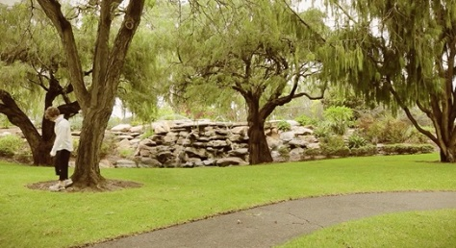
Suggested answers:
tranquil grassy
serene sunny
spacious open
quiet paved
green willowed
(Accept any reasonable answers)

- Look at the three settings and read the descriptions:

A  A crowded football bar | B  A wet market | C  A jam-packed beach
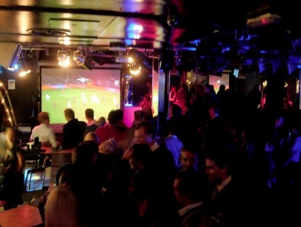  "Danish football fans, London" by adrian, acediscovery is licensed under CC BY-NC-ND 2.0 |  | 
Noisy soccer fans are drinking beer with much cheer and laughter. Drinkers’ eyes are glued to the huge TV screen broadcasting a live match of British Premier League. They shout and jump excitedly whenever a team scores a goal. | Desperate hawkers keep calling out to passers-by about how fresh and cheap their goods are. The fruits look luscious and juicy while the leafy green vegetables look fresh. The place is filled with a foul smell of fish. | Merry swimmers, laid-back holiday-makers and sweaty sun-bathers are finding their own leisure space. While some are lying on the fine sand, others are splashing water all over their bodies and wading in the sea to keep themselves cool under the scorching sun.

LT 2.1.4T
- Fill in the table with words from the descriptions that appeal to our different senses.

Sense | Relevant word / phrase in the description
Sight | “huge”, “leafy green vegetables”, “fresh”
Hearing | “noisy”, “cheer and laughter”, “shout”, “calling out”, “splashing”
Taste | “drinking beer”, “luscious and juicy”
Touch / feel / motion | “jump excitedly”, “sweaty sunbathers”, “lying on the fine sand”, “wading”, “cool”, “the scorching sun”
Smell | “foul smell of fish”

- Which setting would you choose for a story about honesty? What character(s) and plot can you develop under the setting in relation to the theme of honesty?
Accept any reasonable answers

Part E: Analysing the fictional elements – developing the plot
LT 2.1.5T
- Below is the summary of the plot of the film My Shoes. Rearrange the following sentences into a logical plot sequence by putting the numbers (1-10) in the appropriate boxes. Some have been done for you as examples.

No. | Event
6 | The poor boy wishes that he could be the other boy.
9 | The caretaker approaches with a wheelchair.
4 | The two boys meet and they sit at the opposite ends of the bench.
8 | With the new body, the rich boy is overjoyed, laughing and running around in the park.
2 | The poor boy wanders back and forth in the park.
1 | A poor boy who wears a pair of torn sneakers is teased by his peers in a park.
7 | His wish is somehow granted. The poor boy switches his body with the rich one.
3 | A rich boy with a pair of new sneakers sits on the bench.
10 | The poor boy learns of his physical condition and cries.
5 | The poor boy is filled with jealousy. He walks away.

- A plot can be divided into FIVE parts:
(i) exposition (background),
(ii) rising action (complications through conflicts),
(iii) climax (or the turning point),
(iv) falling action and
(v) resolution.
Match the plot sequence in Q1 with the following FIVE parts and write the numbers
(1-10) in the boxes below.
6, 7
8, 9
10
There is always a surprise or a twist towards the end in a successful short film / story.

Climax
Resolution
Falling action
Rising action
Exposition
3, 4, 5

1, 2

Part F: Analysing the dramatic elements – establishing characters through costumes and acting
LT 2.1.6T
The way the characters look (e.g. appearance, make-up) and dress (i.e. costumes) reflects their personalities, and cultural and socio-economic background. Characters also express themselves through facial expressions, body movements, speeches / dialogues, which are all parts of the acting.

- Look at two shots from My Shoes below. Describe the two characters’ costumes and acting. Share your answers with your classmates.

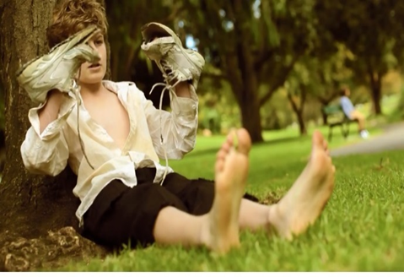
- Describe his appearance and costumes:
e.g. fluffy hair
shabby clothes, worn-out shoes used as hand puppets, bare feet
- What does his look tell you about his socio-economic background?
It shows that the boy is probably from a poor family that cannot afford to buy new clothes for him.
- What is he doing? To whom is he speaking and what is his speech about?
He is using his worn-out shoes as puppets to complain about the unfairness in life. He questions why somebody can have nice shoes but he cannot and expresses his wish to be the rich boy.
- How does his speech tell you about his personalities and feelings?
His speech is full of bitterness, envy and discontent. It shows us that he is not happy or satisfied with his life. He is cynical and resentful.

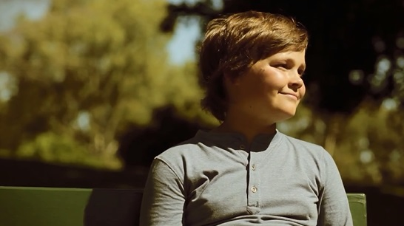
- Describe his appearance and costumes:
soft shiny hair, clean and neat clothes, round cheeks with a contented smile

- Describe his facial expressions:
eyes gazing far away, a beaming face with a satisfying smile

- How do his facial expressions tell you about his personalities & feelings?
He looks hopeful, positive and cheerful. His contented smile seems to suggest that he is satisfied with his life and enjoying his time alone.
LT 2.1.6T
Some films rely more on acting (facial expressions, body movements) than speeches or dialogues, but it can also be very effective in presenting deep feelings and appealing to the audience’s emotions.

LT 2.1.6T

- Is the story presented more through acting (body movements and facial expressions) OR speeches and dialogues?
The story is presented more through acting (e.g. the boys’ actions and facial
expressions). The poor boy only speaks to himself in one scene with the worn-
out shoes as puppets under the tree and the rich boy does not speak at all in the
entire film. However, viewers know their feelings and states of mind from their
facial expressions and actions (e.g. pulling a long face, wearing a contented
smile).

Part G: Analysing the cinematic elements – describing music and sounds in films
LT 2.1.7T
Music can arouse emotions and build up the mood of a film. It can also enrich the images and facilitate plot development (e.g. heightening the suspense, creating tension).
Below are some adjectives to describe different aspects of music and sound tracks.

Musical style | modern, classical, jazz, rock’n roll, gospel
Instruments used | piano, vocal, electronic, orchestral
Melody | soft, infectious, simple, repetitive, memorable, sweet, strong, harmonious, beautiful
Beat and pace | heavy, uplifting, fast, slow, even, uneven, brisk
Feeling, mood and psychological effect | relaxed / relaxing, tense, sentimental, haunting, emotional, suspenseful, light-hearted, sad, serious, calming, dramatic,

- Describe the sound tracks you hear and the feelings you have after listening:
Track | Description of the music | How I feel
Track 1
Track 2
Track 3
Track 4

- Listen to the music of My Shoes without looking at the images. What kind of music is used? How does the music change as the plot advances? What effect does this create?
Soft piano music is used to bring out the sense of sadness at the beginning. When
the plot reaches the climax, the tempo of the music is quickened to create
excitement and highlight the change. It helps to build the viewers’ anticipation.

Part H: Analysing the cinematic elements – identifying camera shots and angles
LT 2.1.8T
Film directors use different types of camera shots and angles to help them achieve the effect they want, for example:

- Camera shots

long shot medium shot close-up extreme close-up

small (size of objects) BIG

Match the chosen shots from My Shoes with the correct terms from the box above:

Shot | Description
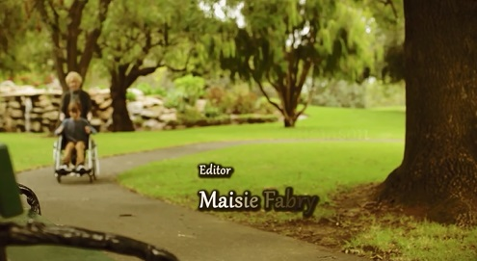 | A shot showing a landscape or buildings from far away is called a long shot. It is often used to set the scene or show the background of the story.
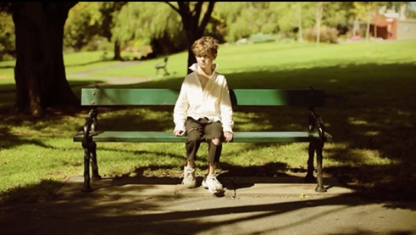 | In this shot, we can see the whole person quite clearly. It is called a medium shot. It helps us identify with the character and enter the story by following him.
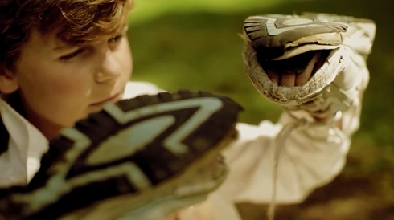 | In a close-up, only the face of the person is shown. It helps us focus on the character’s facial expressions and is often used to highlight feelings and emotions.
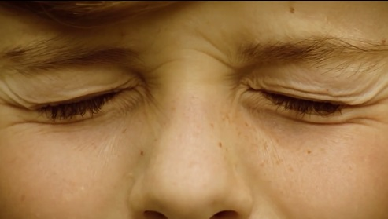 | An extreme close-up is used to focus on fine details and intense feelings.
LT 2.1.8T
- Camera angles

high-angle shot eye-level shot low-angle shot

Match the chosen shots from My Shoes with the correct terms from the box above:

Shot | Description
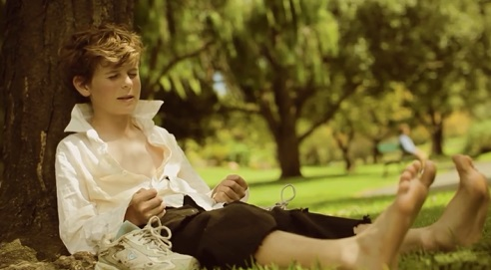 | An eye-level shot is taken when the camera is looking straight on with the subject. It presents characters and things in a more objective way, creating little psychological effect on the viewers.
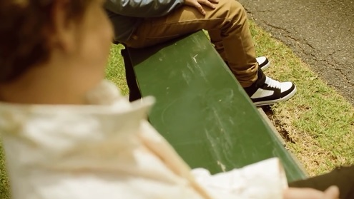 | A high-angle shot is a shot in which the camera is higher than the subject and is looking down upon the subject. This kind of shot can sometimes make the subject look small or weak. In this shot, it is used to show that the boy is focusing his attention on the other boy’s new shoes.
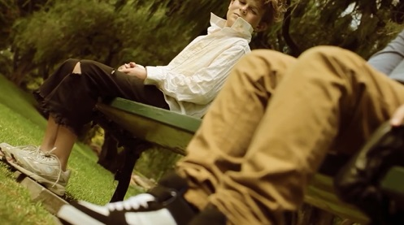 | A low-angle shot is taken from below the subject. This kind of shot sometimes has the power to make the subject look powerful or threatening. Here it shows the boy as being hostile and unfriendly, staring at the other boy’s legs and shoes.
LT 2.1.8T

Task 2 Designing a Storyboard
LT 2.2.1T
Part A: Understanding the features of a storyboard
To help you plan for the shooting, Mr Lam has asked you to create a storyboard to present the plot of your short film.

- Elements of a storyboard
A storyboard is a graphic representation of a film for showing the sequence of the events / scenes. It includes a series of panels with illustrations and notes on what is happening in the scenes. In each panel, you can show the setting, positions, dialogues, acting of the characters, etc.

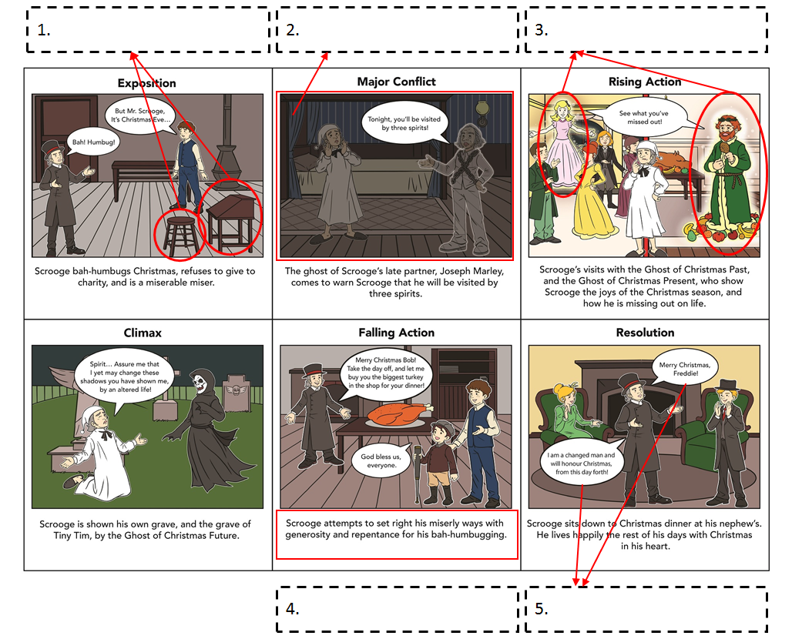
- Read the storyboard of A Christmas Carol below and match the following items
(A-E) with the appropriate panels.
B
D
C
A
E
- Lighting B. Dialogues C. Foreground and background
D. Short descriptions of the scene E. Props
Adapted from www.storyboardthat.com/privateboards/nathanael-okhuysen/christmas-carol-plot-diagram

- What other elements can you include in the storyboard?
LT 2.2.1T
Camera shots and angles
Sound effects (e.g. background music, special audio effects)

- How to draw a storyboard?
The seven steps below show you how to create a storyboard but they are in a wrong order. Work with a partner to put the steps in the correct order.

Order | Step for drawing a storyboard
4 | Sketch the setting and characters
1 | Brainstorm a list of events in the story  (Examples: when and where your story takes place; who will be present; what actions will take place)
3 | Decide on the order of events  (Examples: flashback, flash-forward)
2 | Identify the key moments and scenes in your story  (Examples: the conflict, the climax, a plot twist)
7 | Finalise the storyboard  (Examples: adding colours; reviewing and revising the dialogues and descriptions if necessary)
6 | Number the panels
5 | Write a description for each panel to show what is happening  (Examples: actions of the characters)  # Add dialogues or information about lighting, camera shots and angles, music and sound effects to facilitate shooting

Part B: Turning a story into a storyboard
LT 2.2.2T
Mr Lam has given you a short story to practise how to turn a story into a storyboard. Select the appropriate scenes from the story and put them in the storyboard.

THE GIFT OF THE MAGI
by O. Henry

1

One dollar and eighty-seven cents. That was all she had. Three times Della counted it. And the next day would be Christmas.

There was clearly nothing to do but sit down on the old sofa and cry. So Della did. You see, life is made up of tears and smiles, but mainly of tears.

As Della had finished crying, she looked out of the window sadly at a grey cat walking along a grey fence in a grey park. Tomorrow would be Christmas Day, and she had only $1.87 to buy Jim a present.

2

Suddenly she turned away from the window and stood before a mirror. Her eyes were shining brightly as she thought about her husband, Jim. She had been saving every penny she could for months to buy a present for Jim. Something fine and rare for her Jim. Quickly she pulled down her hair and let it fall to its full length.

There were two things that Jim and Della were very proud of. One was Jim’s gold watch that had belonged to his father and his grandfather. The other was Della’s hair. It was brown and shiny like a cascade. When she let it loose, it reached below her knee and it fell around her like a beautiful cloak.

Quickly and nervously she pinned it up again. Once she hesitated for a minute and stood still while a tear or two went down her face. She put on her old brown jacket and her old brown hat. Then she rushed out of the door and down the stairs to the street.

She stopped at a shop with the sign “Madame Sofronie – Hair Goods of All Kinds.”

“Will you buy my hair?” asked Della.

“Take your hat off and let’s have a look at it,” said Madame.

Down fell the brown cascade.

“Twenty dollars,” said Madame.

The next two hours had gone happily. Della was searching the stores for Jim’s present. She found it at last. It was a platinum watch chain. As soon as she saw it she knew that it would be right for Jim’s watch.

3

At 7 o’clock, coffee was made and the frying pan was hot on the stove. Della was about to start cooking.

Jim stepped in the house and his eyes were fixed upon Della, and there was an expression in them that she could not understand, and it terrified her. It was not anger, nor surprise, nor disapproval, nor horror, nor any of the feelings that she had expected. He simply stared at her with that strange expression on his face.

Della got up and went over to him.

“Jim, darling,” she cried, “don’t look at me that way. I had my hair cut off and sold because I couldn’t have lived through Christmas without giving you a present. It’ll grow again. You don’t know what a nice gift I’ve got for you.”

“You’ve cut off your hair?” asked Jim slowly, as if he did not understand.

“Cut it off and sold it,” said Della. “Don’t you like me just as well? I’m still the same without my hair.”

Jim seemed to wake suddenly from a dream. He drew a package from his overcoat pocket and put it on the table.

“Don’t make any mistake about me, Della,” he said, “I don’t think there’s anything in your haircut that could make me love you less. But if you open that package you’ll see why I did not know what to say just now.”

With nimble fingers Della tore at the string and paper. Her excited scream of joy quickly changed to tears and cries. For there lay the set of combs that Della had admired for months in a shop window. Beautiful combs, with jewels in them - but her hair had gone and she had no use for them.

She held them close to her heart and at last, she was able to look up with dim eyes and a smile and say, “My hair grows fast, Jim!”

Then Della remembered that Jim had not yet seen his beautiful present. She showed it to him eagerly.

“Isn’t it lovely, Jim? I hunted all over town to find it. You’ll look at the time a hundred times a day now. Give me your watch. I want to see how it looks on it.”

“Della, don’t get disappointed as I had sold the watch to get the money to buy your combs. Let’s put our precious presents away and keep them a while. They’re too nice to use just at present. We should cherish our time together and get the supper ready now.”

“You’re right.” Della smiled with contentment.

END

Adapted from www.eduhk.hk/alttasks/material/unit02/Gifts_text_101204.doc
LT 2.2.2T
- Answer the following questions to help you select important details for inclusion in the storyboard for “The Gift of the Magi”.
LT 2.2.2T

Exposition | - When was the story set?  Christmas eve  - What does “she” in line 1 in the first paragraph refer to?  Della
Conflict | - What was Della’s most valuable possession?  Her long hair  - What problem did the characters face in the story?  Della and Jim, a poor couple, struggled to buy a nice Christmas gift for each other.  - Why did Della feel frustrated and cry?  She did not have enough money to buy her husband a gift.
Rising Action | - What did Della get Jim for Christmas?  A platinum watch chain  - How did Della get enough money to buy Jim’s Christmas gift?  She sold her hair to get money to buy a platinum watch chain for Jim.
Climax | - How did Jim react when he saw Della’s new hairstyle? Why?  He was shocked because he had sold his watch for money to buy Della a set of combs for her long hair, which Della no longer had.
Falling Action | - What did Jim and Della decide to do with the Christmas presents?  They decided to put the gifts away until they could both use them.
Resolution | - How did Jim and Della respond to the situation and feel at the end of the story?  Despite the fact that the gifts they had bought for each other were no longer useful, Jim and Della did not blame each other. They cherished each other and the time together. They learnt a valuable lesson about sacrifice and love.
Theme | - Which of the following best identifies the theme of the story?  A. Absence makes the heart grow fonder.  B. Count your blessings.  C. Never judge a book by its cover.  D. Do as you would be done by.
If you were to make a short film for the story “The Gift of the Magi”, which scenes would you include to present the story and messages?
- Imagine you are to make a short film for the story “The Gift of the Magi”. Draw a storyboard and add dialogues and descriptions as necessary.
LT 2.2.2T
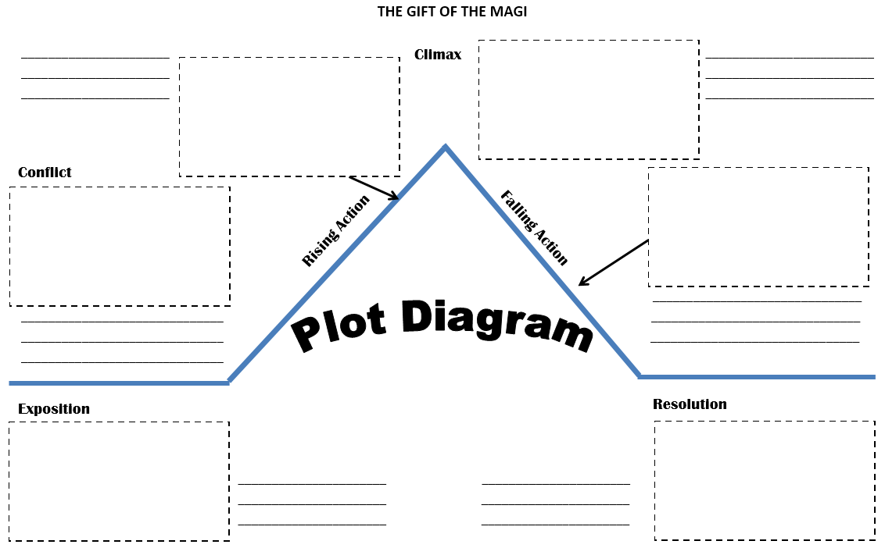

Suggested Answer
LT 2.2.2T
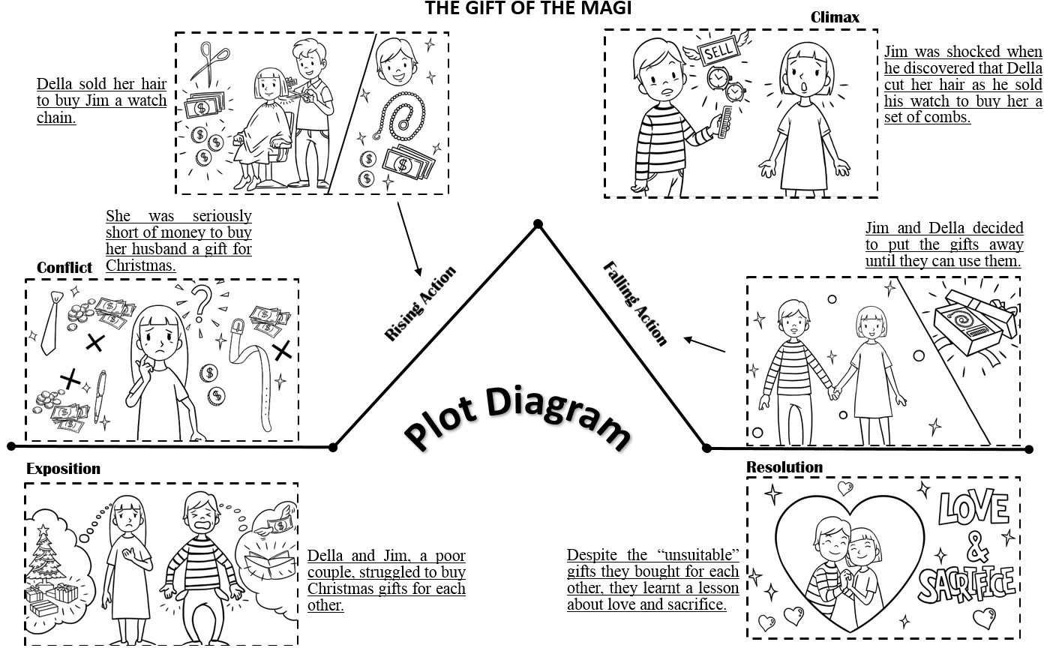

Part C: Designing a storyboard
LT 2.2.3T
To take part in the Short Film Competition, you and your group members are going to make a short film of under five minutes based on one of the messages: (a) “Count your blessings”; OR (b) “Never judge a book by its cover”. Use the storyboard below to brainstorm the details of the short film with your group members.
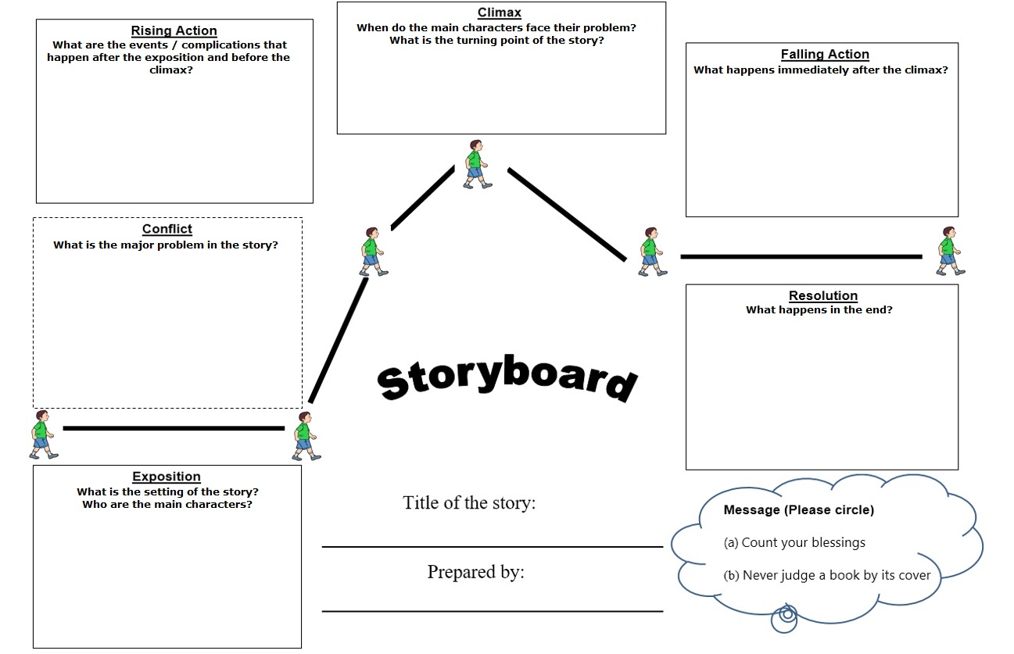

Task 3 Reading Synopses and Comments on Films
LT 2.3.1T

Part A: Reading and writing film synopses
You are required to provide a synopsis, which is a short summary of your film, when you submit your entry for the short film competition. Mr Lam has prepared some examples to illustrate what makes a good synopsis.

Example 1
Inside Out (2015)
Directors: Pete Docter, Ronnie Del Carmen
PG | 94 min | Animation, Adventure, Comedy | 19 June 2015 (USA)

Growing up can be a rollercoaster, and this is particularly true for Riley, who is relocated from Minnesota to San Francisco when her father starts a new job. Riley experiences a myriad of emotions - Joy, Fear, Anger, Disgust and Sadness, which all live in Headquarters, the control centre inside Riley’s mind. Riley has to work her way through the emotions as she adjusts to a new life in San Francisco. These emotions fight against each other and cause turmoil in Headquarters. Although Joy tries to be the main emotion and help Riley stay positive, the emotional struggle goes on as the others conflict on how best to settle in a new city, home and school.

Example 2
If I Stay (2014)
Director: R.J. Cutler
PG-13 | 107 min | Drama, Music, Romance | 22 August 2014 (USA)

Mia Hall (Chloë Grace Moretz), a gifted young cellist, used to think the biggest dilemma in her life would be to choose between her musical dreams – entering the prestigious Juilliard School or the love of her life – staying with Adam (Jamie Blackley), a rock singer and guitarist. A leisure family trip changes her world in the blink of an eye. Mia’s life is left hanging in the balance. Caught between life and death, Mia has only one decision to make, which will not only decide her future but also her ultimate fate.

Example 3
Maleficent (2014)
Director: Robert Stromberg
PG | 97 min | Action, Adventure, Family | 30 May 2014 (USA)

Maleficent (Angelina Jolie), a young fairy with giant wings, enjoys a tranquil life growing up in the Moors, a peaceful forest kingdom inhabited by many kind supernatural creatures. One day, King Henry (Kenneth Cranham) leads his army to conquer the Moors for the human world. Maleficent rises to protect the Moors, but she suffers a cruel betrayal by Stefan (Sharlto Copley), her childhood sweetheart – a brutal act that turns her tender heart into stone. Resolved to avenge Stefan’s betrayal, Maleficent places a curse on his baby daughter Aurora. As the child grows into a beautiful lady (Elle Fanning), Maleficent realises that Aurora holds the key to peace in the kingdom – and perhaps to Maleficent’s true happiness too.

- Answer the following questions to understand the features of an effective film synopsis:
LT 2.3.1T

a. | What is the length of the above synopses?
 | Rather short, around 100 words
b. | What tense is used to tell the story?
 | The present tenses
c. | Which of the following items are provided in the synopses? Tick the appropriate boxes.  setting (time and place the story takes place)  the protagonists or main characters
the main plot
dialogues

d. | What kind of information is provided in brackets?
 | The name of the actor / actress in that character’s role
e. | Is the ending of the story fully revealed in the synopses? Why?
 | The ending of the story is not totally revealed in order to arouse the readers’
 | interest in watching the film to find out the ending.
f. | Which of the three films do you want to watch most after reading the synopses? Why?
 | Accept any reasonable answers
 | (e.g. I would like to watch Maleficent most because its plot is complicated
 | and engaging. I am really eager to know if Maleficent will resolve her conflict
 | with Aurora and Stefan and become a warm-hearted fairy again.)

- With reference to the features introduced above, write a short synopsis of about 100 words on a film you have recently watched.

Film title: | A Christmas Carol
Director: | Robert Zemeckis
Year of release: | 2009
Ebenezer Scrooge (Jim Carrey), a stingy moneylender who runs his business by
exploiting his employees, hates Christmas. On Christmas Eve, Scrooge is visited
by the ghost of his dead partner Jacob Marley (Gary Oldman), who is now forced
to spend his afterlife carrying heavy chains forged from his greedy ways.
Awakened by three Christmas spirits who reveal to him his miserable existence
– his loss in the past, his greed and cruelty at present and the grim fate that awaits
him in the future, Scrooge must face his own story of growing bitterness and
meanness and decide what his own future will hold. The question is – Is he
willing to change? (110 words)
Part B: Reading comments on films to master the language
LT 2.3.2T
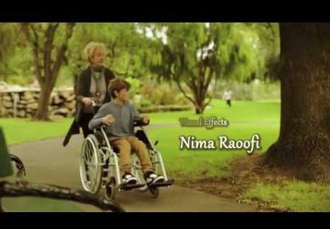
While looking for more information about the films discussed in the workshop, you have found an online forum capturing viewers’ comments on two films.

My Shoes (2012) directed by Nima Raoofi

  Movie_Fan | The movie is beautifully shot and well-paced. The ending cannot be more surprising. The final twist is really thought-provoking – I end up being more grateful for what I have after watching the film. This is a masterpiece that definitely deserves three minutes of your life.
  Bravo | The piano music is exceptional and complements the plot really well. I was excited when the slow and soft music turned fast as the boy’s wish came true, but only to find out the miserable and shocking truth in the end. The music really facilitates and enhances the plot development.
  Film-lover | This is a deftly directed piece that teaches us a valuable moral lesson. The paralysed boy can still smile despite his inability to walk whereas the able boy is complaining about his worn-out shoes and life being unfair. If a physically disabled person can be satisfied with his life, having old shoes is surely nothing to be sad about. The short film reminds us not to judge others’ lives by looking on the surface. We tend to focus on the shortcomings in our lives and envy others for what they have. The film is a wake-up call, conveying a serious message about the importance of contentment.
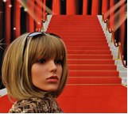  Red_Carpet | The performance of the two child actors is outstanding. They carry their roles as two boys from two opposite worlds brilliantly. The contrast of the two characters is very sharp.

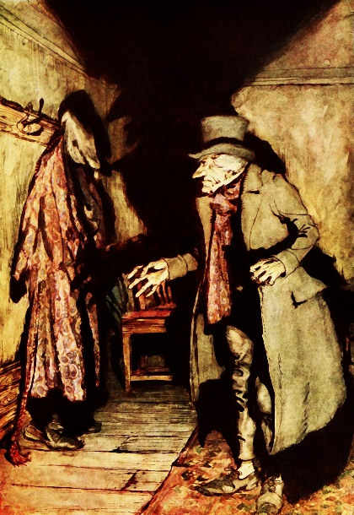
LT 2.3.2T

A Christmas Carol (2009) directed by Robert Zemeckis

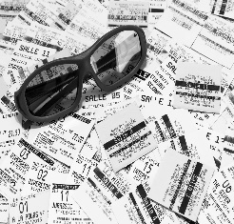  Cinemagoer | Jim Carrey steals the show as miserly Ebenezer Scrooge. He’s a perfect Scrooge and the entire movie is an outburst of his talents. He uses his voice and mannerisms to great effect and graces the film. Gary Oldman and Colin Firth perform quite well in key supporting roles though Jim Carrey definitely outshines them. Leslie Zemeckis can be at times wooden and self-conscious in her role as Fred’s wife.
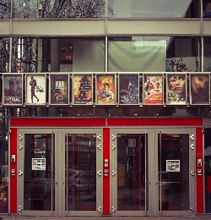  Boxofficer | The cinematography and animation are superb. The use of 3D enlivens and enriches Dickens’ classic story. The costumes and images powerfully capture the spirit of the times in the 19th century London. The special effects add appeal to modern-day audience. The scenes featuring the Ghost of Christmas Present are visually stunning and breathtaking.
  Curator_Tim | Maybe because I am not a big fan of 3D, I just think that a large part of the film is an excessive display of 3D technology and some of the special effects go over-the-top and create too much horror and unsettling feelings. For example, the visit of the three spirits is more gruesome than it should be! The sight of Marley’s Ghost with a flapping jaw is far too scary for small children. The film strays away from Dickens’ original work when the director shows off what the camera can do with aerial scenes zooming over Victorian London. The biggest stray is the chase scene with a mini-Scrooge going through drain pipes to escape an oncoming coach and horses trying to run him down. All these are unnecessary for presenting the theme and message of the story.
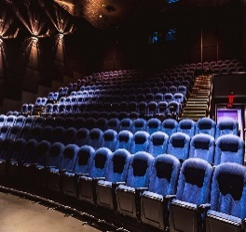  SamUsherer | This wonderful remake of Dickens’ famous story will surely be on my list of films that define the season, along with Christmas Story, Home Alone, and It’s a Wonderful Life. I have always enjoyed this story because it explores the themes of charity and redemption – there is no better time than Christmas to spread this message of love and kindness. The story shows how people can be compassionate, even in the face of people who may look heartless and cold-blooded like Ebenezer Scrooge.

To facilitate your understanding and learn vocabulary for commenting on films, you have organised the comments using the note-sheet below:
LT 2.3.2T

- Identify the aspect(s) of the film the comments focus on and whether they are on the whole positive or negative about the film:

Commentator | Main aspect covered in the comment (e.g. plot, theme / message, acting, sound effects / music, visual effects) | Generally positive (+) / negative (-) about the film
Movie_Fan | plot | +
Bravo | music | +
Film-lover | message | +
Red_Carpet | acting | +
Cinemagoer | acting | + (with some negative comments)
Boxofficer | visual / cinematic effects / costumes | +
Curator_Tim | visual / cinematic effects | -
SamUsherer | theme / message | +

- A lot of adjectives are used in the comments to describe different aspects of the films. Identify them and organise them using the table below:

 | Adjective used | Commentator
Acting skill | outstanding, perfect, wooden, self-conscious | Red-carpet  Cinemagoer
Music | exceptional, slow, soft, fast | Bravo
Visual image / cinematic effect | superb, stunning, breathtaking, over-the-top, excessive, gruesome, scary | Boxofficer  Curator_Tim
The whole film in general | beautifully shot, well-paced, thought-provoking, deftly directed | Movie_Fan  Film-lover

- Some verbs help to discuss the content and the cinematic effects of the film. Complete the sentences using the verbs in the word box below. Make sure your answers are grammatically correct.
LT 2.3.2T

facilitate | spread | enliven | enhance | convey
present | create | enrich | explore

- The use of music helps facilitate / enhance / enrich the development of the story. (Bravo)

- The film presents / explores the theme of kindness and spreads / conveys the message that love is the most powerful force and priceless gift. (Curator_Tim, Film-lover, SamUsherer)

- The special effects enliven / enrich / enhance the story. They help to create an eerie mood and a sense of suspense in the film. (Boxofficer, Curator_Tim)

Task 4: Entering the Short Film Competition
LT 2.4.1T
LT 2.4.1

Part A: Producing and presenting a short film
You are about to make a short film of under five minutes to enter the competition. Mr Lam has prepared a list of reminders for you. Read the reminders carefully and follow the steps below:
Before shooting

- Read the storyboard which outlines your story.
- Decide the role to be taken up by each group member and think about how the characters should look, act and speak in each scene.
- Develop a script if necessary, memorise the lines before the actual shooting to ensure a smooth running.
- Prepare the costumes and props needed for each scene / shooting location.
- Decide on the shooting schedule and the equipment / mobile device to use (e.g. iPhone, iPad).
- Test the equipment to ensure it is working and with sufficient battery life and storage capacity.
- Rehearse and trial run each scene to estimate the time and predict problems likely to arise. Fine-tune the storyboard and script if necessary.

While shooting

- Test the device by conducting a trial recording in the actual surroundings to make sure the sounds and images can be captured clearly.
- Speak loudly to make sure the characters’ speeches and dialogues can be heard clearly. Use a portable microphone if necessary.
- Preview after each scene to make sure the recording is satisfactory. Have a second shooting before moving on in case of undesirable effects.

After shooting

- Make use of the functions available on your device, apps or computer to do editing, and add sound effects, music and subtitles.
- Write a synopsis of about 100 words to provide a plot summary of the film.
- Review your work with the assessment form at LT 2.4.2 and make necessary revisions.
- Upload the edited clip and synopsis to the competition page.

After uploading

- View and comment on two other films on the competition page. Focus your comment on a different aspect for each film and write at least 100 words in total. Review the comments with the assessment form provided at LT 2.4.3 and make necessary revisions before posting.
- Vote for your favourite film for the “Audience Award”.
Teacher’s notes:
- Teachers may create a group with the use of social learning platforms or learning management systems (e.g. Edmodo, e-class) and use it as a competition webpage to facilitate the sharing of works and peer review among students, as well as the polling for the Audience Award.
- Teachers can check with the teachers concerned to understand students’ previous knowledge in editing and the apps or software available for use at school. Make special arrangements to provide mobile devices for shooting and editing tools for students who do not have access to them outside class / school.

Group ( )
LT 2.4.1T
Members’ names: _____________________________________________________________________

Assessment Form: Short Film and Synopsis
Assessor:
Task: |  | In groups:  - Produce a short film of under five minutes on one of the messages:  - “Count your blessings” OR (2) “Never judge a book by its cover”  - Provide a short synopsis of the film in about 100 words
Please tick: |  |  | Needs  Improvement | Meets some requirements | Satisfactory | Good | Excellent
Part A: Short Film
 | Fictional Aspect
 | The film is relevant to the topic and fulfils the task requirements
 | The chosen message is effectively presented.
 | The plot is engaging and well-developed.
 | The characters are well-established.
 | The setting is appropriate and well-chosen.
 | Dramatic Aspect
 | The actors use their voices effectively and speak in appropriate tone and manner.
 | The actors act with appropriate body language, movements and facial expressions.
 | The costumes are appropriate and effective.
 | Cinematic Aspect
 | Music and sound effects are effectively used to enhance the story and performance.
 | Camera shots and angles are appropriately used to create effects.
Part B: Short Synopsis
 | The synopsis is of appropriate length (around 100 words).
 | Major information of the film (e.g. plot, setting, name of characters) is provided.
 | Tenses are used appropriately to tell the plot.
 | The synopsis can arouse readers’ interest in seeing the film (e.g. withholding the ending).
Overall Comments
LT 2.4.2T
Part B: Commenting on other entries and voting for the Audience Award
Individually, view two films produced by other competitors and write comments on them. Select a different aspect (e.g. message, plot, acting, audio-visual effects) to comment on for the two films. Write at least 100 words in total.

Name: ______________________( ) Class: ___________ Date: _______________________

Assessment Form: Comments on Films
Please tick: |  |  | Needs  Improvement | Meets some requirements | Satisfactory | Good | Excellent
Comment 1 (on Film 1)
 | The view on the film is presented clearly.
 | Relevant details from the film are provided to illustrate and justify the point(s).
 | Adjectives are appropriately used to describe the chosen aspect of the film.
 | Verbs and tenses are appropriately used to discuss the chosen aspect of the film.
Comment 2 (on Film 2)
 | The view on the film is presented clearly.
 | Relevant details from the film are provided to illustrate and justify the point(s).
 | Adjectives are appropriately used to describe the chosen aspect of the film.
 | Verbs and tenses are appropriately used to discuss the chosen aspect of the film.

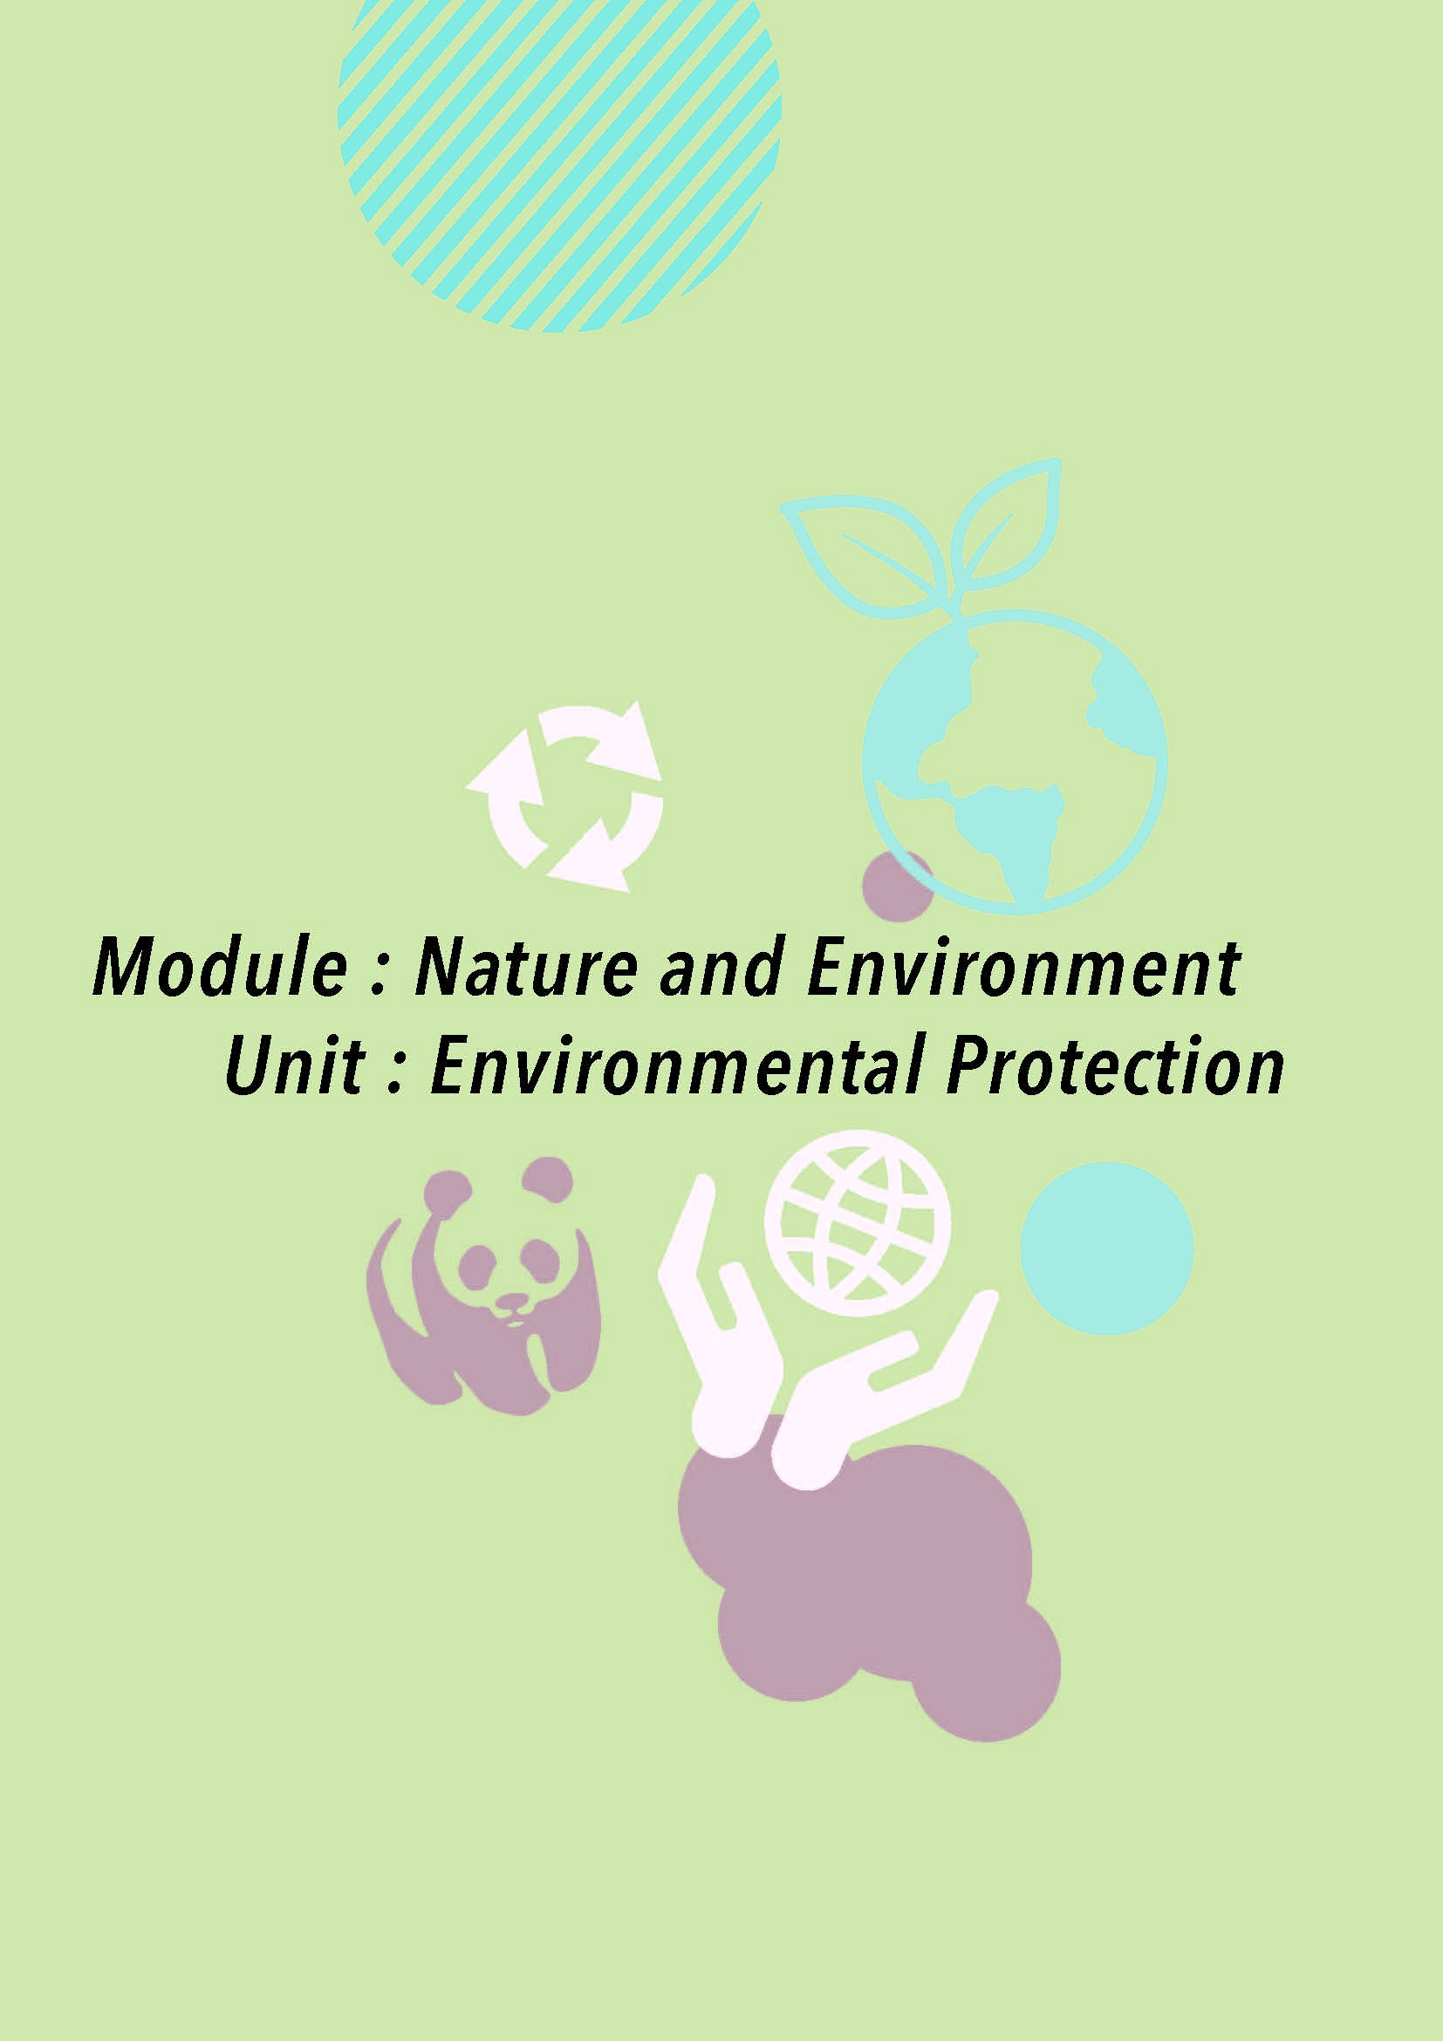

(3) Module: Nature and Environment
Unit: Environmental Protection
(Bank page)
Overview

Situation
You are Chris Lee, a summer intern in the Publicity Team of Go Green, a non-governmental organisation committed to promoting environmental protection and green living. Your team is responsible for designing advertising materials to raise public awareness of environmental problems. Raymond Lam, Head of the Publicity Team, has asked you to identify an environmental issue which is worth public attention and design an e-booklet to educate the public about it.

You have to complete the following tasks:
Task 1: Identifying and Researching into an Environmental Issue
You will watch a set of slides on the environmental problems that the world is currently facing and choose one issue for further research and exploration.

Task 2: Reading and Analysing a Leaflet
You will read a leaflet to identify its organisation and text features, and analyse the tactics used to enhance its logical and emotional appeal.

Task 3: Devising a Plan for the Production of an e-Booklet
You will devise the outline for an e-booklet on your chosen environmental issue and produce the e-booklet using relevant apps or software.

Materials
- LT 3.1.1 – LT 3.3.4
- Online videos
- An enlarged mind map (Appendix C)
- PowerPoint slides (Environmental Issues) (Appendix D)
- A sample e-booklet (The Invisible Health Hazard) (Appendix E)

Procedures:

- Introduce the context and the tasks to students with reference to the Overview.

Task 1 Identifying and Researching into an Environmental Issue

- Before the lessons, encourage students to read and view materials online to enrich their knowledge on the topic. Below is a suggestion:
- “The Top Ten Environmental Issues Should Make You Worry” by Schooled by Science (https://schooledbyscience.com/environmental-issues/).

- At the beginning of the lesson, arouse students’ interest in the module by playing a short video on the topic as a starter. Below is a suggestion:
- “Planet in Focus - Global Environment Outlook” by UN Environment (https://www.youtube.com/watch?v=3dyhAcGyd20)
The speed of the video can be reduced, if needed.
- Ask students the following questions to elicit their previous knowledge and help them connect the topic to their daily life and the Hong Kong context:
- What are some of the environmental problems that Hong Kong is facing? Are they serious?
- Can you name some of the green groups / organisations in Hong Kong? What do they do and promote?
- Do you care about the environment? What can you do to help save the Earth?

- Introduce the context and situation of the unit to students:
- Ask students to read the situation and explain to them:
- what a summer intern is (e.g. temporary staff, summer job)
- what the publicity team in a green group does (e.g. to make promotional materials, to reach out to the public)
- Tell students that they are going to produce an e-booklet on an environmental issue for raising public awareness, and explain the steps and tasks that prepare them for the final production.

Part A: Identifying an environmental issue (LT 3.1.1 & PowerPoint slides)

- Explain to students that the purpose of LT 3.1.1 is to encourage them to think critically about the environmental issues that Hong Kong is facing. Guide them to prioritise the environmental issues based on the level of severity and urgency and identify one for further exploration.

- Show the slides presenting different environmental problems in the world. Ask students to name the problems as they view the relevant pictures, and briefly brainstorm their causes and impacts. The environmental problems include air pollution (slide 2), deforestation (slide 3), overpopulation (slide 4), water pollution (slide 5) and global warming (slide 6).

- Ask questions on the affective dimension of the pictures in the slides (e.g. “Describe one picture that is particularly striking and explain your choice.”)

- Guide students to identify an issue that deserves public attention and immediate action in Hong Kong, and justify their choice with reasons. Allow students to choose an issue outside those presented in the slides and remind them to consider the following factors:
- the urgency and severity of the problem
- the general public’s existing knowledge and level of awareness
- the possible outcomes of our ignorance and indifference to this problem
- the relevance of the problem to Hong Kong (i.e. in what ways Hong Kong people are causing the problem and affected by it)

- Get students to organise their ideas in the mind map provided, share their ideas in groups and choose an environmental issue to work on. Invite some of them to talk about their choice.

Part B: Researching into the environmental issue (LT 3.1.2)

- Explain to students that the purpose of LT 3.1.2 is to develop their online research skills and ability to evaluate the quality and reliability of the information on the Internet. (Advanced understanding is not required at this stage as the activity only aims to raise students’ awareness and develop their habit of mind, so that they will question the reliability of online information critically instead of believing immediately what they read.)

- Conduct the lesson in a room with Internet access and tablet devices / computers, if possible, to allow opportunities for hands-on experience.

- Go through the task instructions and requirements with students by:
- asking them to read the email from Mr Lam and identify the tasks they are required to complete (i.e. the mind map and the record form); and
- asking them to read the mind map and understand what kind of information they need to look for.

Part C: Learning about effective information search (LT 3.1.3 & an enlarged mind map (LT 3.1.2))

- Refer students to the notes on “How to search the Internet effectively” and “How to evaluate online resources” and go through the following:
How to search the Internet effectively?
- Ask students to name some search engines (e.g. Google, Bing, Baidu).
- Demonstrate the use of some search commands (e.g. keywords, search commands “...”, OR, +, -) in class.
- Introduce only the use of quotation marks and “OR” if students find it hard to cope with all four search commands.

How to evaluate online sources?
- Explain to students the importance of understanding of the hidden messages, embedded values and / or socio-cultural impacts of multimodal texts.
- Go through the factors to consider and the guiding questions on assessing the quality of websites with students. Provide more examples if necessary.

- Refer students to the Record Form on Sources of Information and explain to them with the two examples the purpose of the form. Demonstrate to students how they can think critically and note down their observations while processing the information online.

- Model the process of assessing the quality of websites using strategies such as think-aloud or questioning to guide students to fill in the form.
- Ask students to discuss in pairs the number of stars they would give to the second sample website considering a range of factors such as usefulness, reader-friendliness, timeliness, accuracy and reliability of information. Emphasis should be placed on whether students can explain how they make judgment based on the criteria and considerations introduced in the guidelines.

- Ask students to start the information search on their chosen environmental issue and fill in the enlarged mind map (LT 3.1.2) and record form (LT 3.1.3) in class. Remind students to:
- consult a range of sources (e.g. both government and NGO’s sites, videos) for a wider perspective on the issue;
- check more than one source on the same topic in order to compare the information provided from different sources and select quality information for inclusion in the mind map;
- simplify and rephrase the language where necessary for consistency in presentation (e.g. presenting the causes in the mind map in noun phrases or short sentences); and
- write the numbers in the spaces provided in the mind map to indicate the sources from which the information is obtained in the record form.

- To cater for learner diversity, vary the task demand in the following ways:
- More advanced students can be challenged to consult a wider range of websites and sources, whereas less advanced students can be assigned to complete the mind map with information from three to four websites only.
- More advanced students can be encouraged to come up with five pieces of information for all items (i.e. causes, effects, actions to be taken by different parties), whereas less advanced students can be asked to come up with three major points for each only.
- More advanced students can be asked to rank the answers for each item (i.e. causes, effects, actions taken by different parties) in the order of importance (with 1 being the most important and 5 least important) to encourage critical thinking and more in-depth research.
- More advanced students are required to find both statistics and expert quotes on the issues, whereas less advanced students can be asked to look for either one.

- Ask students to complete the mind map and record form at home and submit them together for your comment.
- Check their mind maps and record forms to make sure:
- sufficient and relevant information is obtained for producing the e-booklet; and
- the answers are not from a single source of information / website.

- Provide feedback and suggest follow-up actions (e.g. further research, consulting more sources) if necessary.

- Remind students to keep the mind map and record form well for use in the subsequent tasks.

Task 2 Reading and Analysing a Leaflet

- Explain that the objective of Task 2 is to familiarise students with the organisation and text features of a leaflet / booklet which is informative and / or persuasive in nature. Remind students that they should be able to apply the knowledge of organisation and text features in the production of the e-booklet.

- Explain the meaning of the suffix “-let” (“something small”) to students (e.g. booklet, leaflet, pamphlet). Tell students that a leaflet is usually a piece of paper (a leaf), often folded, containing all the necessary information, whereas a booklet or pamphlet may look more like a book containing a few pages. An e-booklet or e-leaflet may have sound effects as well. Show students some authentic leaflets / booklets if necessary.

Part A: Reading a leaflet (LT 3.2.1)

- Ask students to read the leaflet before the lesson, come up with some ideas or make some brief notes on the questions to facilitate discussion and make effective use of the lesson time.

- When going through the sample text and checking the answers with students, guide them to relate what they have noticed in the sample text to the e-booklet that they are going to create.

Part B: Analysing a leaflet (LT 3.2.2)

- Content
- Check students’ general understanding of the text by going through the items in the table with them. Remind students to bear these questions in mind when they plan and produce their e-booklet:
- Why do I create the e-booklet?
- Who are my target readers?
- What message(s) do I want to convey to the target readers?
- What tone should I adopt to convince readers to take action?

- Organisation
- Guide students to notice the two key features of leaflets and explain why they are important:
Features | Reasons
The use of headings / subheadings | To signpost ideas and provide a clear focus
The use of bullet points / short paragraphs | To present main points in a precise and concise manner to enhance clarity and reader-friendliness

- Ask students to look at the headings and work out the focus of each paragraph.

- Explain that an engaging heading can be used (e.g. questions) to present the information. Ask students to think of some interesting headings for different parts of the e-booklet to catch readers’ attention.

- Language features
- Introduce different kinds of techniques that help to create a catchy title / tagline / slogan in a leaflet or booklet. Examples can be provided to explain the techniques and illustrate their use:
Language features / techniques | Examples:
Rhyming words  (Not necessarily the ending words) | The best solution to pollution is your immediate action.
Alliteration | Shout out against shooting sharks.
Pun | Echo the eco – Learn to live green
Parallel structure | A greener world A brighter future
Triplet | Love Green, Live Green, Think Green

- Ask students to think of a catchy title or slogan for their e-booklet using one to two of the techniques introduced. Tools like an online rhymer may help them generate ideas.

- For Q3 and Q4, put emphasis on the communicative functions performed by the various language items (i.e. the future perfect tense) and sentence patterns (e.g. conditional sentences, inversion, imperatives and rhetorical questions) if students are already familiar with the forms. Guide students to identify the target items from the text and analyse how they are used in context to achieve the desired effects.

- Ask students to look at their mind maps (LT 3.1.2) and make five sentences on their chosen environmental issue, with each using one of the target language items introduced.
- Emotional appeal
- Advise students to take into consideration the following components of the compositional dimension of multimodal texts in order to enhance the emotional appeal of their e-booklet:
- the use of strong adverbs and adjectives (Linguistic)
- vivid pictures and images (Visual-spatial)
- music and sound effects (Audio)

- For Q1, heighten students’ awareness of how the choice of adjectives can reveal the writer’s stance and value judgment by asking them to:
- read the paragraph on “Overfishing” again with all the emotional and emphatic adjectives / adverbs removed (as below); and
- explain the difference in meaning or effect when the existing adjectives are replaced with more neutral ones (e.g. “growing / high demand for shark fins” instead of “greedy demand”).

Overfishing
Populations of many shark species (e.g. hammerhead sharks, dusky sharks and sandbar sharks) have been declining due to our high demand for shark fins, particularly in Hong Kong and the mainland, and the lack of sustainable shark fishery management worldwide. As animals of slow reproduction, shark populations are shrinking. Many important species of sharks can hardly be found in open water in future unless overfishing is stopped immediately.

- Ask students to think of some strong adjectives / adverbs that they can use in the e-booklet to enhance emotional appeal. Here are some suggestions:
 | Strong adjectives / adverbs
Situation | alarming, worrying, devastating, critical, terrible, desperate, deplorable
Consequences | harmful, grave, fatal, dire, serious
Trends  (rise / increase)  (fall / decrease) | drastic(ally), rapid(ly), significant(ly)
(Most of the above adjectives are negative in meaning and they are used to talk about a serious problem and its undesirable consequences.)

- For Q2 and Q3, tell students that the following strategies are used to make pictures powerful:
- containing humour (e.g. sarcastic remarks)
- offering surprise (e.g. a new way of looking at things)
- arousing emotions (e.g. unease, pity, sympathy, fear)
- provoking new thoughts / a fresh perspective on a subject

- Ask students to choose the most powerful image from each set in Q3 and justify their choice with the points discussed above. Remind students to bring in knowledge of distance and camera angles learnt in LT 2.1.8 (e.g. close-up to show characters’ intense emotions, high angle shots to show helplessness) where appropriate to describe the effects the pictures create.

- Logical appeal
- Explain to students that logical appeals often come from scientific proof and evidence and people tend to believe experts and authorities.

- Tell students that the three common ways to enhance persuasiveness and reliability of the texts are:
- providing statistical data,
- quoting from experts / professionals, and
- citing cases or providing real-life examples.

- Remind students to include expert quotes and statistical data in their e-booklet.

- Explore the critical dimension of multimodal texts with students by getting them to take note of the following when searching for suitable quotes and statistical data online:
- the authority of the person / organisation presenting the data / speech
- the timeliness of the data / speech
- whether the person / organisation has any vested interest or profit related to the data / speech presented

- Ask students to take down the quotes, data and the sources of information for the production of the e-booklet.

- Tell students that quotes and statistical data can be presented with graphics (e.g. diagrams and speech bubbles) in the e-booklet. If students would like to present them in sentences in the main text, the following structures can be introduced to them:
Statistical data | - A survey / report by (the organisation) in (year) showed that…  - According to the survey conducted by (the organisation) in (year), ...
Quotes | - As said by (name), (post title), …  - (Name), (post title), commented / pointed out / opined that…

Task 3 Devising a Plan for the Production of an e-Booklet

- Explain to students that the purpose of LT 3.3.1 is to give them information about the requirements of the e-booklet which they are going to produce, and that they can develop a better understanding of how to use images and typographical features to achieve certain effects.

Part A: Understanding the requirements of the e-booklet to be produced (LT 3.3.1)

- Ask students to work in pairs to find out the requirements of the e-booklet to be produced through decoding the messages embedded in the images / graphics provided. Use the following questions to guide students to work out the answers:

- Topic
  - Why is the font size of the number “1” enlarged? (This is to emphasise that students should only focus on and investigate ONE environmental issue only.)
    - Remind students to limit the scope of the topic in order to instigate more in-depth discussion, e.g. picking a particular type of pollution if they would like to discuss the issue of pollution.

- Cover and title
  - How are the arrows and the eyes related to the title? (The title should be able to draw readers’ attention, i.e. an eye-catching title.)
    - Elicit from students some techniques to create a catchy title if time allows. [Refer to LT 3.2.2]

- Content
  - With reference to the mind map, what ideas should be included if you want to raise readers’ awareness of an environmental issue? (They should include severity, causes, impact and actions to be taken.)

- Length
  - How many pages should there be in your e-booklet? (five to six)
  - Discuss briefly the content of the five pages:
    - Page 1 (Book cover): create a catchy title and choose a powerful image to arouse readers’ attention
    - Page 2 (Background / severity): provide some background information of the problem, and discuss how serious the problem is
    - Page 3 (Causes): examine why the problem has occurred
    - Page 4 (Impacts / effects): discuss the consequences and in what ways people are affected
    - Page 5 (Actions to be taken): suggest things to be done to alleviate / solve the problem from the perspectives of at least three stakeholders
  - Tell students that they could design more than five pages if time allows and there should be a clear focus on each page.
- Visual and sound effects
  - What images are there above the image of the book? What do they represent? (a microphone (voice-over), a music note and a picture)
    - Remind students to select pictures / images that appeal to readers’ senses and feelings.
    - Encourage students to add audio recordings (e.g. voice-over) by reading aloud certain parts of the e-booklet with emphasis and emotions to arouse readers’ interest and enhance persuasiveness of the messages.

Part B: Planning for the e-booklet (LT 3.3.2)

- Explain to students that the purpose of LT 3.3.2 is to help them make a plan for the production of the e-booklet.

- Go over the different parts of the template provided:
  - Food for thought
  - A checklist for reviewing the language features used
  - A checklist for reviewing the tactics and language of persuasion used

- For the design of the page, remind students that they can draw, describe or stick pictures in the spaces to illustrate their design. [Refer to LT 1.4.3]

- Draw students’ attention to the keywords under “Food for thought” on the “Content” pages. Use the following questions to guide students to brainstorm the details to be included on each page:
  - How can we design creative and thought-provoking headings and subheadings? [Refer to LT 3.2.2]
  - What message do you want to express / reinforce through the pictures or images? Describe the things that should appear in the pictures or images.
  - If background music is to be used, how will the song / music help convey the intended messages? (e.g. “Heal the world”, a song about the importance of making a change and saving our planet by Michael Jackson can be used to talk about the actions to be taken. Remind students that they could download royalty-free music clips online for use.)
  - Will voice-over be added to certain parts of the e-booklet? What effects does it create? (e.g. students could use a solemn and sad tone to intensify the worrying situation of an environmental issue.)
  - What special effects can be added? How will the special effects help reinforce the messages? (e.g. students could change the colour of words, enlarge the font size of key words or highlight certain images.)

- Remind students of the following when devising the plan:
  - Be reader-friendly: Do not include too many words on each page. Make the main points concise. Supplement more complex and key messages with images.
  - Be creative: Create original and thought-provoking headings and subheadings. Do not limit them to merely factual descriptions such as “Three Causes of Global Warming”, “Actions to be Taken”. Include wordplay, special effects and layout, etc. to make the messages easy to remember.
  - Be persuasive: Quote statistics, findings and speeches from authoritative organisations and respected figures. Do not rely on personal opinions and judgments.

- Remind students to make use of the checklist at the bottom of the Content pages to note down the tactics and language of persuasion used. Tell them that the checklist serves as a tool to help review whether the e-booklet is persuasive or not. Remind them that they should also include the words to appear on each page, either by writing the words in the spaces provided or sticking a piece of paper with the words to be included, so that teachers can provide comments on them.

Part C: Acknowledging sources of information (LT 3.3.3 & a sample e-booklet)

- Explain to students that the purpose of LT 3.3.3 is for them to learn how to acknowledge sources of information. Introduce the concept of intellectual property by eliciting students’ responses to the following questions:
  - How would you feel if someone used your work as if it were their original work? (not being respected, feel like something valuable being taken away, angry)
  - When do we need to acknowledge sources of information? (whenever we use an image, a picture, an idea or some specific information such as statistics in a text from the Internet or other sources)
  - Do we need to cite the source if we only borrow an idea from a text or a website? (Yes. If we want to borrow an idea from an author, we should paraphrase the idea. Even if we do not use the exact wording of the author, we should still cite the source as the idea contributes to our work.)

- Reinforce the concept of intellectual property by providing students with the following definition and stress again the importance of acknowledging sources of information.
  - Intellectual property refers to the ownership of an idea or invention. It could be an invention, a book, a song, a company name or a product design. Intellectual property rights protect someone’s idea, invention or creation from being copied by others.

- Tell students that they should compile a list of references on the last page of the e-booklet. Go over with students the ways to cite information and pictures / images, and remind them that there are various formats to follow.

- Consolidate students’ understanding of the features of a persuasive e-booklet using the sample, The Invisible Health Hazard. Highlight the following features when going over the sample:

- Language features
- Use of catchy titles and slogans
    - The word “Invisible” in the book title is transparent to imply that many of us are unaware of such a ubiquitous health hazard.
    - The slogan “Don’t Be Mean, Keep Air Clean” with rhyming words is used on p.5 to make the message more effective.
- Use of persuasive language
    - Parallel structure is used on p.4 under “Health implications” to explain the causal relationship between pollutants and our health. (“The more pollutants we produce, the more we suffer.”)
    - Inversion is used on p.4 under “Economic impact” to emphasise the negative impact of air pollution on Hong Kong’s economy. (“Not only does it drive away potential investors, but foreign professionals are also likely to choose to reside in some less polluted cities like Singapore.”)
    - A conditional sentence is used on p.4 to talk about the economic impact of air pollution. (“If the problem is not dealt with properly, the tourism industry, one of the major pillars of the economy of Hong Kong, will certainly be hard hit.”)
    - An imperative sentence is used on p.5 stating the actions to be taken by different parties to keep the air in Hong Kong clean. (For example, “Choose public transport over private transport.”)
- Use of headings, subheadings and bullet points
    - Thought-provoking headings are used to highlight the focus of the page. For example, instead of using the word “causes”, a question “Who is the culprit?” (p.3) is used as the heading to arouse readers’ interest in reading further for the causes of the air pollution problem.
    - “The Dreadful Cost” (p.4) is used as the heading to hint on the catastrophic impact of air pollution.

- Emotional appeal
- Use of adjectives to add emotions to the description:
    - “… the alarming air pollution problem…” (p.3)
    - “… lethal particulates in the air…” (p.4)
- Use of powerful images to arouse readers’ emotions:
    - Cover: a man with a gas mask (to illustrate that the air quality keeps deteriorating to a level at which everyone needs to wear a gas mask to avoid inhaling toxic gases)
    - Cause (p.3): the traffic jam at the entrance of the cross-harbour tunnel (to illustrate how the exhaust fumes from lines of vehicles pollute the air in Hong Kong)

- Logical appeal
- Use of statistics from reliable sources and quotes from experts / professionals to highlight the seriousness of the problem:
    - “… pollutants in the Hong Kong air were three times higher…” (p.2)
    - “…there are 90,000 hospital admissions and 2,800 premature deaths…” (p.2)

- Demonstrate to students how to create an e-booklet using an appropriate software or app. Examples of software and app used to create e-booklets include:
  - For iOS: Book Creator, Pages, iBooks Author
  - For Android: My Picture Books
  - For Windows: Microsoft Word, Microsoft PowerPoint, Adobe Digital Editions

Part D: Assessing the e-booklet (LT 3.3.4)

- Ask students to review their e-booklet using the checklist to ensure that their e-booklet has included most of the features.

- Guide students to upload their e-booklet to an online learning platform, e.g. Edmodo, e-Class, Google Classroom. For ease of uploading their e-booklet to an online learning platform or printing a copy of it, students may be instructed to export their e-booklet as a PDF file.

- Show students the Assessment Form in class and elicit from them the key areas that will be assessed in the four aspects to raise their awareness of the elements of a good e-booklet.
  - Content: relevant and comprehensive ideas, supporting details that are valid and help enhance logical appeal
  - Organisation: coherent and logically connected ideas, effective use of headings, subheadings, bullet points and short paragraphs
  - Language: catchy and effective titles, accuracy, range of vocabulary, effective use of persuasive language
  - Audio-visual presentation: powerful images, effective use of music and sound effects

- Divide students into groups of four, get them to view the e-booklets produced by their fellow group members and give comments on their work using the Assessment Form.

- Provide feedback on students’ e-booklets using the Assessment Form and highlight the strengths and areas for improvement in the Section “Overall Comments”.

- As a round-up for the whole activity, select three e-booklets to discuss in class. Guide students to think about why the three pieces of work are good. Highlight key features for critical viewing skills (elements from the affective and compositional dimensions) instead of focusing only on factual description, e.g. how the images arouse readers’ emotions and desires, how adjectives and adverbs are used to enhance persuasiveness, how colour and font size are utilised to show emphasis. Then provide your feedback on why they are well-produced in terms of content and language.

Task 1 Identifying and Researching into an Environmental Issue
LT 3.1.1T
LT 3.2.1

Part A: Identifying an environmental issue
Mr Lam is holding a team meeting today to discuss the topic for the upcoming e-booklet. For brainstorming, he will show the slides that present the major environmental problems the world is currently facing. Choose one problem that you think deserves public attention and immediate action in Hong Kong. Share your ideas with your team and convince them to adopt it as the topic of the e-booklet. You may use the following mind map to organise your ideas.
What are the consequences if it is ignored?

Why is it so serious?

An environmental problem

Is the general public aware of it?

How relevant is it to Hong Kong?

Students who need more support could be provided with the following discussion framework.

I think (any environmental issue) is an issue of top priority. It deserves public attention and immediate action for a few reasons:

First, ____________________________________________________________________

Second, __________________________________________________________________
Third, ____________________________________________________________________

I think our upcoming e-booklet should focus on this issue.

Part B: Researching into the environmental issue
LT 3.1.2T
The environmental issue you have suggested is adopted by the team. Mr Lam would like you to collect more information about it for the production of an e-booklet to be uploaded for public access. Read his email and the guidelines provided to complete:

- A mind map on an environmental issue
- A record form on sources of information

Email from Mr Lam

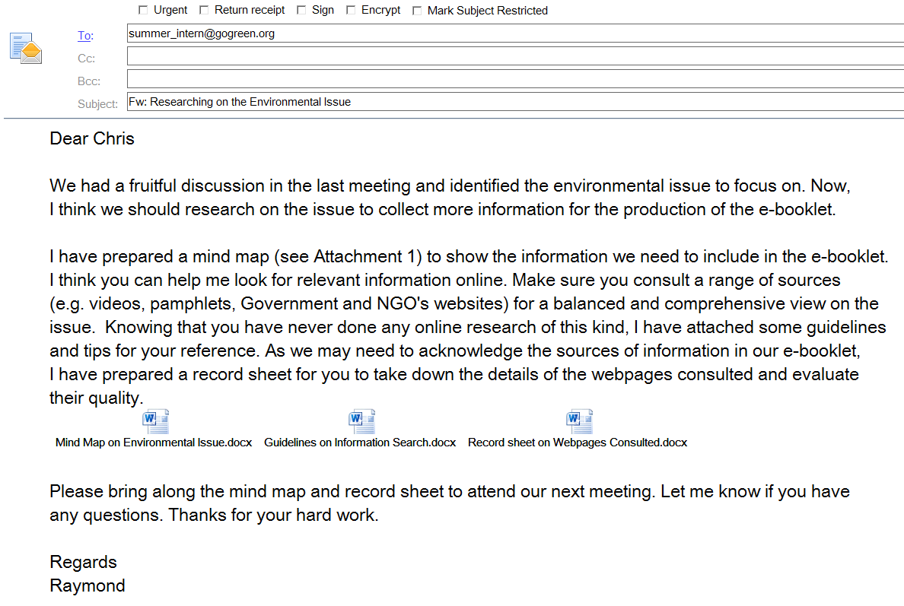
Dear Chris

We had a fruitful discussion in the last meeting and identified an environmental issue to focus on. Now, I think we should research into the issue to collect more information for the production of the e-booklet.

I have prepared a mind map as attached to show the information we need to include in the e-booklet. I think you can help me look for relevant information online. Make sure you consult a range of sources (e.g. videos, pamphlets, Government and NGO’s websites) for a balanced and comprehensive view on the issue. Knowing that you have never done any online reseach of this kind, I have also attached some guidelines and tips for your reference. It is important for us to acknowledge the sources of information in our e-booklet and ensure the quality of information. I have prepared a record form for you to take down the relevant details of the websites consulted and evalute their quality.

Please bring along the mind map and record form to attend our next meeting. Let me know if you have any questions. Thanks for your hard work.

Regards
Raymond

LT 3.1.2T
Effects
Environmental Issue:
Get students to write the numbers in the spaces provided to indicate the sources from which the information is obtained in the record form.
Solutions
Quotation(s) from Experts / Professionals:

Useful Statistical Data:

Party 5______

Action 1

Action 2

Party 4______

Action 1

Action 2

Party 3______

Action 1

Action 2

Party 2______

Action 1

Action 2

Party 1______

Action 1

Action 2

Causes
Part C: Learning about effective information search
LT 3.1.3T

How to search the Internet effectively?

- Find the right search engines (e.g. engines that separate paid listings or sponsored links from main editorial results)

- 1 or 2 keywords per search may not be enough for an effective query. Use up to 6 to 8 keywords, preferably nouns, per search. Avoid articles (e.g. “a”, “the”) and pronouns (e.g. “it”, “them”).

- Use the following search commands to refine your search where appropriate:

- Combine keywords into phrases using quotation marks to show search results with the keywords in the exact order
e.g. “negative impacts of global warming”

- Use “+” to show search results that contain both phrases
e.g. “global warming”+ “greenhouse gases”

- Use “OR” to show search results that contain either one of the phrases
e.g. “negative impacts of global warming” OR “harmful effects of global warming”

- Use “-” to show all search results that contain the first word / phrase but not the second to exclude unwanted results
e.g. “solution to water pollution”-“water purifier”

LT 3.1.3T
How to evaluate online sources?

To assess the quality and credibility of online sources, consider the following:
1. The site domain of the URL
The site domain often shows:
- the nature and purpose of the site (e.g. “.org” for a non-profit making organisation, “.com” for a business or commercial organisation, “.gov” for a government site, “~” for a personal page)
- the country of origin of the site (e.g. “.hk” for Hong Kong sites, “.uk” for the United Kingdom sites).

2. The author / content provider of the site
Questions to consider:
- Can the author / content provider of the site be identified?
- Is the author / content provider an authority in the field?
- What is the author’s / content provider’s intention in providing the information? (e.g. appealing for donation) For what purpose is the text created?
- Does the author / content provider have a hidden agenda and personal interest related to the information provided? (e.g. is it an air-purifier seller providing information on the severity of air pollution?)

3. Accuracy and objectivity of information
Questions to consider:
- Is the information provided accurate, verified and well supported with details and evidence?
- Are sources of information cited? Is there a reference list at the end?
- Does the page present a particular view on the topic? If yes, why?
- Are there any biases (e.g. one-sided view on issues, full of loaded and inflammatory words)?

4. Timeliness of information
Questions to consider:
- When was the page created / updated? Is the information provided current and valid?
- Is the site well-maintained? Are the hyperlinks functional?

Record Form on Sources of Information
LT 3.1.3T

 | Site Name / Article Title & URL | Author/  Content Provider | Purpose of the  Site / Article | Date of Creation  Last Updating | Relevant Information Provided | Rating* | Remarks
e.g. | Wikipedia: Air pollution in Hong Kong  https://en.wikipedia.org/wiki/Air_pollution_in_Hong_Kong | Unknown | To provide information on the causes and effects of air pollution in Hong Kong, as well as the actions taken by the Government and other NGOs against it | Date of creation: unknown  Date of last updated:  17 January 2019 | Causes  Effects  Solutions / actions to be taken (by: the Hong Kong government, NGOs )  Statistics / expert quotes | ☆☆☆☆ | Some data may need verification.
e.g. | The Solutions to Air Pollution  https://www.greenpeace.org/eastasia/press/1190/beijings-first-air-pollution-red-alert-of-2016-coal-burning-the-culprit-greenpeace/ | Greenpeace  East Asia | To inform the reader of the actions the Chinese government should take against air pollution | N/A | Causes  Effects  Solutions / actions to be taken (by: policy makers, the Chinese government )  Statistics / expert quotes |  | It is more about the air pollution in the mainland instead of that in HK.
1 |  |  |  |  | Causes  Effects  Solutions / actions to be taken (by: ___________ )  Statistics / expert quotes
2 |  |  |  |  | Causes  Effects  Solutions / actions to be taken (by: ___________ )  Statistics / expert quotes
3 |  |  |  |  | Causes  Effects  Solutions / actions to be taken (by: ___________ )  Statistics / expert quotes

4 |  |  |  |  | Causes  Effects  Solutions / actions to be taken (by: ___________ )  Statistics / expert quotes
5 |  |  |  |  | Causes  Effects  Solutions / actions to be taken (by: ___________ )  Statistics / expert quotes
6 |  |  |  |  | Causes  Effects  Solutions / actions to be taken (by: ___________ )  Statistics / expert quotes
7 |  |  |  |  | Causes  Effects  Solutions / actions to be taken (by: ___________ )  Statistics / expert quotes
8 |  |  |  |  | Causes  Effects  Solutions / actions to be taken (by: ___________ )  Statistics / expert quotes
9 |  |  |  |  | Causes  Effects  Solutions / actions to be taken (by: ___________ )  Statistics / expert quotes
10 |  |  |  |  | Causes  Effects  Solutions / actions to be taken (by: ___________ )  Statistics / expert quotes
*Rate on the quality of the source (e.g. usefulness, user-friendliness, accuracy, reliability and timeliness of information) with five ☆ being the highest.

Task 2 Reading and Analysing a Leaflet
LT 3.2.1T

Part A: Reading a leaflet
You are going to design an e-booklet to educate the public about an environmental issue, e.g. the current situation, causes and effects of an environmental issue, and the possible ways to solve or alleviate the problem. To help you understand the organisation and text features of an e-booklet, Mr Lam has shown you a leaflet with similar features. Study the example below and answer the questions that follow.
Language features: Conditional
Language features: Future perfect tense
Language features: Inversion
Save Sharks from Extinction Be Part of the Solution!
Focus: current situation, background of the issue
Struggling for survival

Sharks used to be the masters of the sea. They are strong enough to stay at the top of the underwater food chain. Existing for over 400 million years, even earlier than dinosaurs, sharks play an important role in balancing the marine ecosystem being top predators in the ocean. However, these natural born hunters are facing the biggest threat ever – overfishing!
Adjectives and adverbs with emotional appeals
Focus: main cause of the problem
Overfishing
Populations of many shark species (e.g. hammerhead sharks, dusky sharks and sandbar sharks) have been declining drastically due to our greedy demand for shark fins, particularly in Hong Kong and the mainland, and the serious lack of sustainable shark fishery management worldwide. As animals of slow reproduction, shark populations are shrinking to an alarming level. Hardly can many important species of sharks be found in open water in the near future unless overfishing is stopped immediately.
Focus: possible consequences and undesirable outcomes
Threat of extinction
The International Union for Conservation of Nature (IUCN) reported that increasing numbers of shark species are threatened with extinction. In 1996, only 15 shark and related species were threatened with extinction but the number will have increased by 16-fold to 240 species by 2018. By 2030, according to IUCN, the entire shark species will have become extinct on the planet.

Year | Number of threatened shark and related species on the IUCN red list
1996 | 15
2000 | 19
2004 | 82
2007 | 114
2010 | 180
2018 | 240
Focus: possible consequences and undesirable outcomes
Unbalanced marine ecosystem
By removing the weak and the sick, sharks effectively regulate the marine food chains. As predators, they can monitor diets of other species, shift their preys’ habitats and indirectly maintain the seagrass and coral reef habitats. Sharks help to keep the ecological balance to ensure biodiversity. If their number continues to decline, the marine ecosystem will be seriously upset.
Focus: the responsibilities of Hong Kong

The role of Hong Kong
Despite being small, Hong Kong is the world’s largest trading centre of shark fins, accounting for 50%-80% of the global trade, according to a report commissioned by the World Trade Organisation in 2010. About 73 million sharks are killed every year to satisfy this huge appetite.

"Shark Finning- an illegal practice" by indiawaterportal.org is
licensed under CC BY-NC-SA 2.0
How can you help save sharks and retain a balanced marine ecosystem?
Focus: actions to be taken by different parties
As an individual consumer
- Stop eating shark fins and persuade your relatives and friends to stop too.

- Encourage your hosts to go for shark-free banquets and consider imitation shark fins or sustainable seafood as an alternative.
- Support restaurants and caterers offering shark-free menus.
- Avoid buying shark-related products such as shark cartilage and accessories made of shark teeth.
"Respect the Fin" by Ryan Steely is licensed under CC BY-ND 4.0

As a corporate consumer
- Pledge not to eat or serve shark fins in corporate functions to demonstrate corporate social responsibility and support for a sustainable planet.
SAY NO
to shark fin soup!
As a caterer or a restaurant owner
- Join our Alternative Shark-free Menu Programme and offer your consumers shark-free banquets.

What are you waiting for? Act now! Only with our concerted efforts can the endangered shark species be preserved. Save sharks by supporting shark-free menus!

Learn more about shark conservation at wwf.org.hk/shark.
LT 3.2.1T
Language features: Rhetorical question
Language features: Imperatives
Language features: Inversion
Language features: Imperatives
Language features: Conditional
Part B: Analysing a leaflet
LT 3.2.2T
Answer the following questions, which will guide you to understand the features of an effective e-booklet:

- Content
Identify the following elements of the text and express your ideas in short answers:
Purpose of writing | - To provide information on the threat of extinction of sharks (e.g. the severity, causes and effects of the problem)  - To appeal for action against eating shark fins / to persuade readers to stop eating shark fins
Target audience | The general public, including individuals, businesses and restaurant owners
Central message | Sharks are threatened with extinction and immediate action is needed to prevent the problem from worsening.
Tone | - Informative when explaining the current situation  - Persuasive when appealing for action

- Organisation
How is the content of the text organised? Why? How is the information presented?
• | The text is organised under headings (e.g. “Struggling for survival”,
 | “Overfishing”) and subheadings (e.g. “As an individual consumer”) because
 | they help readers identify the main points of each section in the leaflet.
• | Short paragraphs or bullet points are used to present the information in a
 | concise manner.

- Language Features
- What is special about the title of the text? What technique is used to make it appealing?
• | The title is catchy with the use of rhyming words (i.e. “extinction” and
 | “solution”).
• | The imperative is also used to add force and call for readers’ action.

- There are many ways to create effective titles or catchy slogans for a booklet / leaflet. Most of them involve wordplay. Here are some examples:
LT 3.2.2T
- Rhyming words (words with the same ending sound)
- Alliteration (words that begin with the same consonant sound)
- Pun (a humorous use of words with multiple meanings or similar sounds)
- Parallel structure
- Triplet (words or phrases repeated three times)

Read the slogans below and identify the language features / techniques used.
Language features can be used in combination.
Slogan | Language feature
Reuse. Reduce. Recycle. | Triplet / parallel structure
Let’s go green to get our globe clean. | Alliteration
Give a hoot. Don’t pollute. | Rhyming words
It pays to be green! | Pun
Global warming – a global warning! | Pun / rhyming words
Nurture Nature. | Alliteration / rhyming words
Crush Greed. Go Green. | Pun, alliteration / parallel structure
Serve to conserve. | Rhyming words
Save paper, save trees, save the planet. | Triplet / parallel structure

- The following language items and sentences are used to talk about the grave consequences of an environmental problem. Complete the table by identifying the relevant examples from the text and selecting the suitable communicative function from the help box.
Language feature | Example in the text | Function in the text
Conditional sentence | - Hardly can many important species of sharks be found in open water in the near future unless overfishing is stopped immediately.  - If their number continues to decline, the marine ecosystem will be seriously upset. | To talk about things that will possibly happen
Future perfect tense | By 2030, according to IUCN, the entire shark species will have become extinct on the planet. | To show an action which will be completed by or will happen before another action in the future

Help box:
LT 3.2.2T
- To show an action which will be completed by or will happen before another action in the future
- To talk about things that will possibly happen

- The following language items and sentence structures are used to create a forceful tone and enhance the persuasiveness of the text. Complete the table by identifying the relevant examples from the text and their communicative functions from the help box.
Language feature | Example in the text | Function in the text
Inversion | - Hardly can many important species of sharks be found in open water in the near future unless overfishing is stopped immediately.  - Only with our concerted efforts can the endangered shark species be preserved. | To emphasise a point or an idea in a more formal manner
Imperative | - All the bullet points in the section “How can you help save sharks and retain a balanced marine ecosystem?”  - Act now! …Save sharks by supporting shark-free menus! | To give an order and command immediate action
Rhetorical question | What are you waiting for? | To raise the interest and concern of readers and encourage them to reflect on the matter

Help box:
- To raise the interest and concern of readers and encourage them to reflect on the matter
- To give an order and command immediate action
- To emphasise a point or an idea in a more formal manner

- Emotional Appeal
- Adjectives and adverbs are sometimes used to add emotions and strengths to the description. Can you highlight the adjectives and adverbs with such an emotional appeal in the paragraph on “Overfishing”? (answers double-underlined in the text)

- Describe the images in the text. How do they bring out the message of the text and appeal to readers’ senses and feelings?
LT 3.2.2T
- The picture of the shark in tears helps present the shark as a victim. The
shark is given human feelings, which arouses readers’ pity.
- The second picture shows the dead bodies of sharks, pricking our conscience
and making us feel guilty for inflicting such pain on sharks because of
human desires.
- The last two pictures contain a slogan that calls for our action and support
for shark-free menus.

- As an English idiom goes, “a picture is worth a thousand words”. A complex idea can be expressed with a powerful image which helps convey the central message forcefully and arouse readers’ emotions and desires. Identify the environmental issues as shown in the pictures. Choose the one you think has the strongest emotional appeal under each environmental issue and explain your choice.
"Lesser the pollution, better the life." By Kristlin Visnapuu is licensed under CC BY-NC-ND 4.0
"screened" by Rockman of Zymurgy is licensed under CC BY-NC-ND 2.0
Environmental issue | Picture A | Picture B | Picture C
Air Pollution
Shark Finning | "Scooping the sharks' fins" by lynac is licensed under CC BY-NC 2.0
Land/Sea Pollution |  | "Plastic Bags Packaging - Awareness - 3rd Year" by Noor Daghistani is licensed under CC BY-NC-ND 4.0  "Shark Fins Drying for Sale by kqedquest is licensed under CC BY-NC 2.0 | "Finned" by MoelSiabod is licensed under CC BY-NC 2.0
V. Logical Appeal
LT 3.2.2T
- Why are the statistics from the reports by the International Union for Conservation of Nature and the World Trade Organisation cited in the text? What points do they illustrate and what impact do they have on readers?
- The statistics from the IUCN report illustrate the alarming and accelerating
trend of shrinking shark populations, which shows how serious the threat of
extinction is.
- The findings from the World Trade Organisation report help show the key role
Hong Kong plays in driving up the demand for shark fins and thus the great
responsibility we should take for solving the problem.
- The use of statistics makes the points more convincing and objective.

- In addition to statistics, what are some other ways to strengthen the points and enhance the validity and persuasiveness of the text?
Quoting speeches from authoritative figures / organisations in the field is
another way to provide supporting details and evidence.

Recap on the features of a persuasive leaflet / e-booklet
- Catchy titles and slogans
- Clear headings and subheadings
- Use of bullet points
- Use of persuasive language
- Use of powerful images
- Use of statistical data and quotes from reliable and authoritative sources

Task 3 Devising a Plan for the Production of an e-Booklet
LT 3.3.1T

Part A: Understanding the requirements of the e-booklet to be produced
Images can help present information effectively and tell stories with impacts and emotions. To show you how images can be used as an alternative to expressing information in words, Mr Lam has given you the following images to introduce to you the requirements of the e-booklet which you and your team members are going to produce. Decode the images and fill in the blanks below.



Problem
Severe?
Why?
Impact?
What to do?




Your e-booklet should:

 | focus on |  | one |  |  |  |  | environmental issue;
 | include a cover with an |  |  |  |  |  |  | eye-catching |  |  |  |  |  | title;
 | discuss the |  |  | severity |  |  |  |  | , | causes |  |  | , impacts of the problem and
 | actions |  |  |  | to be taken by different parties;
 | be | five |  |  |  | to | six |  |  |  |  | pages long;
 | include |  | pictures |  |  |  |  | and images on each page to help present the
 | message; and
 | include some sound effects (e.g. |  |  |  |  |  |  |  |  |  | music |  |  | , | voice-over | ) and
 | add special effects, if necessary, on each page.

Part B: Planning for the e-booklet
LT 3.3.2T
Use the following templates to design the e-booklet. Include as many details as possible and all the words to appear on each page.

Title: ________________________________________________________________
Environmental issue to focus on: __________________________________________
Cover Design

Language features used:
- Rhyming words Alliteration Parallel structure Pun
- Triplet Others: __________________________________
Reasons for using the language feature(s):
_________________________________________________________________

Content (Page _____)
LT 3.3.2T
Provide the background information (e.g. most affected areas, severity) of the environmental problem.
Food for thought: headings / subheadings, pictures and images, layout, background music, voice-over, special effects

Tactics and language of persuasion used:
- Persuasive language (e.g. ____________________________)
- Statistical data from reliable sources Quotes from experts / professionals
- Powerful images Others: ________________________________________

Content (Page _____)
LT 3.3.2T
Discuss the causes of the environmental problem.
Food for thought: headings / subheadings, pictures and images, layout, background music, voice-over, special effects

Tactics and language of persuasion used:
- Persuasive language (e.g. ____________________________)
- Statistical data from reliable sources Quotes from experts / professionals
- Powerful images Others: ________________________________________

Content (Page _____)
LT 3.3.2T
Provide the possible impacts caused by the environmental problem.
Food for thought: headings / subheadings, pictures and images, layout, background music, voice-over, special effects

Tactics and language of persuasion used:
- Persuasive language (e.g. ____________________________)
- Statistical data from reliable sources Quotes from experts / professionals
- Powerful images Others: ________________________________________

Content (Page _____)
LT 3.3.2T
Suggest ways to alleviate / solve the environmental problem from the perspective of at least three stakeholders.
Food for thought: headings / subheadings, pictures and images, layout, background music, voice-over, special effects

Tactics and language of persuasion used:
- Persuasive language (e.g. ____________________________)
- Statistical data from reliable sources Quotes from experts / professionals
- Powerful images Others: ________________________________________

Part C: Acknowledging sources of information
LT 3.3.3T
Below are some guidelines on acknowledging sources of information. Based on the guidelines, compile a list of references for the e-booklet you produce.

Citing and acknowledging sources of information is crucial as:
- it helps readers identify and verify the information;
- it gives credit to the author of an original idea / concept / work; and
- it provides evidence that your materials are well-researched.

Acknowledge the sources of information in your e-booklet using the following format:
The year of publication refers to the year when the article was first published, not last updated / modified.

- When citing website articles with an author
Author’s Last Name, First Initial. (Year of Publication). Article Title. Retrieved from URL

e.g. Kao, E. (2019). Is Hong Kong's air policy being manipulated for the sake of development? Retrieved from https://www.scmp.com/news/hong-kong/health-environment/article/2182585/hong-kongs-five-year-air-quality-targets-are

- When citing website articles without an author and the year of publication
Article Title. (Year of Publication). Retrieved from URL
Use (n.d.) when the publication year is unknown.
e.g. Air quality in Hong Kong. (n.d.) Retrieved from https://www.gov.hk/en/residents/environment/air/airquality.htm

- When citing pictures / images
LT 3.3.3T
Author’s Last Name, First Initial. (Year of Publication). Title of Picture / Image [Type of work]. Retrieved from URL

e.g. Tsang, S. (2018). Smog hangs over buildings in Hong Kong on Mondays as the air pollution reached high levels [Photograph]. Retrieved from https://www.scmp.com/news/hong-kong/health-environment/article/2172821/air-pollution-hong-kong-posing-serious-health-risk
The retrieval date is required if the source materials may change over time.

- When citing pictures / images without the author, title and year of publication
[Description of the Picture]. Retrieved [Retrieval Date] from URL

e.g. [Untitled image of the foggy Victoria Harbour]. Retrieved Jan 21, 2019 from https://www.gov.hk/en/residents/environment/air/airquality.htm

- When citing video clips
Author’s Last Name, First initial. (Year of Upload). Title of Video [Type of Work]. Retrieved from URL

e.g. TEDx Talks. (2018). Air pollution: let’s analyse, clean, and deliver. [Video file]. Retrieved from https://www.youtube.com/watch?v=nvH_sgnE268
The author refers to the person who posted the video online. If the author is unknown, then the screen name should be used. The capitalisation of the screen name should be identical to how it appears online.

Part D: Assessing the e-booklet
LT 3.3.4T

Use the checklist below to review whether your e-booklet has included the following:

- a cover page with a memorable title
- background / current situation of the environmental problem
- main cause(s) of the problem
- impacts of the problem
- actions to be taken by different parties to solve / alleviate the problem
- supporting details (e.g. statistics, examples, quotes)
- a list of references
- use of headings / subheadings / bullet points
- use of images / pictures
- use of music / sound effect / voice-over
- use of different fonts / font size / colours

Use the following assessment form to assess the e-booklets produced by your team members
LT 3.3.4T
Assessment Form
Name:
Title:
Environmental issue:
 |  |  | Needs  Improvement | Meets basic requirements | Satisfactory | Good | Well  Done
 | Content
Ideas and information presented in the following parts are relevant and comprehensive:
- the background and current situation of the environmental problem
- the main cause(s) of the problem
- the impacts and effects of the problem
- the actions to be taken by different parties to solve / alleviate the problem
 | Supporting details (e.g. statistics, examples, quotes) are provided to enhance validity and logical appeal.
 | Organisation
 | Headings and subheadings are effectively used.
 | Points are clearly presented in bullet points or short paragraphs.
 | Different parts of the booklet are coherent and logically connected.
 | Language
 | The title is catchy and effective.
 | The language is accurate.
 | A range of vocabulary on the issue is appropriately used.
 | Relevant language items and sentence patterns are used to enhance persuasiveness of the text.
 | Audio-visual Presentation
 | Powerful images are used to arouse readers’ emotions.
 | Music and sound effects are effectively used.
 | Images and sound effects effectively complement the words to convey the message of the text.
Overall Comments



References

(Blank page)
References

Albers, P., & Harste, J. (2007). The Arts, New Literacies, and Multimodality. English Education, 40(1), 6-20. Retrieved from http://www.jstor.org/stable/40173265

Baker, F. W. (2012). Media Literacy in the K-12 Classroom. Eugene, OR.: International Society for Technology in Education.

Callow, J. (2005). Literacy and the Visual: Broadening our Vision. English Teaching: Practice and Critique, 4(1), pp. 6—19.

Cazden, C., Cope, B., Fairclough, N., Gee, J., Kalantzis, M., Kress, G., Luke, A., Luke, C., Michaels, S. and Nakata, M. (The New London Group) (1996). A Pedagogy of Multiliteracies: Designing Social Futures. Harvard Educational Review, 66(1), pp. 60-92.

Centre for Media Literacy. (2008). Literacy for the 21st Century: An Overview & Orientation Guide to Media Literacy Education. Malibu, CA.: Author. Retrieved from www.medialit.org/sites/default/files/01a_mlkorientation_rev2.pdf

Churchill, D. (2010). New Literacy in the Digital World: Implications for Higher Education. ALSR 2010: Conference towards Future Possibilities. Retrieved from https://core.ac.uk/download/pdf/61010522.pdf

Cope, B., & Kalantzis, M. (2000). Multiliteracies: Literacy Learning and the Design of Social Futures. Psychology Press.

Goldstein, B. (2016). Visual Literacy in English Language Teaching: Part of the Cambridge Papers in ELT Series. Cambridge: Cambridge University Press.

Serafini, F. (2014). Reading the Visual: An Introduction to Teaching Multimodal Literacy. New York: Teachers College Press.

(Blank page)


Appendices

(Blank page)
Content

Appendix A………………………………………………………………… |  |  | p.147
Module: Technology
Task 2: Comparing Products
Audio Clip for the briefing session on Smartie Watch 2.0

Appendix B………………………………………………………………… |  |  | p.149
Module: Technology
Task 4: Writing a Speech
PowerPoint Slides on Smartie Watch 2

Appendix C ………………………………………………………………... |  |  | p.153
Module: Leisure and Entertainment
Task 2: Designing a Storyboard
Enlarged Storyboard (A3 size)

Appendix D ………………………………………………………………... |  |  | p.157
Module: Nature and Environment
Task 1: Identifying and Researching into an Environmental Issue
Enlarged Mind Map (A3 size)

Appendix E ………………………………………………………………… |  |  | p.161
Module: Nature and Environment
Task 1: Identifying and Researching into an Environmental Issue
PowerPoint Slides on Environmental Issues
Appendix F ………………………………………………………………… |  |  | p.167
Module: Nature and Environment
Task 3: Devising a Plan for the Production of an e-Booklet
Sample e-Booklet

(Blank Page)


Appendix B

Module: Technology
Task 4: Writing a Speech
PowerPoint Slides on Smartie Watch 2

(Blank Page)

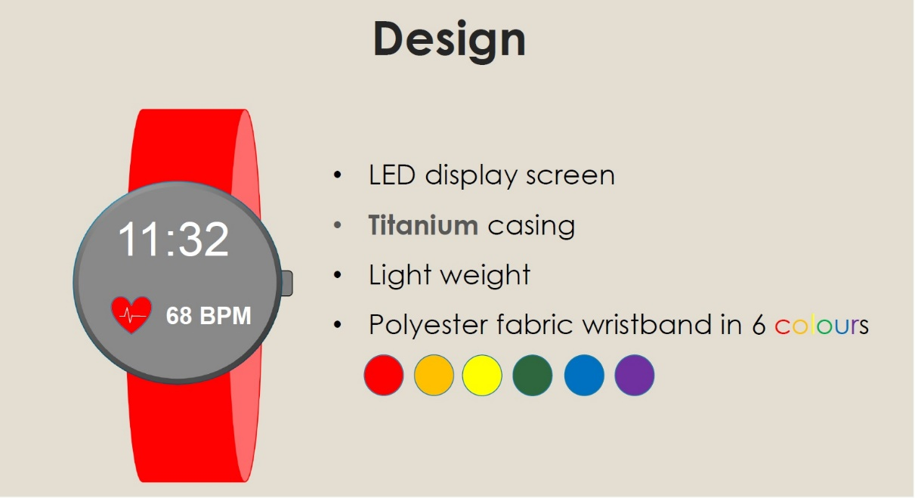
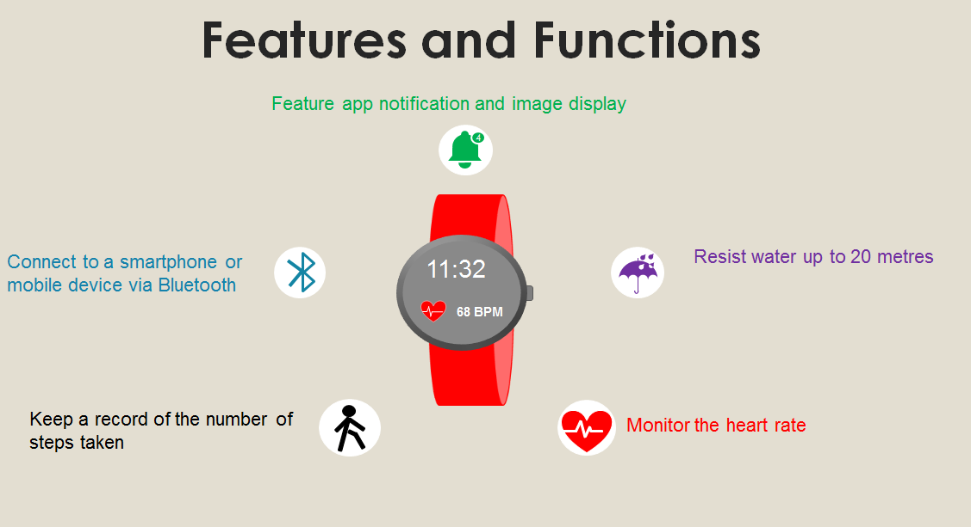
(Blank Page)

Appendix C

Module: Leisure and Entertainment
Task 2: Designing a Storyboard
Enlarged Storyboard (A3 size)

(Blank Page)

Part C: Designing a storyboard
To take part in the Short Film Competition, you and your group members are going to make a short film of under five minutes based on one of the messages: (a) “Count your blessings”; OR (b) “Never judge a book by its cover”. Use the storyboard below to brainstorm the details of the short film with your group members.

(Blank Page)

Appendix D

Module: Nature and Environment
Task 1: Identifying and Researching into an Environmental Issue
Enlarged Mind Map (A3 size)

(Blank Page)

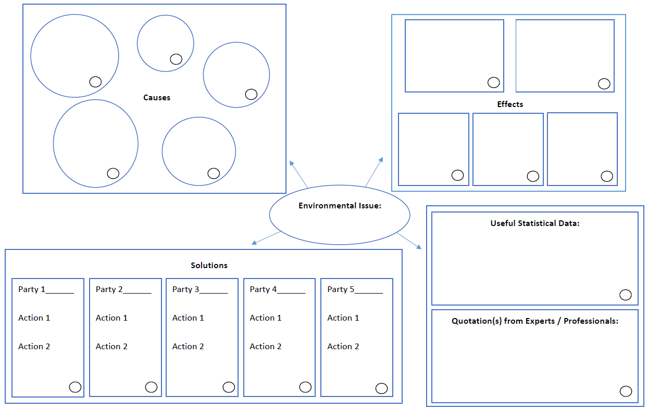
(Blank Page)

Appendix E

Module: Nature and Environment
Task 1: Identifying and Researching into an Environmental Issue
PowerPoint Slides on Environmental Issues

(Blank Page)



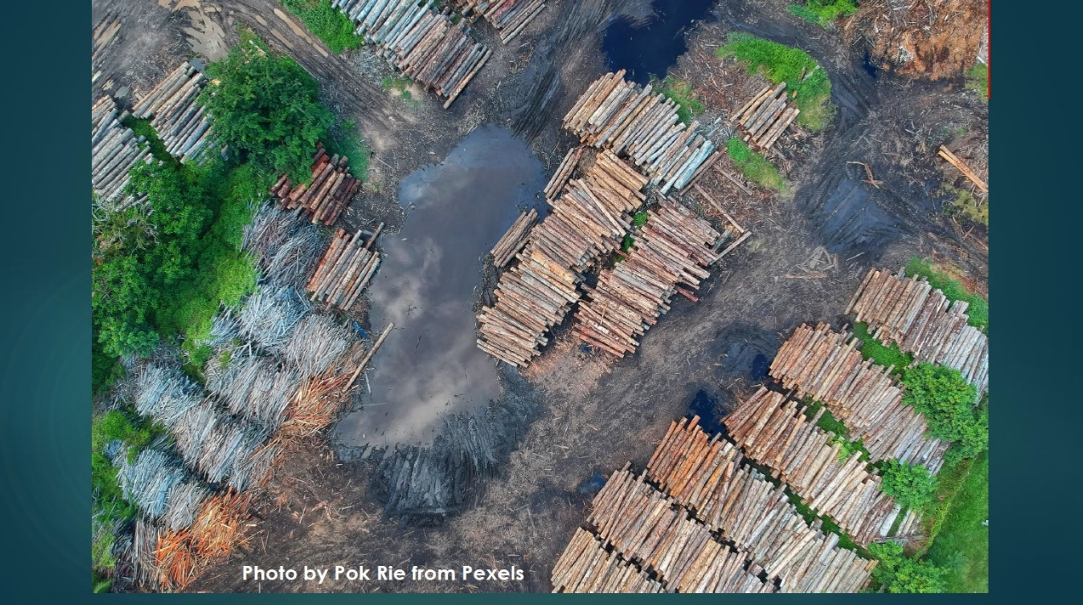


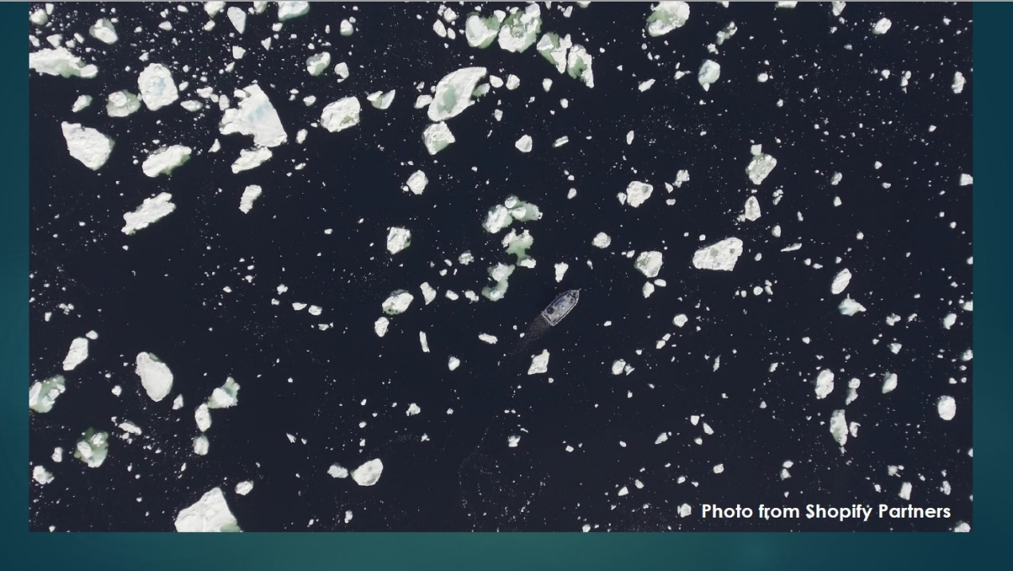

(Blank Page)

Appendix F

Module: Nature and Environment
Task 3: Devising a Plan for the Production of an
e-Booklet
Sample e-Booklet

(Blank Page)


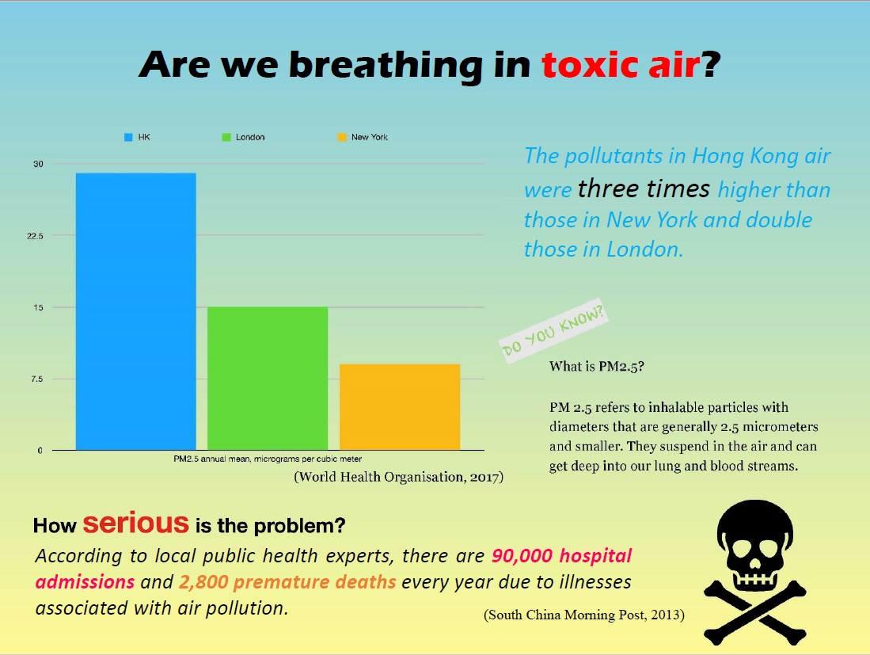
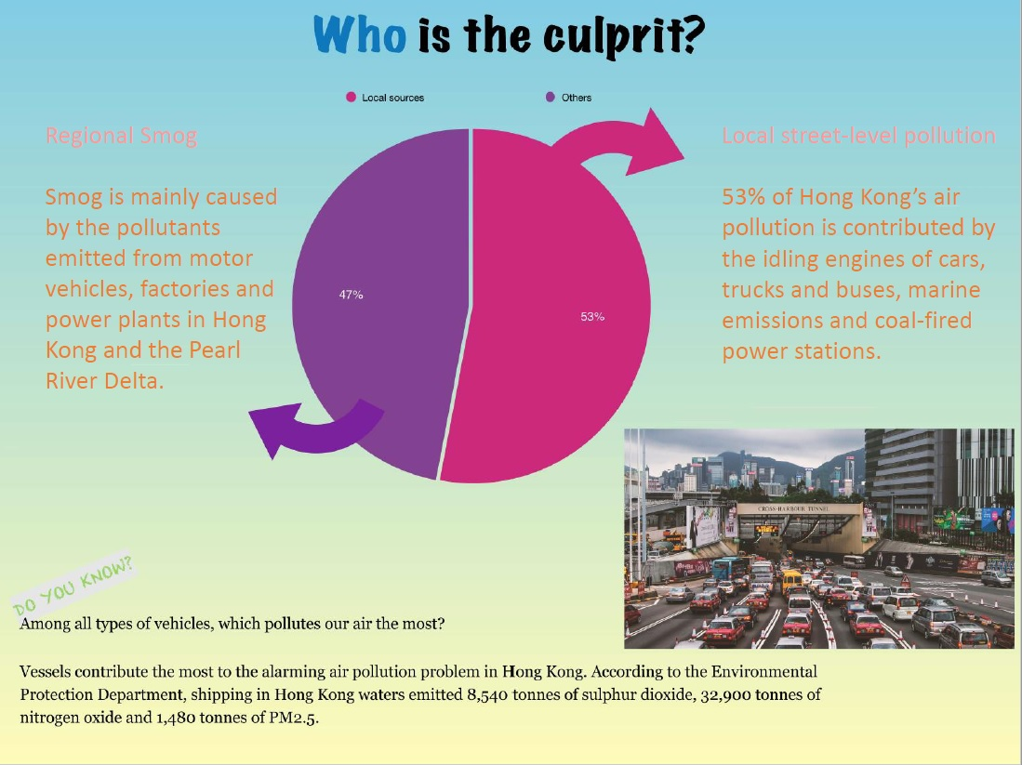
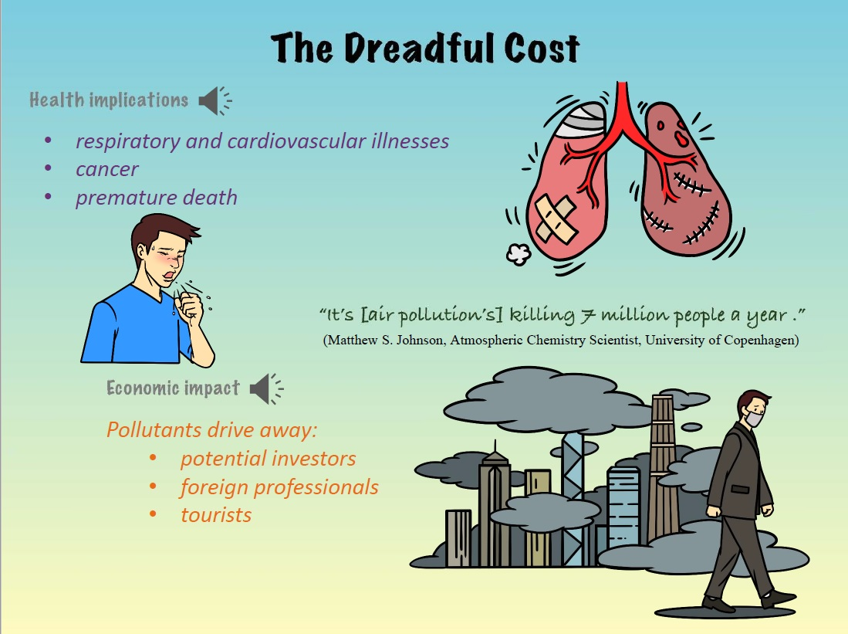
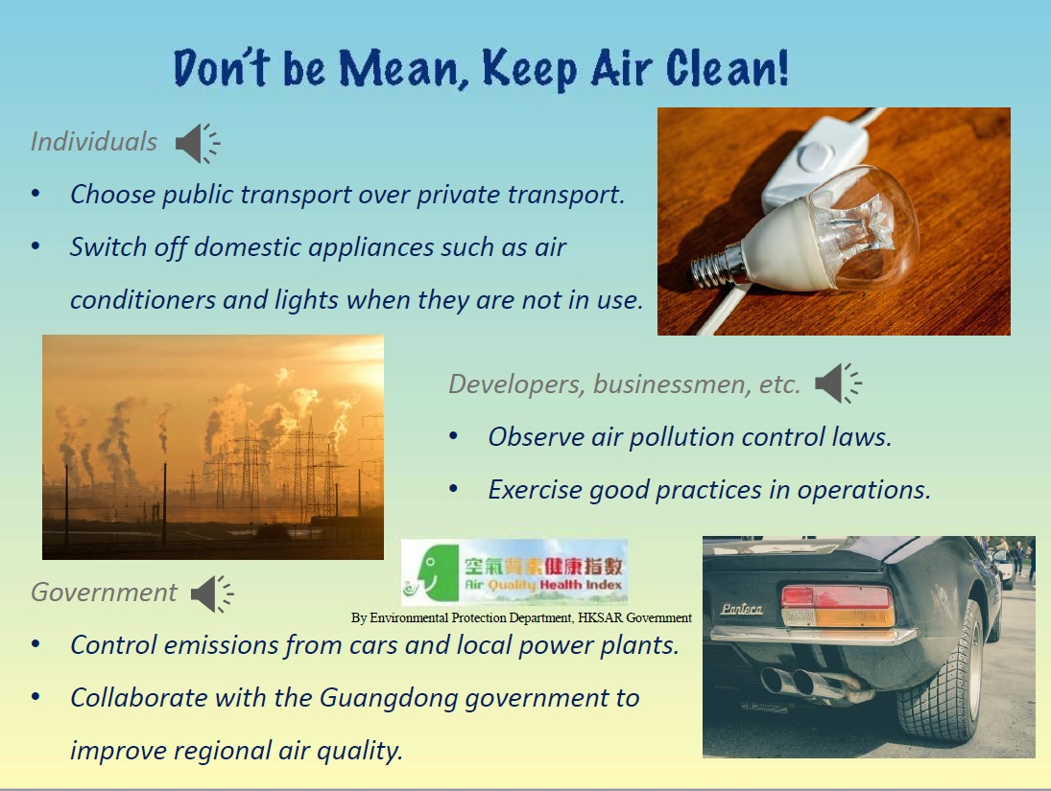
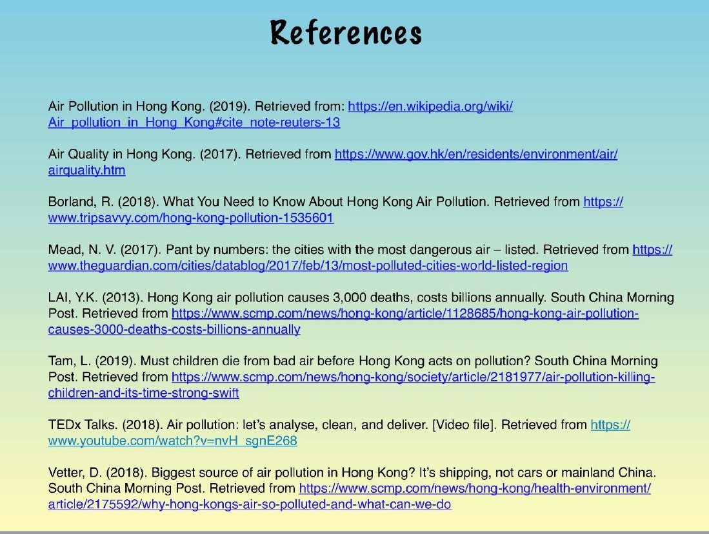


(Blank Page)

